Lesson № 7 |  | School: | Karaagash basic school
Date: |  | 04.03.24 | Teacher's name: Kenzhebaeva A.S
Grade: 3 |  | Number present: | Number absent:
Theme of the lesson: |  | Number games
Learning objectives(s) that this lesson is contributing to |  | 3.L1 Understand short supported classroom instructions in an increasing range of classroom routines .  3.W7 spell a growing number of familiar high – frequency words accurately during guided writing activities .  3.UE11 Use has got / have got there is / are statements and question forms including short answers and contractions.
Lesson objectives |  | All learners will be able to:
Understand the theme of the lesson;
Interpret & demonstrate short supported classroom instructions with support ·
count and spell cardinal numbers 1 -100 to count and ordinal numbers 1-10 with support.
 |  | Most learners will be able to:
Identify the theme.
interpret & demonstrate short supported classroom instructions with little support · spell cardinal numbers 1 -100 to count and ordinal numbers 1-10 with little support.
Do exercise in the card.
 |  | Some learners will be able to:
Understand the meaning of the text .
interpret & demonstrate short supported classroom instructions
count and spell cardinal numbers 1 -100 to count and ordinal numbers 1-10 without support .
Assessment criteria |  | (H/T)-2.p.  Сut out the squares at the bottom of the page -2.p.  Write the number words for 10-100 -2.p.  Match a word to a pictures -2.p.  Complete the numbers vocabulary .-2.p.
Materials |  | Pictures, Students books, Cards, Record –player.
Methods ; |  | Conversation, demonstration of illustrations to the theme, songs.«Game» method.
Results of the lessons; |  | Fixing vocabulary on a topic Develop skills of reading, listening, speaking and unprepared speech;  Achieving the lesson goal.
Planned timing | Planned activities |  |  | Student's actions | Assessment | Resources
Organization moment  1 min  Phonetic drill  2 min | Good morning, children !  How are you today?  Who is on duty today ?  Who is absent today?.  What date is it today?  I'm glad to see you!  If you're all right, show me your fingers like this -    Children , repeat after me:  One, two.  How are you?  Three, four.  Knock at the door.  Five, six.  Crosses and ticks. |  |  | “The wish flower” method helps to start the lesson with good wishes to each other.  The aim: To develop Ss speaking skills and create friendly atmosphere  Efficiency: By wishing each other they feel better and feel the support of others.  Ss greeting with the T.  Ss answer the questions and show their fingers.  T; show a photo,  Ss repeat after teacher. | At the organization moment T tries to award active Ss. «The praise» method is used to evaluate Ss with phrases like:  “Good job!  Well done!” | Picture.
Checking home task  5 -min | T: So, if you're ready, let's start our lesson. But before, let's check up you homework.  T moves around the class and listens the students. Then T asks some learners to retell what they heard. |  |  | Ss read their home task to each other.  Diff-n: MAS are asked to give extended answer. | FA:2. points.  Gestures! | Pupils book.  Ex.25.103.p.
Direction to the topic  1-min | Today we’ll talk about ‘ Number games ’  So, open your students' books at page 111.  Aim of the lesson:  - Practice and do exercise .  - Learn the new vocabulary . |  |  | Ss write the date and topic .  The aim: ensure the general comprehension for the new theme of the lesson. | «The praise» method is used to evaluate Ss with phrases like:  FA: Perfect!  Well done! | Pupils book.
Work with new theme  5-min | Subjeсt-speсifiс vосаbulаrу аnd terminоlоgу:  Let’s read these new words orally together. Write down new words: repeat after me.  - Numbers –сандар.  - ordinal numbers-реттік сандар  - cardinal numbers  Okay ,good job! Excellent. |  |  | Ss learners study new words and copy new words to their copybooks.  Aim: pronounce the topic vocabulary words correctly. | FA: Gestures!  Great! | Pupils book.
MAIN PART  (27-min)  Task 1  7-min  Task 2  5-min  Task 3  5- min  Task 4  5-min  Task 5  5-min | Children, listen to me carefully Look at the ex.5.  Who wants to start ?.Who is next? Is it clear ?. Listen to the audio.  Have you got any questions ?.  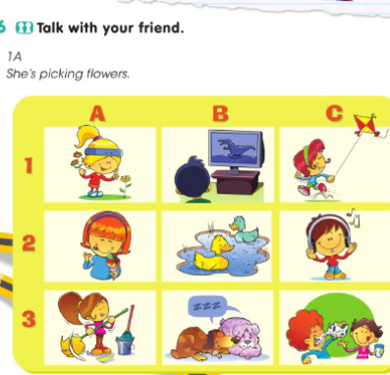  Dear children listen to me attentively. Let’s do next ex. 2. Time is up !.Is it clear ?. Who can start?.  I will give you 5 min.  Are you ready ?.  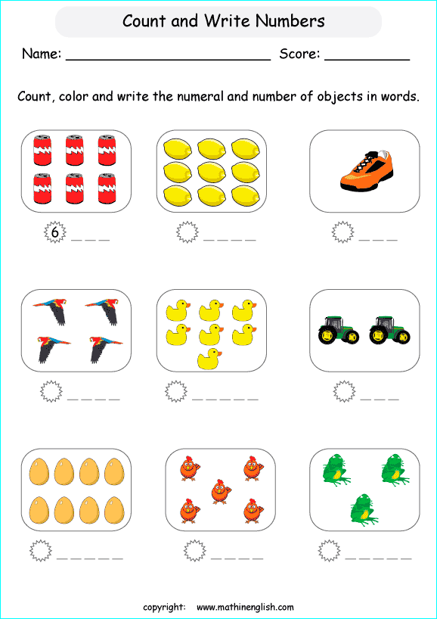  Guys listen to me carefully!!!.  Let’s do next ex. 3.  Who can start?. Is it clear ?.  I will give you 5 min.  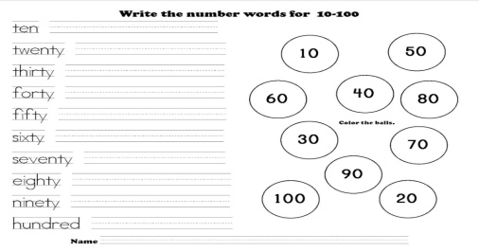  Guys listen to me carefully!.  Look at the ex.4. Is it clear ?..  I will give you 5 minutes for this exercise. Who can start?.  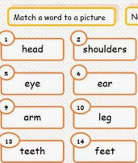  Children ,listen to me carefully.  Look at the ex.5.  I will give you 5 min.  Who wants to start?.Who is next?  Is everything clear ?.  Have you got any questions ?.  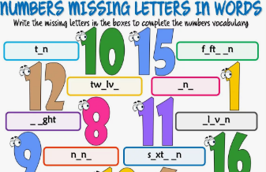 |  |  | T-explains a task and give Ss time to think.  Children count ,color and write the numeral and number of objects in words .  Aim: develop speaking and critical thinking skills.  T-explains a task and give Ss time to think .  Children cut out the squares at the bottom of the page.  T-explains a task and give Ss time to think.  Children write the number words for 10-100 .  T-explains a task and give Ss time to think.  Children match a word to a pictures.  T-explains a task and give Ss time to think.  Children write a missing letters in the boxes to complete the numbers vocabulary . | Orally-assessment.  «The praise» method is used to evaluate Ss with phrases like:  FA: Perfect!  Well done!  "Teacher-class checking". Teacher tells correct answer,  Ss check themselves.  FA.2.p.  “Good job!  Great work.  "Teacher-class checking". Teacher tells correct answer,  Ss check themselves.  FA;2.p.  “Good job!  Well done!”  "Teacher-class checking". Teacher tells correct answer,  Ss check themselves.  FA;2.p.  “Good job!  Well done!”  The "Temperature measurement" technique. The teacher in the process of completing tasks finds out how well the students perform.  FA;2.p.  Excellent. | Pupils book..111.  Cards  Worksheet.  Handout.  Handout.  Cards  Copybook.  Handout.  Cards  Copybook.  Handout.  Cards  Copybook
Reflection  3-min | 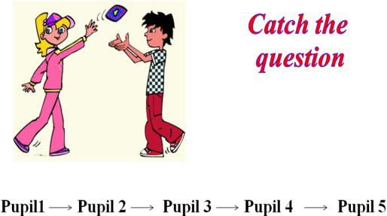 |  |  | Ss the teacher distributes the cards and the students write answer.  Aim: To know how many Ss got the theme. | Self-assessment.  .  Differentiation: «Conclusion» method is used to finish the lesson. | Cards.
End  1-min | Giving home task  -Now please, open your diaries and write down your home work.  OK, your home task will be  Ex.6.p.111  Children, thank you for your work! The lesson is over, GOOD BYE. |  |  | Ss write down your H\T in diaries. |  | Pupils book.

