Lesson № 1 |  | School: | Karaagash basic school
Date: |  | 15.01.24 | Teacher's name: Kenzhebaeva A.S
Grade: 4 |  | Number present: | Number absent:
Theme of the lesson: |  | Weather 1
Learning objectives(s) that this lesson is contributing to |  | 4.1.9.1 recognize words that are spelt out from a limited range of general and curriculum topics;  4.2.1.1 make basic statements which provide information on an increasing range of general and some curricular topics;  4.3.5.1 understand the main points of short simple texts on a growing range general and some curricular topics by using contextual clues;
Lesson objectives |  | All learners will be able to:
Understand the theme of the lesson;
Recognize 4-5 countries and/or weather words in listening task;
Write 5-8 weather words from prior learning;
 |  | Most learners will be able to:
Identify the theme.
Recognize 5-6 new words in listening task;
Write 7-10 weather words from prior learning;
 |  | Some learners will be able to:
Understand the meaning of the text.
Recognize 7-8 new words in listening task;
Write 9-12 weather words from prior learning;
Assessment criteria |  | (H/T)-2.p.  Draw a mind map with the weather words-2.p.  Read and match .then say -2..  Use the words in the box to complete the sentences below-2.p.  Find the hidden vocabulary words and circle-2.p.
Materials |  | Pictures, Students books, Cards, Record –player.
Methods ; |  | “ Discussing method . "Illustration method , Demonstration method, Audio-lingual .
Results of the lessons; |  | - Introduce some other words related to weather forecast.  - Drill pronunciation.  - Give learners Vocabulary worksheet to glue into their vocabularies
Planned timing | Planned activities |  |  | Student's actions | Assessment | Resources
Organization moment  1 min  Phonetic drill  2 min | Good morning, guys !  How are you today?  Who is on duty today ?  Who is absent today?.  What date is it today?  I'm glad to see you!  If you're all right, show me your fingers like this -    Children , repeat after me:  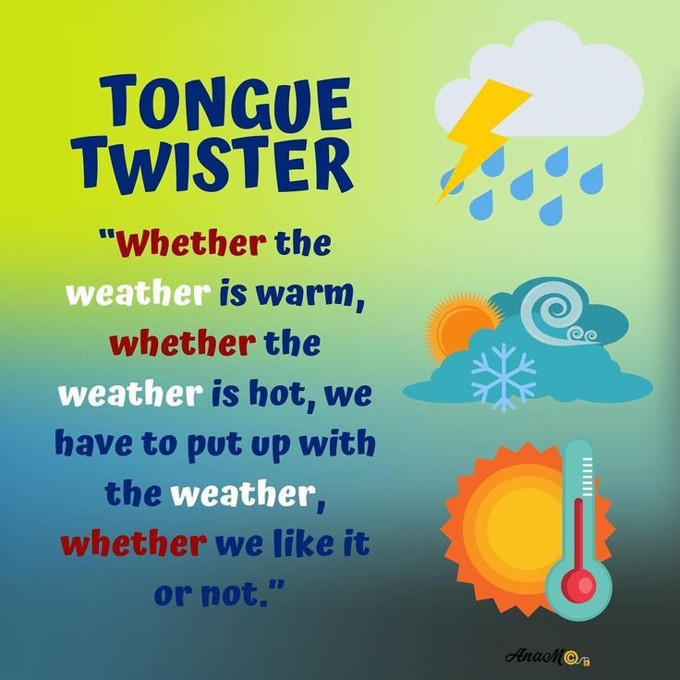 |  |  | “The wish flower” method helps to start the lesson with good wishes to each other.  The aim: To develop Ss speaking skills and create friendly atmosphere  Efficiency: By wishing each other they feel better and feel the support of others.  Ss greeting with the T.  Ss answer the questions and show their fingers.  T; show a photo,  Ss repeat after teacher. | At the organization moment T tries to award active Ss. «The praise» method is used to evaluate Ss with phrases like:  “Good job!  Well done!” | Picture.
Checking home task  5 -min | T: So, if you're ready, let's start our lesson. But before, let's check up you homework.  T moves around the class and listens the students. Then T asks some learners to retell what they heard. |  |  | Ss read their home task to each other.  Diff-n: MAS are asked to give extended answer. | FA:2. points.  Gestures! | Students' books.  Ex.4.67.p.
Direction to the topic  1-min | Today we’ll talk about ‘ Weather 1 ’  Answer the questions ;  1. What is the weather like today?  2.What season is it now ?.  So, open your students' books at page 69.  Aim of the lesson:  - Learners talk about whether .  - Learn the new vocabulary . |  |  | Ss write the date and topic and answer the question.  The aim: ensure the general comprehension for the new theme of the lesson. | «The praise» method is used to evaluate Ss with phrases like:  FA: Perfect!  Well done! | Students' books.
Work with new theme  5-min | To consolidate new vocabulary;  Let’s read these new words orally together. Write down new words: repeat after me.  1. Cloudy-бұлтты.  2.Foggy-тұманды.  3.Windy –желді.  4.Raining –жанбырлы.  5.Sunny-шуақты.  6.Snowing-қарлы.  Okay ,good job! Excellent. |  |  | Ss learners study new words and copy new words to their copybooks. | FA: Gestures!  Great! | Students' books.
MAIN PART  (27-min)  Task 1  7-min  Task 2  5-min  Task 3  5- min  Task 4  5-min  Task 5  5-min | Children, listen to me carefully  Have a look at the ex. 1.  Who wants to start ?.Who is next? Is it clear ?. Listen to the audio.  Have you got any questions ?.  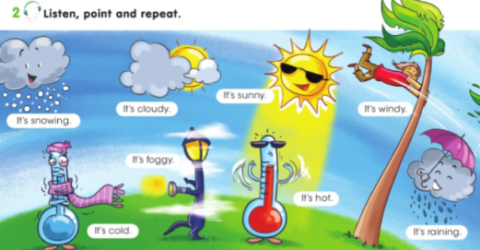  Guys listen to me attentively.  Let’s do next ex. 2.Time is up !.  .Is it clear ?. Who can start?.  I will give you 5 min.  Are you ready ?.  Writing .  Teacher divides the class into 2-3 groups, hands in a sheet of blank paper and asks them draw a mind map with the weather words they know from their prior learning. Ask groups present their findings before the class and compare their knowledge of words. Whole class discussion.  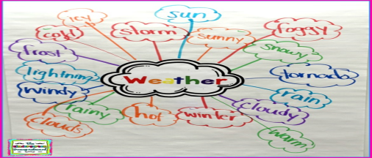  Guys listen to me carefully!!!.  Let’s do next ex. 3.  Who can start?. Is it clear ?.  I will give you 5 min.  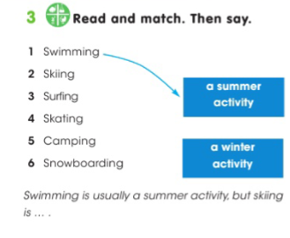  Guys listen to me carefully!.  Look at the ex.4. Is it clear ?..  I will give you 5 min. Who can start?.  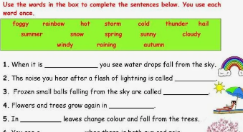  Guys listen to me carefully.  Look at the ex.5.  I will give you 5 min.  Who wants to start?.Who is next?  Is everything clear ?.  Have you got any questions ?.  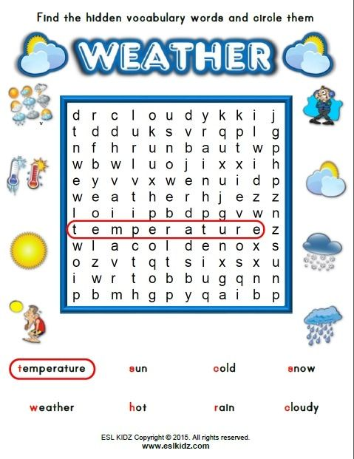 |  |  | T-explains a task and give Ss time to think.  Ss listen to the audio point and repeat .  T-explains a task and give Ss time to think.  Ss draw a mind map with the weather words they know from their prior learning .Whole class discussion .  T-explains a task and give Ss time to think.  Ss read and match .then say .  T-explains a task and give Ss time to think.  Ss use the words in the box to complete the sentences below.  T-explains a task and give Ss time to think.  Ss work in pairs .  Find the hidden vocabulary words and circle them. | Teacher monitors and gives feedback to students’ answers.  Orally-assessment.  Discussing method  In this method, the teacher discusses a matter with his pupils.Ss try to dominate through logical argument.  The "Temperature measurement" technique. The teacher in the process of completing tasks finds out how well the students perform.  FA;2.p.  Excellent.  Teacher monitors and gives feedback to students’ answers  FA:2.p  "Teacher-class checking". Teacher tells correct answer,  Ss check themselves.  FA;2.p.  “Good job!  Great work.  "Teacher-class checking". Teacher tells correct answer,  Ss check themselves.  FA;2.p.  “Good job!  Well done!” | Students book p.69.  https://youtu.be/Cm6XLZ-75QU?feature=shared  Copybook  Record –player  Students book p.69.  Copybook  Students book p.69.  Copybook  Cards .  Handout.  Handout.  Cards  Copybook.
Reflection  3-min | 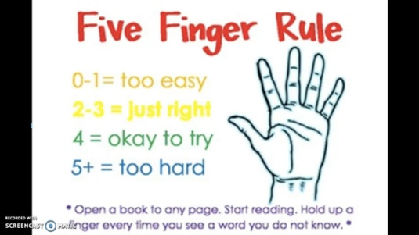 |  |  | Ss the teacher distributes the cards and the students write answer.  Aim: To know how many Ss got the theme. | Self-assessment.  .  Differentiation: «Conclusion» method is used to finish the lesson. | Cards.
End  1-min | Giving home task  -Now please, open your diaries and write down your home work.  OK, your home task will be  Ex.6.p.70  Children, thank you for your work! The lesson is over, GOOD BYE. |  |  | Ss write down your H\T in diaries. |  | Students book.

