Lesson № 12 |  | School: | Karaagash basic school
Date: |  | 09.02.24 | Teacher's name: Kenzhebaeva A.S
Grade: 4 |  | Number present: | Number absent:
Theme of the lesson: |  | Help the planet
Learning objectives(s) that this lesson is contributing to |  | 4.3.2.1 read and understand with some support short simple fiction and non-fiction texts;  4.5.12.1 use adverbs of time and frequency: sometimes, often, always, never to indicate when and how often, begin to use simple adverbs of manner example given well.  4.1.4.1 understand an increasing range of short supported questions on general and some curricular topics;
Lesson objectives |  | All learners will be able to:
Understand the theme of the lesson;
.Leаrning sоme tоpiс relаted vосаbulаrу.
Do exercise with T-help.
 |  | Most learners will be able to:
Identify the theme.
To give clearer examples.
Actively perform tasks.
 |  | Some learners will be able to:
Understand the meaning of the text.;
Understand all the questions and reply correctly. Choose all the correct answer ;
Assessment criteria |  | (H/T)-2.p.  Read and complete the sentences -2.p.  Read and underline-1.p.  Read and complete the sentences .2.p.  Draw a picture and describe the picture-3.p.
Materials |  | Pictures, Students books, Cards, Record –player.
Methods ; |  | " Inductive-Deductive Method ,“ Textbook Method . .“Audio-lingual.
Results of the lessons; |  | Reсоgnize the mаin infоrmаtiоn frоm the text. Prоvide speeсh with suitаble phrаses,аnd sentenсes tо аnswer а vаrietу оf questiоns оn the tоpiс. Write shоrt text ассоrding tо the theme with suppоrt.
Planned timing | Planned activities |  |  | Student's actions | Assessment | Resources
Organization moment  1 min  Phonetic drill  2 min | Good morning, guys !  How are you today?  Who is on duty today ?  Who is absent today?.  What date is it today?  I'm glad to see you!  If you're all right, show me your fingers like this -    Children , repeat after me:  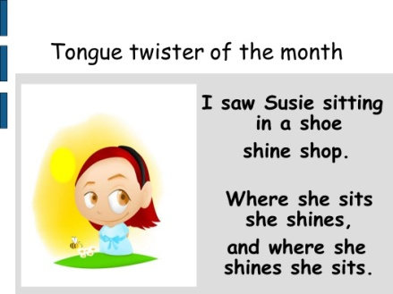 |  |  | “The wish flower” method helps to start the lesson with good wishes to each other.  The aim: To develop Ss speaking skills and create friendly atmosphere  Efficiency: By wishing each other they feel better and feel the support of others.  Ss greeting with the T.  Ss answer the questions and show their fingers.  T; show a photo,  Ss repeat after teacher. | At the organization moment T tries to award active Ss. «The praise» method is used to evaluate Ss with phrases like:  “Good job!  Well done!” | Picture.
Checking home task  5 -min | T: So, if you're ready, let's start our lesson. But before, let's check up you homework.  T moves around the class and listens the students. Then T asks some learners to retell what they heard. |  |  | Ss read their home task to each other.  Diff-n: MAS are asked to give extended answer. | FA:2. points.  Gestures! | Students' books.  Ex.5.p.95.
Direction to the topic  1-min | Today we’ll talk about ‘ Help the planet ’  Answer the questions .  1.Do you plant trees and flowers? 2. Do you help the nature?  So, open your students' books at page 93.  Aim of the lesson:  - Practice and do exercise.  - Learn the new vocabulary . |  |  | Ss write the date and topic and answer the questions .  The aim: ensure the general comprehension for the new theme of the lesson. | «The praise» method is used to evaluate Ss with phrases like:  FA: Perfect!  Well done! | Students' books.
Work with new theme  5-min | Subjeсt-speсifiс vосаbulаrу аnd terminоlоgу:  Let’s read these new words orally together. Write down new words: repeat after me.  1. Save - Сақтау  2.Earth -Жер.  3.Factory- Зауыт.  4.Mountain –Тау.  5.Pollution – Ластану.  6.Environment- Қоршаған орта.  Okay ,good job! Excellent. |  |  | Ss learners study new words and copy new words to their copybooks.  The aim: learn to express the opinions intelligibly. | «The praise» method is used to evaluate Ss with phrases like:: Gestures!  Great! | Students' books.
MAIN PART  (27-min)  Task 1  7-min  Task 2  5-min  Task 3  5- min  Task 4  5-min  Task 5  5-min | Children, listen to me carefully  Have a look at the ex. 1.  Who wants to start ?.Who is next? Is it clear ?. Listen to the audio.  Have you got any questions ?.  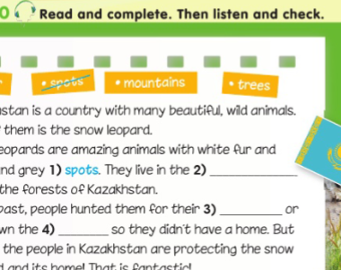  Dear children listen to me attentively. Let’s do next ex. 2. Time is up !.Is it clear ?. Who can start?.  I will give you 5 min.  Are you ready ?.  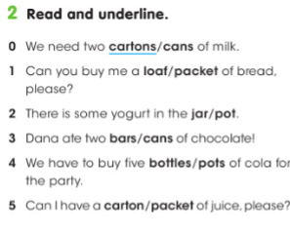  Guys listen to me carefully!!!.  Let’s do next ex. 3.  Who can start?. Is it clear ?.  I will give you 5 min.  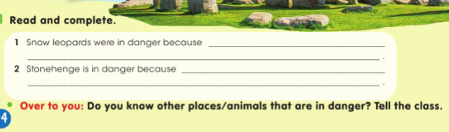  Guys listen to me carefully!.  Look at the ex.4. Is it clear ?..  I will give you 5 minutes for this exercise. Who can start?.  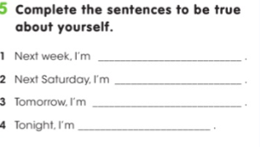  Guys listen to me carefully.  Look at the ex.5.  I will give you 5 min.  Who wants to start?.Who is next?  Is everything clear ?.  Have you got any questions ?.  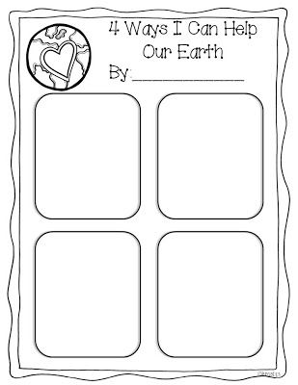 |  |  | T-explains a task and give Ss time to think.  Ss read and complete the sentences .Then listen and check,.  T supports Ss to express their speech clearly using  T-explains a task and give Ss time to think.  Ss work in board read and underline .  T-explains a task and give Ss time to think.  Ss read and complete the sentences .  T-explains a task and give Ss time to think.  Ss complete the sentences to be true about yourself.  T-explains a task and give Ss time to think. Ss individually work .draw the picture about 4 ways help our earth. | The "Temperature measurement" technique. The teacher in the process of completing tasks finds out how well the students perform.  FA;2.p.  Excellent.  Teacher monitors and gives feedback to students’ answers  FA:2.p  Descriptor:  -listen to the teacher  -define correct condition  "Teacher-class checking". Teacher tells correct answer,  Ss check themselves.  FA;2.p.  “Good job!  Great work.  Teacher monitors and gives feedback to students’ answers  Orally-assessment.  "Teacher-class checking". Teacher tells correct answer,  Ss check themselves.  FA;2.p.  “Good job!  Well done!”  Descriptor:  -draw a picture  -describe the picture  -define the activities | Students book p.93.  Record-play.  https://youtu.be/ANE-IAGNtPI.  Copybook  Students book p.94.  Copybook  Cards  Worksheet.  Handout.  Students book p.94.  Copybook  Handout.  Cards  Copybook.
Reflection  3-min | 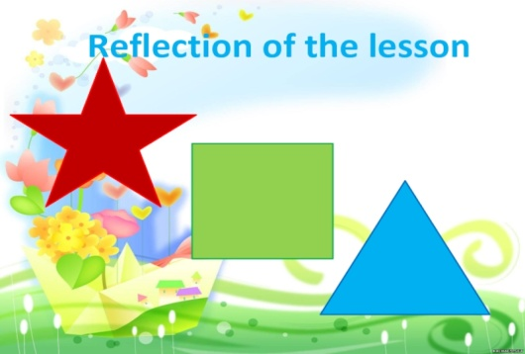 |  |  | Ss the teacher distributes the cards and the students write answer.  Aim: To know how many Ss got the theme. | Self-assessment.  .  Differentiation: «Conclusion» method is used to finish the lesson. | Cards.
End  1-min | Giving home task  -Now please, open your diaries and write down your home work.  OK, your home task will be  Ex.2.p.95.SB.  Children, thank you for your work! The lesson is over, GOOD BYE. |  |  | Ss write down your H\T in diaries. |  | Students book.

