Lesson № 5 |  | School: | Karaagash basic school
Date: |  | 24.01.24 | Teacher's name: Kenzhebaeva A.S
Grade: 4 |  | Number present: | Number absent:
Theme of the lesson: |  | Snow and ice.
Learning objectives(s) that this lesson is contributing to |  | 4.5.13.1 use can to make requests and ask permission, use must/mustn’t/have to to talk about obligation, use have + object + infinitive to talk about obligations;  4.5.14.1 use prepositions of location, position and direction: at, in, on, behind, between, in front of, near, next to, opposite, above, up, down, on the right, on the left, use prepositions of time : in, on, at, before, after, use with/without to indicate accompaniment with for instrument and for to indicate recipient;  4.5.16.1 use conjunctions and, or, but, because to link words and phrases
Lesson objectives |  | All learners will be able to:
Understand the theme of the lesson;
Learn some vocabulary connected to books .
Pronounce and name same words.
Do exercise with T-help.
 |  | Most learners will be able to:
Identify the theme.
Speak about the theme.
Do exercise in the cards
 |  | Some learners will be able to:
Understand the meaning of the text.
Use new words on topic fluently .
Give information about the theme.
Assessment criteria |  | (H/T)-2.p.  Choose and write on the igloo the words-2.p.  Read again . Correct the sentences-2.p.  Choose and complete.-2.p.  Fill in the gaps-1.p.  Write the words in alphabet order-1.p.
Materials |  | Pictures, Students books, Cards, Handout.
Methods ; |  | “ Discussing method . " Textbook Method. Visual method .
Results of the lessons; |  | Read for general meaning and specific detail .  Develops the speaking ,listening and reading skills .  Do comprehension checking tasks on the reading and listening material.
Planned timing | Planned activities |  |  | Student's actions | Assessment | Resources
Organization moment  1 min  Phonetic drill  2 min | Good morning, guys !  How are you today?  Who is on duty today ?  Who is absent today?.  What date is it today?  I'm glad to see you!  If you're all right, show me your fingers like this -    Children , repeat after me:  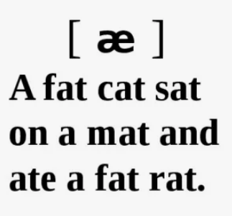 |  |  | “The wish flower” method helps to start the lesson with good wishes to each other.  The aim: To develop Ss speaking skills and create friendly atmosphere  Efficiency: By wishing each other they feel better and feel the support of others.  Ss greeting with the T.  Ss answer the questions and show their fingers.  T; show a photo,  Ss repeat after teacher. | At the organization moment T tries to award active Ss. «The praise» method is used to evaluate Ss with phrases like:  “Good job!  Well done!” | Picture.
Checking home task  5 -min | T: So, if you're ready, let's start our lesson. But before, let's check up you homework.  T moves around the class and listens the students. Then T asks some learners to retell what they heard. |  |  | Ss read their home task to each other.  Diff-n: MAS are asked to give extended answer. | FA:2. points.  Gestures! | Students' books.  Ex..p.
Direction to the topic  1-min | Today we’ll talk about ‘ Snow and ice. ’  So, open your students' books at page 78.  Aim of the lesson:  - Leaner’s talk about snow and ice.  - Learn the new vocabulary . |  |  | Ss write the date and topic .  The aim: ensure the general comprehension for the new theme of the lesson. | «The praise» method is used to evaluate Ss with phrases like:  FA: Perfect!  Well done! | Students' books.
Work with new theme  5-min | To consolidate new vocabulary;  Let’s read these new words orally together. Write down new words: repeat after me.  1. Snowflake-қар ұшқыны.  2.Sunglasses-күннен қорғайтын көзілдірік.  3.Ice-crystal –мұз кристалы.  4.Gloves-қолғаптар.  5.Scarf-шарф.  Okay ,good job! Excellent. |  |  | Ss learners study new words and copy new words to their copybooks. | FA: Gestures!  Great! | Students' books.
MAIN PART  (27-min)  Task 1  7-min  Task 2  5-min  Task 3  5- min  Task 4  5-min  Task 5  5-min | Children, listen to me carefully  Have a look at the ex. 1.  Who wants to start ?.Who is next? Is it clear ?. Listen to the audio.  Have you got any questions ?.  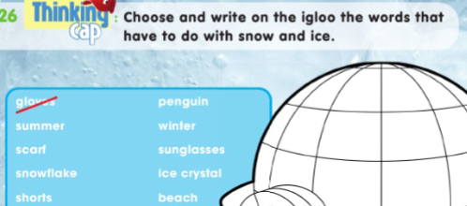  Guys listen to me attentively.  Let’s do next ex. 2.Time is up !.  .Is it clear ?. Who can start?.  I will give you 5 min.  Are you ready ?.  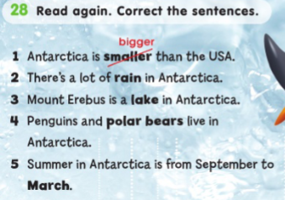  Reading .  Children, listen to me carefully!!!.  Let’s do next ex. 3.  Who can start?. Is it clear ?.  I will give you 5 min.  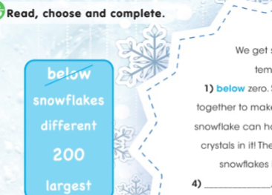  Guys listen to me carefully!.  Look at the ex.4. Is it clear ?..  I will give you 5 minutes for this exercise. Who can start?.  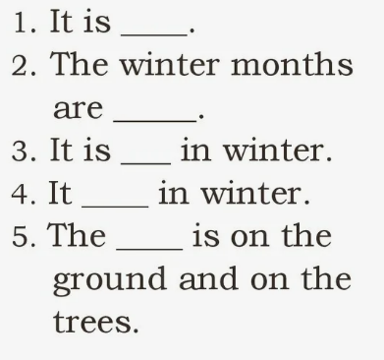  Guys listen to me carefully.  Look at the ex.5.  I will give you 5 min.  Who wants to start?.Who is next?  Is everything clear ?.  Have you got any questions ?.  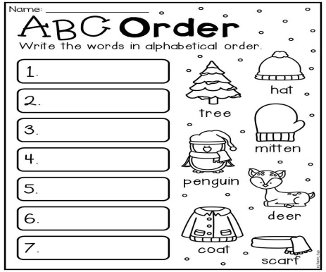 |  |  | T-explains a task and give Ss time to think.  Ss Choose and write on the igloo the words that have to do with snow and ice .  T-explains a task and give Ss time to think.  Ss read again . Correct the sentences .  T-explains a task and give Ss time to think.  Ss read, choose and complete.  T-explains a task and give Ss time to think.  Ss work in board. fill in the gaps  T-explains a task and give Ss time to think.  Ss write the words in alphabet order. | Teacher monitors and gives feedback to students’ answers  FA;2.p.  Textbook Method  • In this method, the teacher read out the book in the class loudly and explain the important point.  The "Temperature measurement" technique. The teacher in the process of completing tasks finds out how well the students perform.  FA;2.p.  Excellent.  Teacher monitors and gives feedback to students’ answers  FA:2.p  "Teacher-class checking". Teacher tells correct answer,  Ss check themselves.  FA;1.p.  “Good job!  Great work.  "Teacher-class checking". Teacher tells correct answer,  Ss check themselves.  FA;2.p.  “Good job!  Well done!” | Students book p.69.  Copybook  Students book p.78.  Copybook  Cards  Worksheet.  Handout.  Cards .  Handout.  Handout.  Cards  Copybook.
Reflection  3-min | 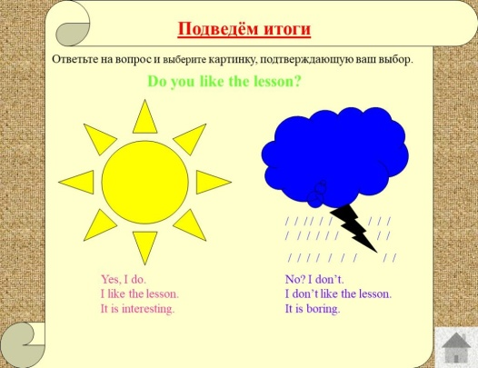 |  |  | Ss the teacher distributes the cards and the students write answer.  Aim: To know how many Ss got the theme. | Self-assessment.  .  Differentiation: «Conclusion» method is used to finish the lesson. | Cards.
End  1-min | Giving home task  -Now please, open your diaries and write down your home work.  OK, your home task will be  Ex.30 p.79 SB.  Children, thank you for your work! The lesson is over, GOOD BYE. |  |  | Ss write down your H\T in diaries. |  | Students book.

