Lesson № 12 |  | School: |  | Karaagash basic school.
Date: |  | 12 .02.24 | Teacher's name: Kenzhebaeva A.S
Grade: 6 |  | Number present: | Number absent:
Theme of the lesson: |  | Peter pan.
Learning objectives(s) that this lesson is contributing to |  | 6.4.1.1 understand the main points in a growing range of short, simple texts on general and curricular topics. 6.4.2.1 understand independently specific information and detail in short, simple texts on a limited range of general and curricular topics.  6.4.4.1 write with topic support in a paragraph to transmit personal information;
Lesson objectives |  | All learners will be able to:
Understand the theme of the lesson;
Answer the questions
Study a model text about Peter pan. .
Learn vocabulary for talking about Peter pan. .
 |  | Most learners will be able to:
Identify the theme.
Answer the questions
Study a model text about Peter pan. .
Learn vocabulary for talking about Peter pan. .
 |  | Some learners will be able to:
Classify the specific information clearly for others.
Answer all the questions according to the text.
Understand the meaning of the text
Learn vocabulary for talking about Peter pan. .
Study a model text about Peter pan. .
Assessment criteria |  | H/T-2.p.  Choose the correct answer -1.p.  Read and complete the sentences-2.p.  Write three words in each category-3.p.  To complete the summary of the story.-2
Materials; |  | Students books, Picture, Copybook ,Play the recording, Handout.
Methods ; |  | "Textbook Method", Brainstorming Method , «The praise» method «Conclusion».
Results of the lesson |  | A learner understand the main points of the story and share with classmates .  A learner read and find out the specific information.  Observe students answering questions.  Learners read a short biography of J.M.Barrie and discuss with their classmates.
Planned timing | Planned activities |  |  |  | Student's actions | Assessment | Resources
Organization moment  1 min  Phonetic drill  2- min | Good morning, guys !  How are you today?  Who is on duty today ?  Who is absent today?.  What date is it today?  I'm glad to see you!  If you're all right, show me your fingers like this -    Guys, repeat after me:  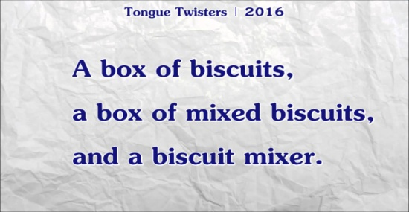 |  |  |  | “The wish flower” method helps to start the lesson with good wishes to each other.  The aim: To develop Ss speaking skills and create friendly atmosphere  Efficiency: By wishing each other they feel better and feel the support of others.  Students greeting with the T.  Ss answer the questions and show their fingers.  T; show a photo,  Ss repeat after teacher. | At the organization moment T tries to award active Ss. «The praise» method is used to evaluate Ss with phrases like:  “Good job!  Well done!” | Students' books.p80.  Picture.
Checking home task  5 -min | T: So, if you're ready, let's start our lesson. But before, let's check up you homework.  T moves around the class and listens the students. Then T asks some learners to retell what they heard. |  |  |  | Ss read their home task to each other.  Diff-n: MAS are asked to give extended answer. | FA; 2  Nice work!.  Perfect. | Students' books.Ex.6p.79.
Direction to the topic  3-min | Guys, look at these pictures and guess. what the story is about?.    Today we’ll talk about “ Peter pan”  The theme of our lesson is “ Peter pan.  Brainstorming Method  1.Who is peter pan?.  2.What do you know about the story of Peter pan ?.  So, open your students' books at p 58.  Aim of this lesson;  - Learners talking about the story of The wonderful wizard of OZ |  |  |  | Ss write the date and topic.  The aim; ensure the general comprehension for the new theme of the lesson.  Brainstorming Method  Through this method, the thinking power of the students improve. | Descriptor;  - Guess the pictures.  - Say about peter pan .  - Give an opinion.  FA; Awesome  Excellent.  Good thinking !. | Students' books.p.80.
Work with new theme  5-min | To consolidate new vocabulary;  Let’s read these new words orally together. Write down new words: repeat after me.  - Lagoon-шағын мүйс.  - Cave-үңгір.  - Forest-орман.  - Leaf -жапырақ.  - Asleep-ұйықтап жатқан.  - Lift up-көтеру.  Okay ,good job! Excellent. |  |  |  | Ss learners study new words and copy new words to their copybooks. | «The praise» method is used to evaluate students with phrases like:  “Very good!” | Students book .p.80.  Blackboard.
MAIN PART  (25-min)  Task 1  7-min  Task 2  3-min  Task 3  5- min  Task 4  5-min  Task-5  5-min | Listening/Reading.  To listen and read for gist;  Guys listen to me attentively.  Look at the exercise 1.  Now, Listen to the audio.  Read the text 1by -1. Is it clear ?.  Who wants to read ?. Who is next?  Have you got any questions ?.  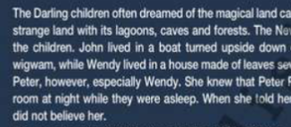  Guys listen to me carefully.  Now, have a look exercise 2.  Is it clear ?. Who wants to read ?. Who is next?  Have you got any questions ?.  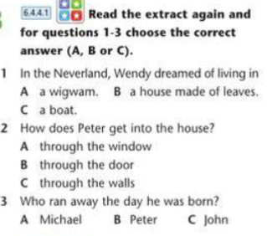  Guys. listen to me carefully.  Let’s start do ex 3.  Have you got any questions ?.  I will give you 5 min.  Is it everything clear ?.  Are you ready?.  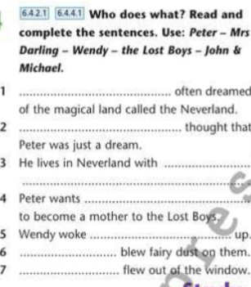  Guys, listen to me carefully.  Let’s start do ex 4. . Is it clear ?.  Have you got any questions ?.  I will give you 5 min.  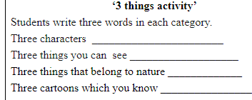  Guys. listen to me carefully.  Let’s start do ex 5.  Have you got any questions ?.  I will give you 5 min.  Is it clear ?. Are you ready?.  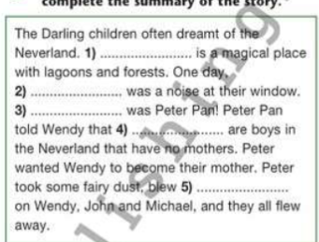  Okay ,Nice work, Well done. |  |  |  | T-explains a task.  Ss read the text 1-by 1 and translate about the text.  T-explains a task and give Ss time to think.  Ss read the extract again and for questions 1-3 choose the correct answer (A,B Or C)  T-explains a task task and give Ss time to think  Ss work in board. read and complete the sentences. Use; Peter-Mrs Darling –Wendy –the lost boys –John ,Michael.  T-explains a task and give Ss time to think  Ss read the text again and write three words in each category.  T-explains a task and give Ss time to think.  Ss fill in with it and there to complete the summary of the story. | «The praise» method is used to evaluate students with phrases like:  “Great!”  Textbook Method  • In this method, the teacher read out the book in the class loudly and explain the important point.  Orally-assessment.  Perfect.  Teacher monitors and gives feedback to students’ answers  FA;1p.  Great work!.  Teacher monitors and gives feedback to students’ answers  .FA:2  Brilliant!.  Bravo!.  "Teacher-class checking". Teacher tells correct answer, Ss check themselves.  FA;2.p.  Brilliant!.  Bravo!.  The "Temperature measurement" technique. The teacher in the process of completing tasks finds out how well the students perform.  FA;2p.  Great work!.  Good thinking !. | Students book p80.  https://youtu.be/1-SUyRYmaoo.  Play the recording.  Students book p80.  Copybook  Students book .p.80.  Copybook  Students book. p.80.  Handout.  Students book.p.80.  Copybook.
Reflection  3-min | 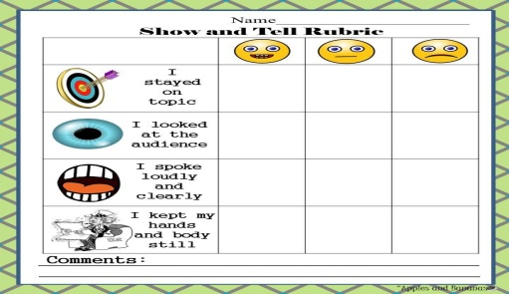 |  |  |  | Aim: To know how many Ss got the theme.  Ss the teacher distributes the cards and the students write answer. | Self-assessment.  Differentiation: «Conclusion» method is used to finish the lesson. | Cards.
End  1-min | Giving home task  -Now please, open your diaries and write down your home work.  OK, your home task will be  Ex.7.p.81 .SB  Children, thank you for your work! The lesson is over, GOOD BYE. |  |  |  | Ss write down your H\T in diaries. | “Thank you for your work!” | Students book. p.81.

