**Qatar - love for centuries**

**Qatar is loved for its magnificent museums, art galleries, gorgeous beaches and parks**

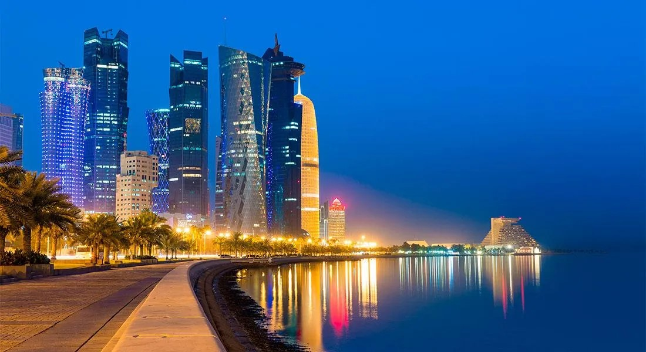

**Qatar is a place where cultural identity meets modernity, where sand meets sea, where people come together to experience unique offerings in culture, sports, business and family entertainment.**

In Qatar, there is a deep respect for the nation's history - archaeological sites and artefacts are painstakingly excavated and cared for - protected in situ or housed in museums. Qatar is home to everything from Neolithic cave paintings to modernist skyscrapers and gentle dugongs in its sparkling waters. Here, ancient dwellings are just steps away from world-class museums, glittering shopping malls, desert adventures and international sports venues.

**This sunny country is waiting for you**

**Golden beaches.** There are different options: crowded, with amenities. Deserted, without infrastructure, with sand dunes or cliffs near the coast. Beaches for snorkeling and diving. Everyone will find a place to their liking. And the landscapes will complement beach relaxation.

**Ancient forts** that remind of the rich history of the country. Archaeological excavations are still underway near some, from the towers of others you can see an incredible panorama of the desert, and in others there are museums. And, of course, forts are historical landmarks.

**Amazing capital** . The architecture of the city amazes with its beauty, diversity and unusual combination of modernity and antiquity. Architects from all over the world create next to traditional Arabic buildings, which gives the capital a multicultural charm. At night, the modern part of Dohu turns into a light show, shining with millions of colorful lights. And after walking along the narrow streets of the old quarters, you will immerse yourself in the Arabic flavor: shopping shops, traditional restaurants, the smells of coffee and cardamom. Markets with all kinds of goodies, spices, paintings, decorations...

**Mesmerizing landscapes** . In Qatar you will see not only endless deserts. There are mangrove forests and oases with wildlife. Birds especially love this country. The rocks of Ras Abrouk surprise with their shape, which resembles huge mushrooms, and in the Dal al-Mesfer cave, gypsum deposits create a magical glow.

**What to see first in Qatar**

The tourism infrastructure of Qatar has reached the highest level, while the price level for various types of services here is affordable. Therefore, the best attractions today are available to anyone in Qatar; you just have to choose those that will be included in your travel plan. Recommendations on what to see first in Qatar are given in this article.

1. **Doha City**

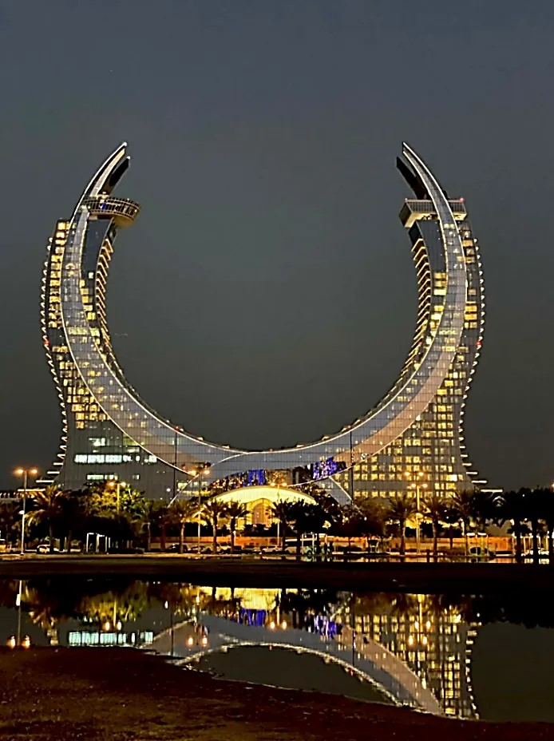

When choosing what to see in Qatar in 1 day, you should first of all go to its capital - Doha. Today it is one of the fastest growing cities in the world and one of the most prosperous cities on the Persian Gulf coast, and for some time now has been the oil and economic center of Qatar. Huge skyscrapers, high-tech buildings, a lot of historical objects in the “old center”, the latest entertainment centers, boutiques, villas, artificial islands - all this attracts millions of tourists to the capital, thanks to which the country’s economy is gaining momentum year after year.

1. **Corniche (Doha)**

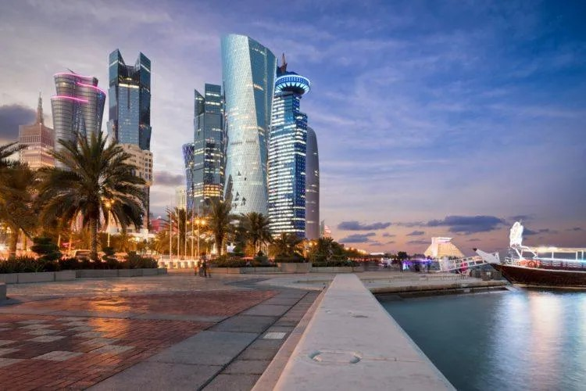

One of the main attractions of the capital is the Corniche, which stretches along the Persian Gulf. Here, right on the coast, the most modern high-rise buildings with amazing architecture are concentrated, symbolizing the economic prosperity of Doha and all of Qatar as a whole. This is a complex of prestigious facilities that alternate with green parks and recreational areas. In recent years, the embankment has become a calling card, the “face” of all of Qatar.

1. **Museum of Islamic Art**

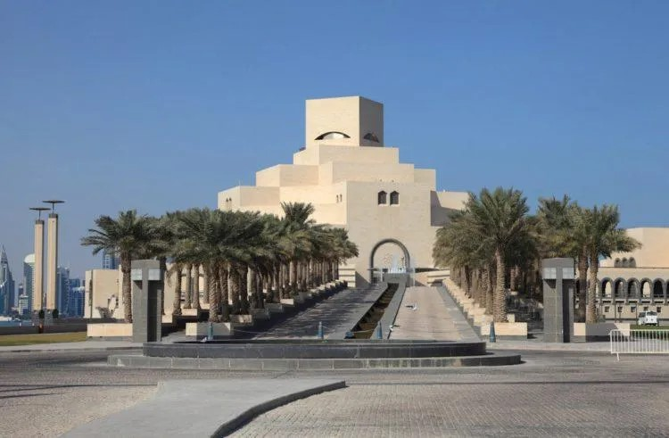

The rating of attractions continues with the Museum of Islamic Art - the main museum of the country and at the same time the largest museum in the Gulf countries. Also, like most attractions in Qatar, the museum is very young - it opened in 2008. The unusual architecture of the building is impressive: several huge stone blocks of the building are erected one above the other in a harmonious composition in the form of a tower, which in appearance resembles a luxurious sheikh’s villa. Inside, a collection of Islamic art is exhibited - examples of ceramics, textiles, manuscripts and other Islamic artifacts.

1. **Aspire Tower**

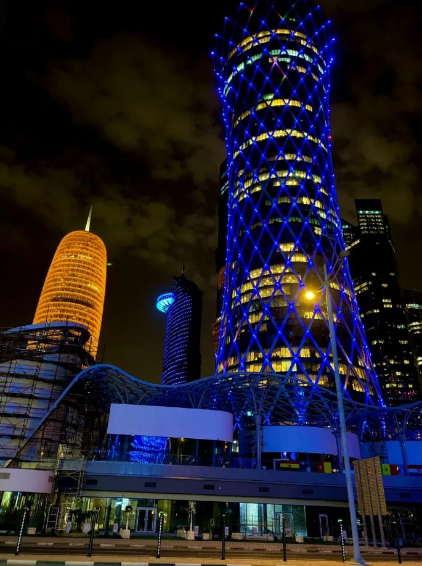

Another attraction of Qatar, worthy of being elevated to the status of a symbol of the country, is located in Doha in the Sports City sports complex and is called the Aspire Tower. This is the object that is among the first places to see in Qatar, and it is simply impossible not to notice it - the torch-shaped tower has a height of 318 m, so it noticeably rises above the capital and is visible from anywhere in the city. A special view of the Aspire Tower is created in the dark - the tower, the surface of which is completely framed by several thousand LED bulbs, begins to glow as if it were wrapped in an LED blanket.

1. **Fort Al Kut**

Despite the fact that most of the attractions of Qatar are still very “young”, there is something to see in Qatar for lovers of antiquity.

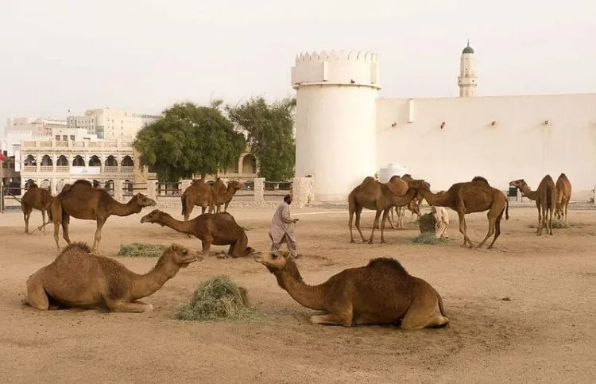

Al Kut is a perfect example of this: the fortification structure was erected at the end of the century before last, when this area of Qatar was still occupied by Turkey. At that time, the fort served as a police station and later as a prison. In the 20s of the last century, Al Kut was completely rebuilt, but for many years the fortress was not used in any way, until a museum was opened in it in 1978, where national crafts, historical photographs and artistic paintings.

When going to Qatar, in addition to the list of the main attractions of Qatar, you should always take into account a couple of other interesting objects if you have the opportunity to see something else. To do this, below is an overview and description of interesting, attractive, impressive places in Qatar that are worthy of a visit.

1. **Umm Salal Mohammed Fort**

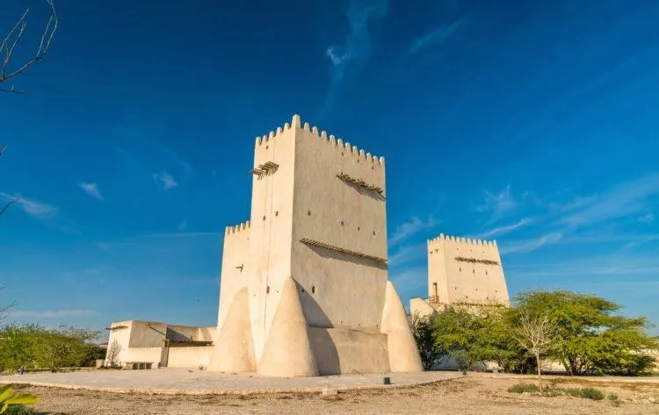

There are many fortifications to visit in Qatar that are similar to Al Kut - for example, Umm Salal Mohammed Fort near the capital.

It is a relatively small fortress with two towers and a restored small mosque. But reviews indicate that this landmark of Qatar is impressive not for its size, but for its location and surrounding landscapes: the contrast of the sultry desert, the clear azure sea and the ancient walls of the fort creates a unique, breathtaking atmosphere.

1. **Fort Zubara**

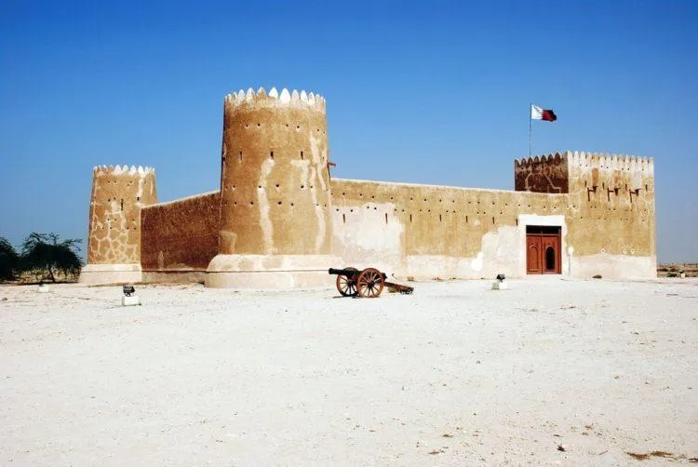

The next example of what to visit in Qatar from fortifications is Fort Zubara, erected at the beginning of the last century as a coast guard post. This landmark of Qatar is a fortress made in a laconic style, traditional for buildings of this type: massive walls and sand-colored crenellated towers look simple and harmonious against the backdrop of desert landscapes. Once on the site of the fort there was a city that flourished as a center of great trade and pearl fishing. Currently, there is a museum within the walls of the fort, where photographs from the excavations of the fortress and various archaeological finds are displayed.

1. **Souk Waqif Market**

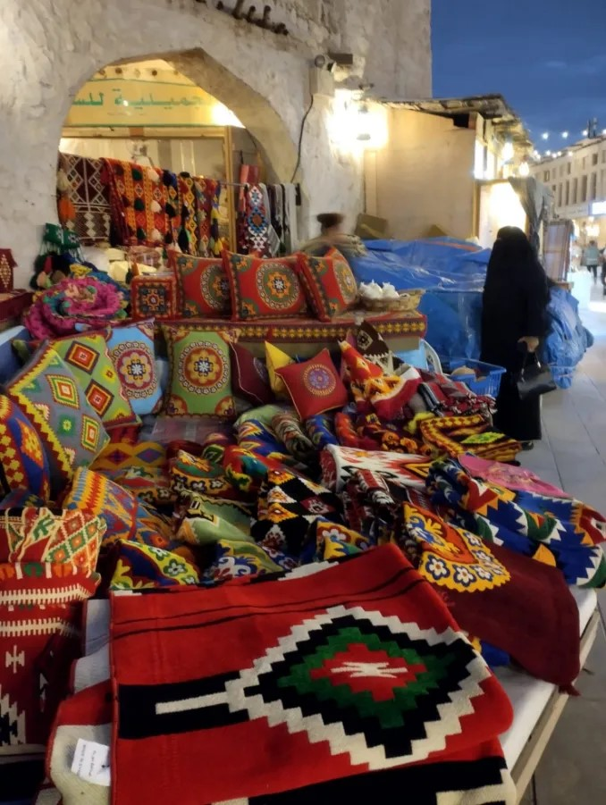

Where to go in Qatar to feel that very spirit of the East, the local national flavor? Of course, go to the Souq Waqif market - one of the most suitable oriental bazaars for tourism in the Middle East. After all, on the territory of the market there is a whole tourist center, as well as a lot of cafes and restaurants with traditional furnishings and classic national dishes. In addition, you can buy souvenirs and handicrafts here, and the market is organized in such a way that there is no usual bustle and crowds here.

1. **Ethnographic village “Katara” (Doha)**

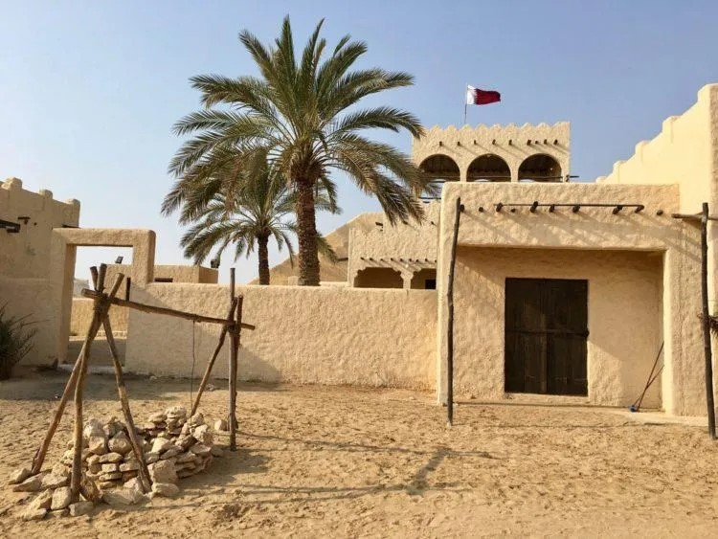

Another colorful attraction of Qatar, which is often included on a trip, is the ethnographic village of Qatar. The main task in creating this facility was to introduce the indigenous people and guests of the country to the centuries-old culture and traditions of the country. This is an ideal place to see in Qatar for a close acquaintance with the spirit of the country and its customs. While strolling through the village, you can stop by an art gallery with selected works by Qatari artists, visit a restaurant serving national cuisine, visit one of the many pearl shops, and even relax on a landscaped beach with various types of water activities.

1. **The Pearl of Qatar - an artificial island**

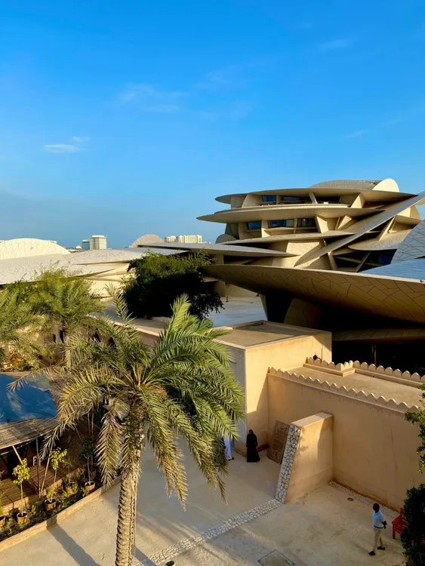

Finally, excursions in Qatar should be supplemented with a visit to a small artificial island - the Pearl of Qatar with an area of only 4 sq. km. The island is a rather ambitious project of the Qatari authorities - now the most prestigious housing is being built here and put up for sale, which is being bought mostly by foreign citizens. The new coast of the island is completely built up with villas and luxury apartments, the best hotels, boutiques and restaurants. And the name “Pearl” arose for the reason that previously pearl mining was actively carried out on the site of the island.

# What to try in Qatar

**The cuisine of Qatar is very diverse** . As a coastal country, Qatar has many seafood dishes to offer - snapper, crab, lobster, tuna and shrimp. Of the traditional dishes with fish, special attention is given to makbus - stewed rice with spices, seafood and meat, served with yogurt. Meat dishes are also common in Qatar. Some of the most popular are guzi - whole baked lamb with rice and nuts, as well as stuffed lamb or kid meat, served with spicy rice.

For snacks, locals often eat eggplant mutabal spread and hummus spread, which is made from chickpeas and sesame seeds. In Qatar, they also prepare something similar to cabbage rolls - rice in grape leaves, warak enab. You might also like the oriental tabbouleh salad made from bulgur, wheat, mint and parsley.

The traditional Qatari meal ends with dates, fresh fruit, halwa and Umm Ali bread pudding. Wash down all these goodies with cardamom coffee or Turkish coffee.

# Types of entertainment by region

**Qatar** is a very small country. Its main tourist destinations are the cities and the coast of the Persian Gulf.

Of the interesting cities, Doha should be named first. In the capital you will find the best beaches, historical and cultural attractions, museums, and modern architecture. **In Al Wakrah** you can see the Sheikh's House, mosques and taste fresh seafood at the fish market. **El Haur** will delight you with secluded beaches, temples and a luxurious palace.

One of the most interesting places for diving is the reef, which is located near the port **city of Messaïd** , where, in addition to the natural underwater world, you will see sunken boats, cars and even a school bus.

Beach holidays with children are best spent on **Dukan Beach** , where there is the necessary infrastructure, a variety of entertainment, and the entrance to the sea is gentle.

# Climate and seasons

The climate in the country is characterized by a continental tropical variant. In summer it is very hot here, the temperature can rise to +50 °C, but in winter the thermometer drops to a comfortable +20-30 °C, which is perfect for a beach holiday.

# Currency

The national currency here is the Qatari rial. You can change currency in banks and private offices. The second rate is more profitable. Large hotels, shopping centers, and restaurants accept credit cards from major international payment systems.

# Major holidays

The main holidays in the country are associated with religion and important events in the formation of the state. Large-scale events are also held here that will be interesting for tourists to attend.

Fans of sports and competitions should visit:

Qatar ExxonMobil Open and Qatar Total Open - open tennis championships.

Qatar International Rally - car racing and the Qatar Grand Prix in Moto GP motorcycle racing.

Formula 1 World Championship on F1H2O water.

The IAAF Diamond League is an athletics competition.

The Tour of Qatar is a cycling competition.

# Medicine

To get to Qatar, you will need to get insurance. This mandatory condition will ensure you full medical care if an insured event occurs. This way you will not only comply with the necessary entry conditions, but also protect yourself from unexpected health expenses.

# Useful tips

Some things to do when preparing for your trip include familiarizing yourself with local codes of conduct. This is necessary to avoid getting into an unpleasant situation and to make the trip more comfortable.

**Qatar is a Muslim country, but there are no strict rules regarding appearance. However, out of respect for local customs, it is better not to go to public places wearing too revealing clothes.**

When taking photographs as a souvenir, remember that you cannot photograph airports, police stations, military installations, or the interiors of mosques. It is also prohibited to photograph local residents and clergy without their permission. If you violate this rule, you face serious penalties, including imprisonment.

Most restaurants and hotels sell alcohol. But taking alcohol outside of these establishments and drinking it in public places is strictly prohibited. The same rule applies to smoking.

No alcoholic beverages are sold during the holy month of Ramadan.

Be sure to bargain in private stores and markets - this way you can reduce the price and experience the real oriental atmosphere.

Tipping is not necessary here; generally, only large restaurants include it in the bill. In other cases, monetary compensation for services is at your discretion. It is not customary to tip a taxi driver.

Friday is a holiday in the country, and many establishments and institutions do not work. Therefore, you need to take this into account when making plans.

If you are not a Muslim, then most likely you will not be allowed into the mosque.

**The main religious holidays are Eid al-Adha and Kurban Bayram**

In honor of these celebrations, cultural events, fireworks and entertainment programs are held throughout the country.

You can immerse yourself deeper into the local atmosphere at the Qatari festivals that take place in spring and summer. There you will see vibrant shows, performances by artists and get a lot of gastronomic experiences, trying different dishes, and you will be able to learn more about the traditions and history of the country.

# Visa

Citizens of the Republic of Kazakhstan can stay on the Qatar Peninsula with a free visa for up to 30 days. The visa is issued upon arrival.