**Greece is a real tourist paradise**

**The country of olives, the unique blue sea with white sand and the sun that shines here 300 days a year**

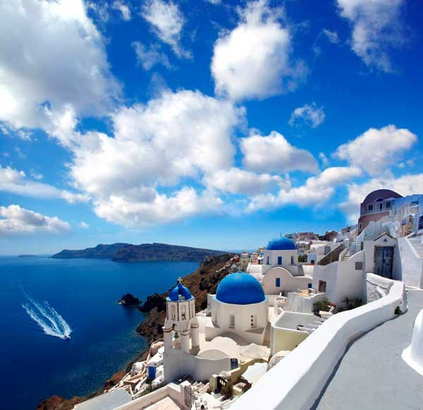

Greece is a real tourist paradise with excellent infrastructure and ample opportunities for all types of holidays. It is a country endowed with a mild climate, amazing natural beauty, stunning landscapes including crystal clear seas, green mountains and beautiful beaches, as well as unique ancient monuments.

People come to Greece to enjoy food and wine, the sea and the midday heat, communication with local residents and nature, antiquities and silence, discos and fun.

A special feature of a holiday in Greece is that you can spend your holiday both on the continent (Thessaloniki, Chalkidiki, Athens, Kastoria) and on numerous islands (Crete, Corfu, Rhodes, Santorini and many others).

**o.CRETE**

**Greece in July is an anthill buzzing under the scorching sun, in which peoples, traditions and languages are famously mixed.** An anthill that waves onto the beaches in the morning and reluctantly retreats in the evening for more noisy entertainment.

The hottest weather occurs from mid-July to mid-August, and the temperature on the islands is higher than on the mainland. But the proximity of the sea smooths everything out, and the heat is easier to bear. The holiday season on the Greek islands lasts from April to October.

**CRETE**

Several thousand islands are collected under the Greek flag. The largest is the island of Crete. This is a tourist center of the Mediterranean, chosen by mankind long before our era: one of the most ancient civilizations, the Minoan, was born on the island of Crete. Fans of Greek mythology will add that this is the birthplace of Zeus, who headed Olympus, and art lovers will remember El Greco.

The island of Crete is the southernmost island in the archipelago and is surrounded by three seas: the Aegean, Libyan and Ionian. There are several hundred beaches here - from world-famous and well-equipped to small bays, where the lack of sunbeds and umbrellas is nothing compared to the excellent view and purity of the azure sea.

**You can relax in Crete in different ways: the island is divided into 4 regions, and each attracts tourists with something special.**

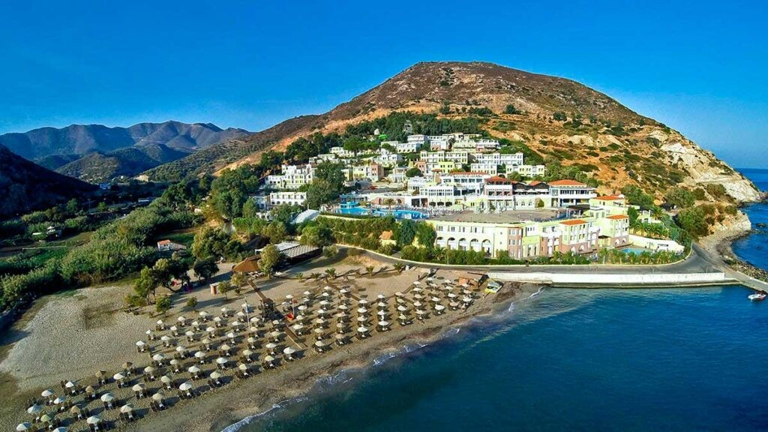

**The central part of the island of Crete, Heraklion** is famous for its attractions: Knossos with the labyrinth of the Minotaur, temples and fortresses, the richest exhibitions of the Archaeological Museum.

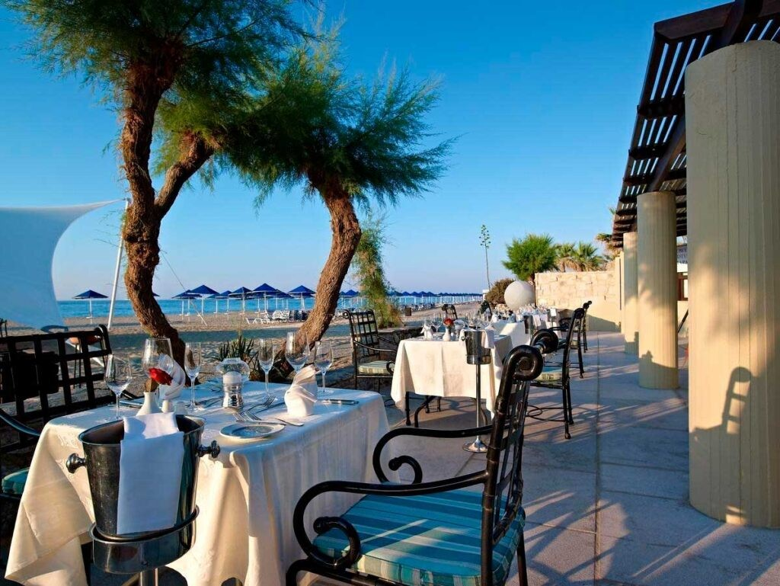

**Rethymnon** is the “soul” of the island: white houses, tiled roofs, cobbled streets, ancient churches and mosques, fantastic mountain gorges, caves, valleys, bays... - Absolutely postcard views.

**Lasithi** in the east of the island is a classic resort with fashionable hotels, gorgeous beaches and the famous salt lake Vulismeni, which is generally fresh, but a canal dug by the Turks in the 19th century significantly changed the ecosystem.

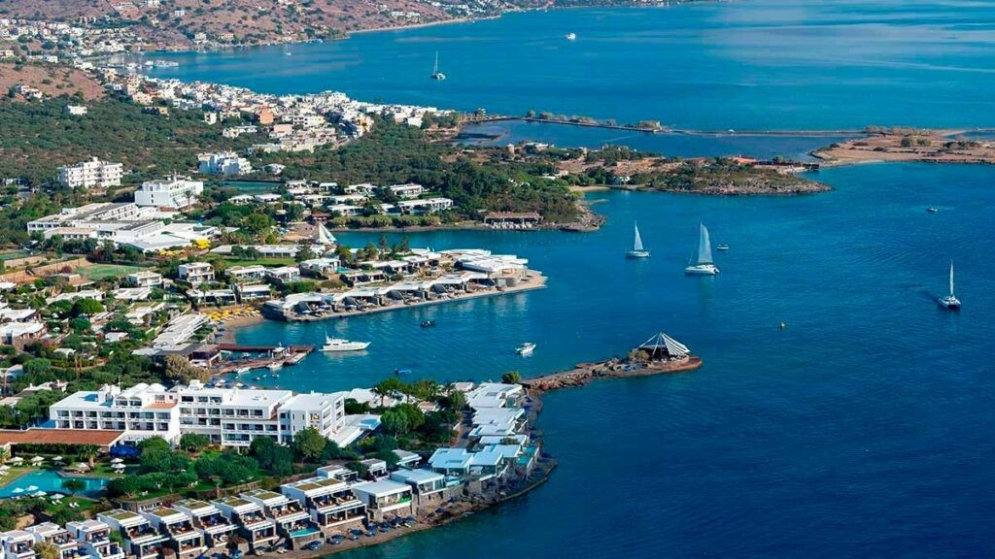

**Chania in the west** is the green part of the island with Europe's largest Samaria Canyon, the White Mountains with 12 gorges, many places of archaeological value and uncrowded beaches.

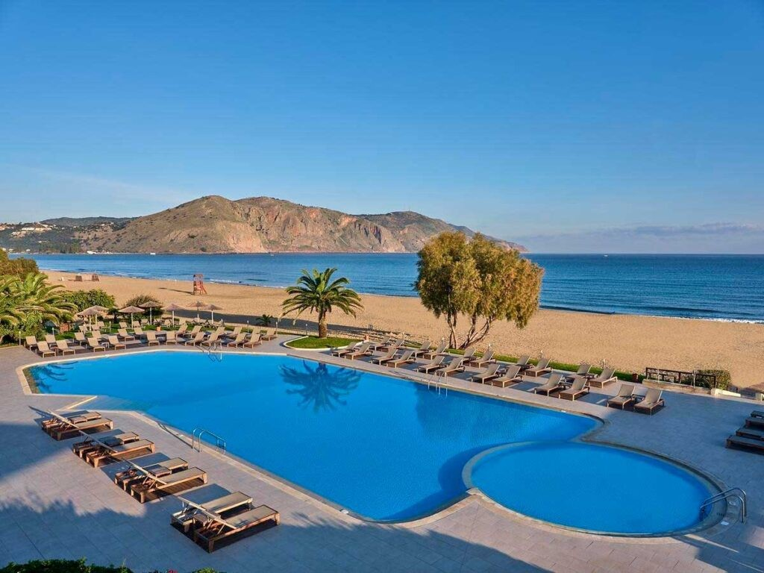

Hotels on the island of Crete differ in classification: they do not use the classic “stars”, but the word-letter designations: deluxe (5 *),* A (5-4), B (4-3), C (3-2), E (no category). But the division is arbitrary: it happens that an E-class hotel offers better service than some C-class hotels.

What else is worth knowing about hotels in Crete - there is no all-inclusive here. When choosing where to stay, do not choose hotels with meals: in any resort in Crete there are so many excellent inexpensive restaurants that you most likely will not take advantage of hotel dinners.

Holidays in Crete are equally good for lovers of excursions and for connoisseurs of Mediterranean nature, lazy time on the beaches and an epicurean lifestyle beyond them. It’s impossible to try just one thing here—however, it’s not recommended: it’s still a vacation.

**Beautiful Greece!**

**CRETE PACKAGE PRICE INCLUDES:**

* Direct flight Almaty - Heraklion - Almaty (air Astana)
* hotel accommodation with selected type of meals
* group transfer airport - hotel - airport
* medical insurance

**SUPPLEMENTS:**

Mandatory tourist tax in Greece is paid by tourists upon check-in at the hotel.

**Group excursions around Crete**

* Knossos Palace - Lassithi Plateau - Cave of Zeus
* Spinalonga - Agios Nikolaos
* St. Myronas - Prignas - St. Barbara - Pagliani •

Children's excursion - Arolithos - Aquarium

* Evening Knossos - Minoan Theater - Cretan Evening
* Premium, Knossos Palace - Lassithi Plateau - Cave of Zeus
* Santorini - Lost Atlantis (SEAJET)
* Santorini - Lost Atlantis (VIP)
* Water City Aqua Park

**WHY SHOULD YOU GO ON EXCURSIONS WITH US:**

1. You will be accompanied by a professional Russian-speaking tour guide.
2. The excursion takes place on comfortable buses.
3. All buses have full 100% insurance for all insured events.
4. The routes of our excursions are non-standard and interesting.

**WE WISH YOU A BRIGHT, BEAUTIFUL, POSITIVE AND TASTY VACATION IN GREECE!**

