Kyiv has a long, rich, and often stormy history. Its beginnings are lost in antiquity. Archaeological findings of stone and bone [implements](https://www.merriam-webster.com/dictionary/implements), the remains of primitive dwellings built of wood and skins, and large accumulations of mammoths’ bones indicate that the first settlements in the vicinity date from the [Late Paleolithic Period](https://www.britannica.com/event/Paleolithic-Period) (some 40,000 to 15,000 years ago). As early as 3000 BCE, [Neolithic](https://www.britannica.com/event/Neolithic) tribes engaging in agriculture and animal husbandry—notably the Trypillya [culture](https://www.merriam-webster.com/dictionary/culture) of the mid-5th to 3rd millennium BCE—lived on the site of modern Kyiv. Excavations continue to uncover many [artifacts](https://www.merriam-webster.com/dictionary/artifacts) from settlements dating from the [Copper](https://www.britannica.com/topic/Copper-Age), [Bronze](https://www.britannica.com/event/Bronze-Age), and [Iron](https://www.britannica.com/event/Iron-Age) ages. The tribes of the area traded with the nomadic peoples of the steppes to the south—the [Scythians](https://www.britannica.com/topic/Scythian), the [Sarmatians](https://www.britannica.com/topic/Sarmatian), and, later, the [Khazars](https://www.britannica.com/topic/Khazar)—and also with the ancient Greek colonies that were located on the Black Sea coast.

The traditionally recognized year of Kyiv’s establishment is 482 CE, and in 1982 the city celebrated its 1,500th anniversary. However, archaeological evidence suggests that the city was founded in the 6th or 7th century. According to the 12th-century chronicle *Povest vremennykh let* (“Tale of Bygone Years,” also known as *The Russian Primary Chronicle*), Kyiv was founded by three brothers, Kyi (Kiy), Shchek, and Khoryv (Khoriv), leaders of the Polyanian tribe of the East [Slavs](https://www.britannica.com/topic/Slav). Each established his own settlement on a hill, and these settlements became the town of Kyiv, named for the eldest brother, Kyi; a small stream nearby was named for their sister Lybed (Lebid). Although the chronicle account is legendary, there are contemporary references to Kyiv in the writings of [Byzantine](https://www.merriam-webster.com/dictionary/Byzantine), German, and Arab historians and geographers.

**The first Rus capital**

[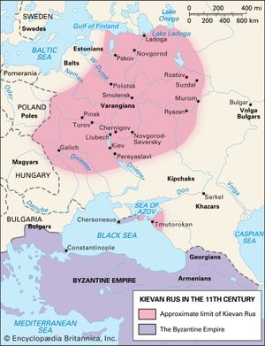](https://cdn.britannica.com/44/3844-050-A9CD1CCE/Kievan-Rus.jpg)

[Kievan Rus in the 11th century](https://cdn.britannica.com/44/3844-050-A9CD1CCE/Kievan-Rus.jpg)

The [Varangians](https://www.britannica.com/topic/Viking-people) (Vikings) seized Kyiv in the mid-9th century, and, as in [Novgorod](https://www.britannica.com/place/Veliky-Novgorod) to the north, a Slavo-Varangian ruling elite developed. Kyiv, with its good defensive site on the high river bluffs and as the centre of a rich agricultural area and a group of early Slavic towns, began to gain importance. About 882 [Oleg](https://www.britannica.com/biography/Oleg) (Oleh), the ruler of Novgorod, captured Kyiv and made it his capital, the centre of the first East Slavic state, [Kyivan (Kievan) Rus](https://www.britannica.com/topic/Kyivan-Rus). The town flourished, chiefly through trade along the Dnieper going south to the [Byzantine Empire](https://www.britannica.com/place/Byzantine-Empire) and north over portages to the rivers flowing to the [Baltic Sea](https://www.britannica.com/place/Baltic-Sea)—the so-called “road from the Varangians to the Greeks,” or “water road.” Trade also went to the [Caspian Sea](https://www.britannica.com/place/Caspian-Sea) and [Central Asia](https://www.britannica.com/place/Central-Asia).

[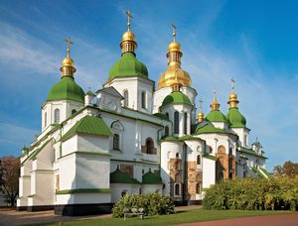](https://cdn.britannica.com/38/129238-050-FD411177/Cathedral-of-St-Sophia-Kiev-Ukr.jpg)

[St. Sophia Cathedral in Kyiv](https://cdn.britannica.com/38/129238-050-FD411177/Cathedral-of-St-Sophia-Kiev-Ukr.jpg)

In 988 the introduction of [Christianity](https://www.britannica.com/topic/Christianity) to Kyiv [enhanced](https://www.merriam-webster.com/dictionary/enhanced) its significance as the spiritual centre of Rus. By the 12th century, according to the chronicles, the city’s wealth and religious importance was attested to by its more than 400 churches. The cathedral of St. Sophia, parts of the Kyiv-Pechersk Lavra (Monastery of the Caves), and the ruins of the [Golden Gate](https://www.britannica.com/place/Golden-Gate-strait-California) remain today as witnesses to Kyiv at the height of its splendour. The town was famed for its art, the mosaics and frescoes of its churches, its craftsmanship in silver, and the quality of many of its manufactures. One of [Europe’s](https://www.britannica.com/place/Europe) major cities, Kyiv established [diplomatic](https://www.britannica.com/dictionary/diplomatic) relations with the Byzantine Empire, England, [France](https://www.britannica.com/place/France), [Sweden](https://www.britannica.com/place/Sweden), and other countries. Travelers wrote of its population as numbering tens of thousands.

[[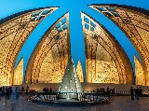](https://www.britannica.com/quiz/countries-and-capitals-quiz)](https://www.britannica.com/quiz/countries-and-capitals-quiz)

**[Britannica Quiz](https://www.britannica.com/quiz/countries-and-capitals-quiz)**

[Countries and Capitals Quiz](https://www.britannica.com/quiz/countries-and-capitals-quiz)

Throughout the period of Kyivan Rus, however, the city was engaged in a succession of wars against the nomadic warrior peoples who inhabited the steppes to the south: in turn, the [Khazars](https://www.britannica.com/topic/Khazar), the [Pechenegs](https://www.britannica.com/topic/Pechenegs), and the Polovtsians ([Kipchak](https://www.britannica.com/topic/Kipchak-people), or Kuman). These conflicts weakened the city, but even greater harm was done by the endless, complex internecine struggles of the princedoms into which Rus was divided. In 1169 Prince [Andrew Bogolyubsky](https://www.britannica.com/biography/Andrew-I-Russian-prince) of Rostov-Suzdal captured and sacked Kyiv. Thus, by the late 12th century the power of the city had declined, and in the following century it was unable to resist the rising and [formidable](https://www.merriam-webster.com/dictionary/formidable) power of the [Mongols](https://www.britannica.com/topic/Mongol). In 1238 a Mongol army under [Batu](https://www.britannica.com/biography/Batu-Mongol-ruler), grandson of [Genghis Khan](https://www.britannica.com/biography/Genghis-Khan), invaded Rus and, having sacked the towns of central Rus, in 1240 besieged and stormed Kyiv. Much of the city was destroyed and most of its population killed. The Franciscan friar and traveler [Giovanni da Pian del Carpini](https://www.britannica.com/biography/Giovanni-da-Pian-del-Carpini) six years later reported only 200 houses surviving in Kyiv.

**Kyiv under Lithuania and Poland**

In the 14th century what was left of Kyiv and its surrounding area came under the control of the powerful and expanding [grand duchy of Lithuania](https://www.britannica.com/place/grand-duchy-of-Lithuania), which captured it in 1362. For a long time thereafter Kyiv had little function except as a [fortress](https://www.britannica.com/technology/fortification) and minor [market](https://www.britannica.com/topic/market) on the vaguely defined frontier between [Lithuania](https://www.britannica.com/place/Lithuania) and the steppe [Tatars](https://www.britannica.com/topic/Tatar), based in the [Crimea](https://www.britannica.com/place/Crimean-Peninsula). It frequently came under attack from the Tatars; in 1482 the Crimean khan, [Mengli Giray](https://www.britannica.com/biography/Mengli-Giray), took and sacked the town. Almost the only survival of Kyiv’s former greatness was its role as the seat of an [Eastern Orthodox](https://www.britannica.com/topic/Eastern-Orthodoxy) metropolitan. A step forward came in 1516, when the [grand duke](https://www.britannica.com/topic/grand-duke) Sigismund I granted Kyiv a charter of [autonomy](https://www.merriam-webster.com/dictionary/autonomy), thereby much stimulating trade.

In 1569 the [Union of Lublin](https://www.britannica.com/event/Union-of-Lublin) between Lithuania and [Poland](https://www.britannica.com/topic/history-of-Poland) gave Kyiv and the Ukrainian lands to Poland. Kyiv became one of the centres of [Orthodox](https://www.britannica.com/topic/Eastern-Orthodoxy) opposition to the expansion of Polish [Roman Catholic](https://www.britannica.com/topic/Roman-Catholicism) influence, spearheaded by vigorous proselytization by the [Jesuits](https://www.britannica.com/topic/Jesuits). In the 17th century a religious Ukrainian brotherhood was established in Kyiv, as in other Ukrainian towns, to further this opposition and encourage Ukrainian [nationalism](https://www.merriam-webster.com/dictionary/nationalism). [Peter Mogila](https://www.britannica.com/biography/Petro-Mohyla) (Petro Mohyla), a major theologian and metropolitan of Kyiv from 1633 to 1646, founded there the Collegium (later the Kyivan Mohyla Academy) as a major Orthodox centre of learning in the East Slavic world.

[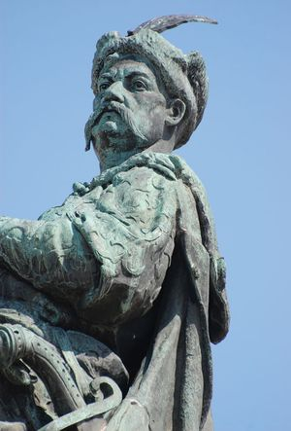](https://cdn.britannica.com/54/135454-050-662FB645/Bohdan-Khmelnytsky-statue-Kiev-Ukraine.jpg)

[Bohdan Khmelnytsky](https://cdn.britannica.com/54/135454-050-662FB645/Bohdan-Khmelnytsky-statue-Kiev-Ukraine.jpg)

In the 17th century there was also increasing unrest among the Zaporozhian [Cossacks](https://www.britannica.com/topic/Cossack) of the Dnieper downstream of Kyiv and an ever-growing struggle between them and the Polish crown. This eventually culminated in the revolt of [Bohdan Khmelnytsky](https://www.britannica.com/biography/Bohdan-Khmelnytsky), who, assisted by the Crimean Tatars, entered Kyiv triumphantly with his insurgent Cossacks in 1649. He came under heavy pressure from the Polish forces, and in 1654 Khmelnytsky and the Cossacks signed the [Pereyaslav Agreement](https://www.britannica.com/event/Pereyaslav-Agreement), in essence submitting [Ukraine](https://www.britannica.com/place/Ukraine) to [Moscow](https://www.britannica.com/place/Grand-Principality-of-Moscow); this was followed by a prolonged and confused period of [strife](https://www.britannica.com/dictionary/strife) and destruction leading in 1667 to the [Truce of Andrusovo](https://www.britannica.com/event/Truce-of-Andrusovo), which confirmed the suzerainty and protection of Moscow over the so-called Left Bank, or the part of Ukraine east of the Dnieper, and Kyiv (actually located west of the river), while Poland gained the Right Bank, or western Ukraine. Thereafter, further struggle ensued against the Turks, with the Cossacks constantly changing sides and engaging in internecine disputes. In 1686 the Treaty of Eternal Peace between Poland and [Russia](https://www.britannica.com/place/Russia) confirmed Russian control of Kyiv, which stood as the sole Muscovite outpost on the right bank of the Dnieper.

**Evolution of the modern city**

**Kyiv under the tsars**

[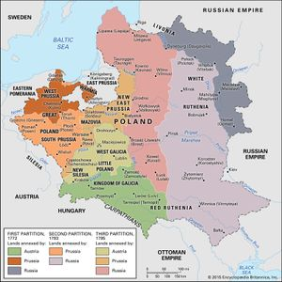](https://cdn.britannica.com/55/3555-050-B065A773/Partitions-Poland.jpg)

[Partitions of Poland, 1772–95](https://cdn.britannica.com/55/3555-050-B065A773/Partitions-Poland.jpg)

In 1793 the [Second Partition of Poland](https://www.britannica.com/event/Partitions-of-Poland), under Russian Empress [Catherine II](https://www.britannica.com/biography/Catherine-the-Great) (the Great), brought Right Bank Ukraine into the [Russian Empire](https://www.britannica.com/place/Russian-Empire), and Kyiv, assisted by the abolition in 1754 of the tariff barriers between [Russia](https://www.britannica.com/place/Russia) and the Ukrainian lands, began to grow in commercial importance. Catherine’s reign was marked by the abolition of the old administrative system and of the post of [Cossack](https://www.britannica.com/topic/Cossack) [hetman](https://www.britannica.com/topic/hetman) (commander in chief) and by the division of [Ukraine](https://www.britannica.com/place/Ukraine) into new administrative provinces, for one of which Kyiv became the centre. Subsequently, Kyiv became the centre of a governor-generalship covering three provinces.

In the first half of the 19th century, Kyiv developed as a major focus of Ukrainian [nationalism](https://www.merriam-webster.com/dictionary/nationalism), although severe persecution from the tsarist government forced the movement to shift the brunt of its activities to [Lviv](https://www.britannica.com/place/Lviv-Ukraine) in the Austrian-ruled Ukrainian regions. In Kyiv, as in Russian cities, there was [clandestine](https://www.merriam-webster.com/dictionary/clandestine) revolutionary activity (beginning with the [Decembrists](https://www.britannica.com/topic/Decembrist) in the early 19th century) that culminated in a series of strikes and demonstrations leading to the [Russian Revolution of 1905](https://www.britannica.com/event/Russian-Revolution-of-1905). An important role in this revolutionary movement was taken by students of the University of Kyiv (now the [Taras Shevchenko National University of Kyiv](https://www.britannica.com/place/Taras-Shevchenko-University-of-Kyiv)), which had been established in 1834.

During the 19th century the expanding economic importance of Ukraine, and especially the growing export of grain, brought further commercial development to Kyiv. Modern factory [industry](https://www.britannica.com/technology/industry) appeared; to the Arsenal, which had been set up as early as the 18th century, were added lumber milling and the building of rivercraft. The town developed significant industries processing agricultural-related products—leather making, tobacco processing, distilling, brewing, and textile production. In the late 1860s Kyiv was connected by rail to both [Moscow](https://www.britannica.com/place/Moscow) and the [Black Sea](https://www.britannica.com/place/Black-Sea) port of [Odessa](https://www.britannica.com/place/Odessa-Ukraine), further [enhancing](https://www.merriam-webster.com/dictionary/enhancing) its role as a centre of industry, commerce, and administration. By the outbreak of [World War I](https://www.britannica.com/event/World-War-I), the city had a population of some 350,000.

**The revolutionary period**

With the outbreak of the [Russian Revolution of 1917](https://www.britannica.com/event/Russian-Revolution), a revolutionary parliament, the [Central Rada](https://www.britannica.com/topic/Central-Rada) (“Council”), was established through the [initiative](https://www.merriam-webster.com/dictionary/initiative) of the Society of Ukrainian Progressives and other cultural, professional, and political associations. Its membership was elected in April 1917 by the [constituent](https://www.merriam-webster.com/dictionary/constituent) All-Ukrainian National Congress. In January 1918 the Central Rada proclaimed an independent Ukrainian state with Kyiv as its capital. Minor uprisings by pro-Soviet [Bolshevik](https://www.britannica.com/topic/Bolshevik) workers, who were mostly concentrated in the Arsenal works, were suppressed, but Soviet troops under the command of Mikhail Muravev came to their aid and on February 9, 1918, entered Kyiv. The occupying troops carried out brutal reprisals against many Ukrainians in the city.

[[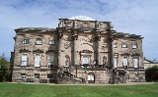](https://www.britannica.com/art/Western-architecture/Kievan-Rus-and-Russia#ref488662)](https://www.britannica.com/art/Western-architecture/Kievan-Rus-and-Russia" \l "ref488662)

**[More From Britannica](https://www.britannica.com/art/Western-architecture/Kievan-Rus-and-Russia" \l "ref488662)**

[Western architecture: Kievan Rus and Russia](https://www.britannica.com/art/Western-architecture/Kievan-Rus-and-Russia" \l "ref488662)

However, by the [Treaty of Brest-Litovsk](https://www.britannica.com/event/treaties-of-Brest-Litovsk) of March 3, 1918—which concluded World War I hostilities between the new Soviet government and the [Central Powers](https://www.britannica.com/topic/Central-Powers)—the Soviet government recognized the independence of Ukraine. [German](https://www.britannica.com/topic/history-of-Germany) troops promptly occupied the country and set up a puppet Ukrainian government in Kyiv, but it collapsed with the German [surrender](https://www.britannica.com/dictionary/surrender) to the Allies in November 1918 and the subsequent withdrawal of German troops. Once more an independent Ukraine was declared in Kyiv, under the leadership of [Symon Petlyura](https://www.britannica.com/biography/Symon-Petlyura), but its brief and stormy history was a series of struggles between Ukrainian nationalist, anti-Bolshevik (White), and Soviet (Red) forces. In November 1919 Kyiv was briefly taken by the White armies under Gen. [Anton Ivanovich Denikin](https://www.britannica.com/biography/Anton-Ivanovich-Denikin) before being finally occupied by the [Red Army](https://www.britannica.com/topic/Red-Army). Yet peace was still denied the city, as the [Russo-Polish War](https://www.britannica.com/event/Russo-Polish-War-1919-1920) erupted in the spring of 1920. In May 1920 the Poles captured Kyiv but were driven out in a counterattack.

**The Soviet period**

Kyiv’s role as the centre for Ukrainian nationalists caused the [Soviet government](https://www.britannica.com/place/Soviet-Union) to transfer the capital of the new Ukrainian Socialist Soviet Republic (Ukrainian Soviet Socialist Republic from 1937) to [Kharkiv](https://www.britannica.com/place/Kharkiv-Ukraine), and it was not until 1934 that Kyiv resumed its capital status. Meanwhile, restoration of the city’s shattered economy was [undertaken](https://www.britannica.com/dictionary/undertaken). During the Soviet [Five-Year Plans](https://www.britannica.com/topic/Five-Year-Plans), from 1928 into [World War II](https://www.britannica.com/event/World-War-II), new [machine tool](https://www.britannica.com/technology/machine-tool), electrical, and chemical industries were established. By 1939 the population had reached 846,724.

[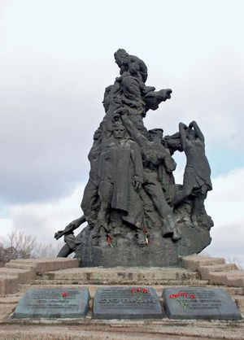](https://cdn.britannica.com/07/158707-050-DDCCC4C7/Kiev-monument-site-Babi-Yar-Ukraine-Nazis.jpg)

[Babi Yar monument in Kyiv, Ukraine](https://cdn.britannica.com/07/158707-050-DDCCC4C7/Kiev-monument-site-Babi-Yar-Ukraine-Nazis.jpg)

The [German invasion](https://www.britannica.com/event/World-War-II) in 1941 again brought severe suffering and destruction to the city. After a fierce 80-day battle, German forces entered it on September 19, 1941. Shortly thereafter, nearly 34,000 Jews were massacred within days in a nearby ravine known as [Babi Yar](https://www.britannica.com/place/Babi-Yar-massacre-site-Ukraine); tens of thousands more Jews, [Roma](https://www.britannica.com/topic/Rom) (Gypsies), and other Ukrainians were killed there over the next two years. Many of Kyiv’s other inhabitants were deported for [forced labour](https://www.britannica.com/topic/forced-labour) and to concentration camps, including almost all the large prewar Jewish population. In 1943 the advancing Soviet troops forded the Dnieper and, after bitter fighting, took Kyiv on November 6. The city itself had suffered great destruction, including more than 40 percent of its buildings and some 800 of its industrial enterprises. For Kyiv’s role in the war, the Soviet government later honoured it with the [Order of Lenin](https://www.britannica.com/topic/Order-of-Lenin), the title of Hero-City, and the Gold Star medal. In the postwar Five-Year Plan, rapid reconstruction was undertaken.

[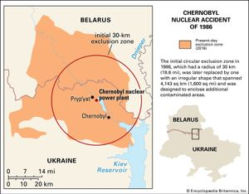](https://cdn.britannica.com/11/196911-050-0185290A/Map-exclusion-zone-nuclear-power-station-Chernobyl.jpg)

[Chernobyl disaster](https://cdn.britannica.com/11/196911-050-0185290A/Map-exclusion-zone-nuclear-power-station-Chernobyl.jpg)

[[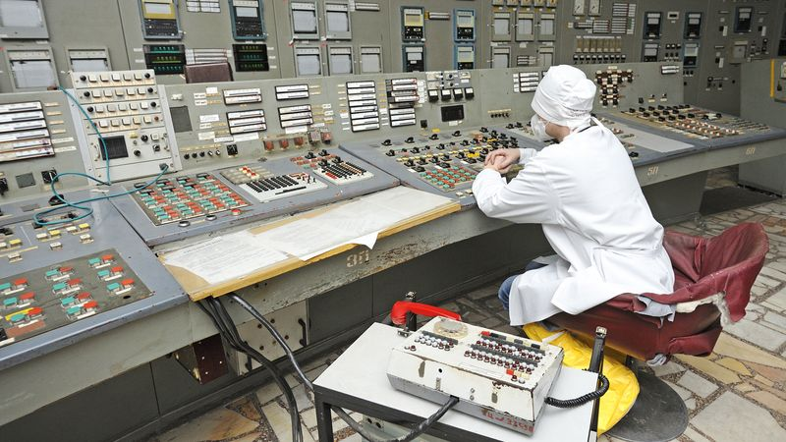](https://www.britannica.com/video/180283/disaster-Chernobyl-video-repercussions)](https://www.britannica.com/video/180283/disaster-Chernobyl-video-repercussions)

Hear about the April 1986 disaster at the Chernobyl nuclear power station and the catastrophe caused by the escaping radiation

[See all videos for this article](https://www.britannica.com/place/Kyiv/images-videos)

Kyiv continued to grow and to strengthen its industrial base during the mid- and late 20th century. On April 25–26, 1986, the [Chernobyl nuclear power station](https://www.britannica.com/event/Chernobyl-disaster) some 65 miles (104 km) north of Kyiv suffered the worst disaster in the history of [nuclear power](https://www.britannica.com/technology/nuclear-power) generation. Although Communist Party officials were aware of the threat posed by windborne radioactive materials, they did not [convey](https://www.britannica.com/dictionary/convey) those concerns to the public, and Kyiv’s annual [May Day](https://www.britannica.com/topic/May-Day-international-observance) parade was allowed to proceed as planned. By that time, the wind had shifted, and residents of Kyiv were being exposed to dangerously high levels of radiation. Elevated levels of radioactive isotopes such as [cesium-137](https://www.britannica.com/science/cesium) were detected in plants and animals in the surrounding area for decades after the incident.

**Kyiv in an independent Ukraine**

[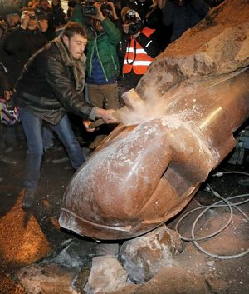](https://cdn.britannica.com/18/173218-050-2BBF4F8D/protesters-Ukrainian-Pres-ties-demonstrations-statue-decision-Dec-8-2013.jpg)

[Maidan protests](https://cdn.britannica.com/18/173218-050-2BBF4F8D/protesters-Ukrainian-Pres-ties-demonstrations-statue-decision-Dec-8-2013.jpg)

Whereas during the Soviet period Kyiv as an international political entity fell largely under the shadow of [Moscow](https://www.britannica.com/place/Moscow), the establishment of an independent [Ukraine](https://www.britannica.com/place/Ukraine) returned Kyiv to the world political stage. Ukrainians voted overwhelmingly in favour of independence on December 1, 1991, but the country struggled to escape Moscow’s orbit. Kyiv became the centre of the ideological battle between Ukraine’s pro-European west and its Russophile east. Tens of thousands took to the streets of the capital to protest [widespread](https://www.britannica.com/dictionary/widespread) fraud and ballot-stuffing in the November 2004 presidential election, in which Russian-backed candidate [Viktor Yanukovych](https://www.britannica.com/biography/Viktor-Yanukovych) defeated pro-Western candidate [Viktor Yushchenko](https://www.britannica.com/biography/Viktor-Yushchenko). Yushchenko, who had narrowly survived an attempted poisoning during the campaign, rallied his supporters in a movement that became known as the [Orange Revolution](https://www.britannica.com/topic/Orange-Revolution). The Ukrainian Supreme Court overturned the election result, and Yushchenko was victorious in the subsequent rerun.

[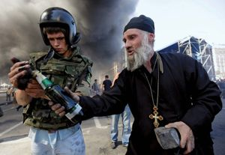](https://cdn.britannica.com/86/181386-050-82DC5B3C/Protesters-government-forces-Molotov-cocktail-Kiev-Maidan-August-7-2014.jpg)

[Ukraine crisis, 2014](https://cdn.britannica.com/86/181386-050-82DC5B3C/Protesters-government-forces-Molotov-cocktail-Kiev-Maidan-August-7-2014.jpg)

Another [wave of protests](https://www.britannica.com/topic/Ukraine-crisis) rocked Kyiv in 2013–14, when Yanukovych, who had succeeded Yushchenko as president, backed out of a planned association agreement with the [European Union](https://www.britannica.com/topic/European-Union) at the eleventh hour. Pro-EU demonstrators set up a camp in Maidan Nezalezhnosti (“Independence Square”) and occupied city hall. Scores were killed in February 2014 when police and security forces opened fire on crowds of protesters. Downtown Kyiv became a battlefield, and the buildings surrounding the [Maidan](https://www.britannica.com/topic/Euromaidan) were scorched by petrol bombs. Abandoned by his political allies and under threat of impeachment, Yanukovych fled to [Russia](https://www.britannica.com/place/Russia), and the protesters, dubbed the Euromaidan movement, ushered in a pro-Western government.

With the overthrow of Yanukovych, Russian Pres. [Vladimir Putin](https://www.britannica.com/biography/Vladimir-Putin) was deprived of his main lever in Kyiv, and Putin quickly moved to destabilize the [interim](https://www.merriam-webster.com/dictionary/interim) Ukrainian government. The invasion and annexation of the Ukrainian [autonomous](https://www.merriam-webster.com/dictionary/autonomous) republic of [Crimea](https://www.britannica.com/place/Crimea) marked the beginning of an extended Russian hybrid warfare campaign against Ukraine. A Russian-backed separatist uprising was engineered in eastern Ukraine, and Kyiv was subjected to repeated [cyberwarfare](https://www.britannica.com/topic/cyberwar) attacks. In 2015 and 2016 hackers, widely believed to be in the employ of Russian intelligence, disrupted the electrical grid in Kyiv, plunging parts of the city into darkness for hours. In February 2022 Putin announced the beginning of a “special military operation” against Ukraine, and [cruise missile](https://www.britannica.com/technology/cruise-missile) strikes preceded a wholesale [invasion of Ukrainian territory](https://www.britannica.com/event/2022-Russian-invasion-of-Ukraine). The Ukrainian military checked the Russian advance at multiple points, however, and thousands of civilians took up arms to defend the capital.

**9 Michael Ivanovich Rostovtzeff**

**8 Isidore Of Kiev**

**7 Peter**

**6 Vladimir II Monomakh**

**4 Hilarion Of Kiev**

**3 Svyatoslav I**

**2 St. Olga**

**1 Igor**

**5 Oleg**

**10Vladimir Lenin**

**Joseph Stalin**

**Ники́та Серге́евич Хрущёв**

**Leonid Brezhnev**

**Presidents**