Three examples of crypto articles on different templates
______________________________________________________________
Example 1
Best 5 Gold Backed Crypto to Make Money
Investing in safe-haven assets is the most reliable way to keep funds safe when economic conditions are unstable. Gold has a safe-haven value that allows many investors to put their funds in gold and gold-related assets. In this way, gold backed cryptos have become a reliable investment opportunity but finding the most reliable crypto tokens is challenging.
The following section will see the list of five gold backed cryptos that are reliable to invest in 2022 with a detailed analysis.
Contents
Best five gold backed crypto coins to buy in 2022
- Tether Gold (XAUT)
- Digix Gold Token (DGX)
- Perth Mint Gold Token (PMGT)
- GoldCoin (GLC)
- Pax Gold (PAXG)
- Pros and cons
- Final thoughts
Best five gold backed crypto coins to buy in 2022
The gold backed crypto aims to work as a derivative where the price of the trading instrument is equivalent to gold. As the asset is backed by physical gold, it offers less volatility and high stability where making money is possible in an easy way. The price change of the gold backed crypto comes from gold’s price change where some instrument offers a 1:1 or 1:100 ratio between the asset and gold.
We will see the list of crypto tokens before proceeding further to the best five crypto coins to buy:
- Tether Gold (XAUT)
- Digix Gold Token (DGX)
- Perth Mint Gold Token (PMGT)
- GoldCoin (GLC)
- Paxos Gold
Tether Gold (XAUT)
Market cap: $468,330,550
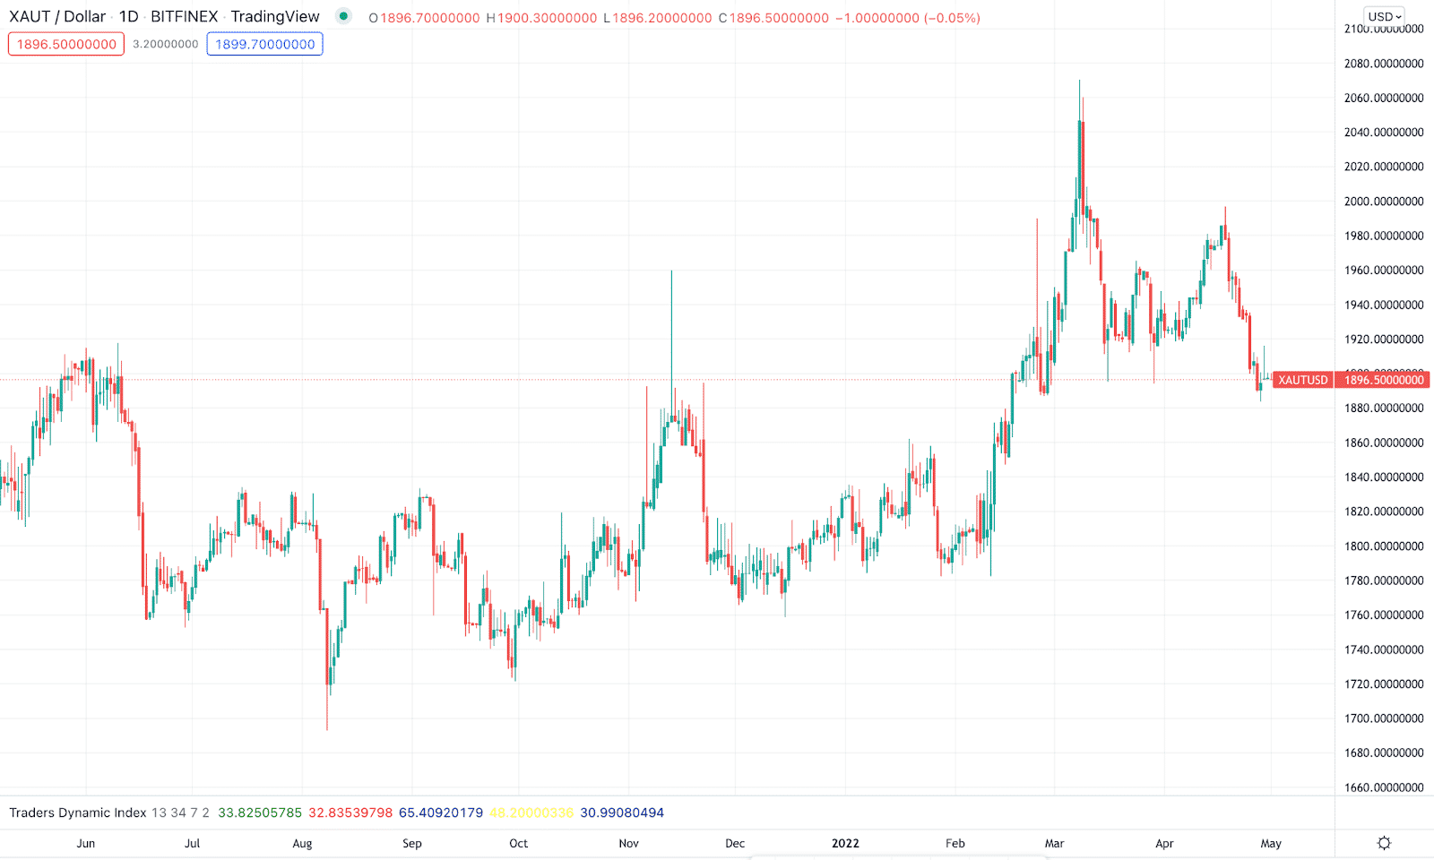
XAUT/USD 1Yprice change
A crypto derivative backed by gold offers an investment opportunity in real-time trading. Investors can quickly transfer the asset from their crypto wallet. According to the London good delivery bar, one XAUT is equivalent to one ounce of gold in this investment method.
According to the latest report, the TetherGold market cap has reached the market cap at $468,330,550 with a total supply of 246,524 XAUT. One user can purchase a maximum of 50 XAUT from the official website after completing some verification steps.
Is TetherGold has the potential to grow?
Its price has a 99% positive correlation with the traditional XAU/USD. Therefore, the possibility of future growth is strong for this instrument, particularly after the Covid-19 pandemic that pushed central banks to print money with a rising interest rate. In that case, the possibility of inflation is high, pushing the gold price up.
Digix Gold Token (DGX)
Market cap: $1,243,565
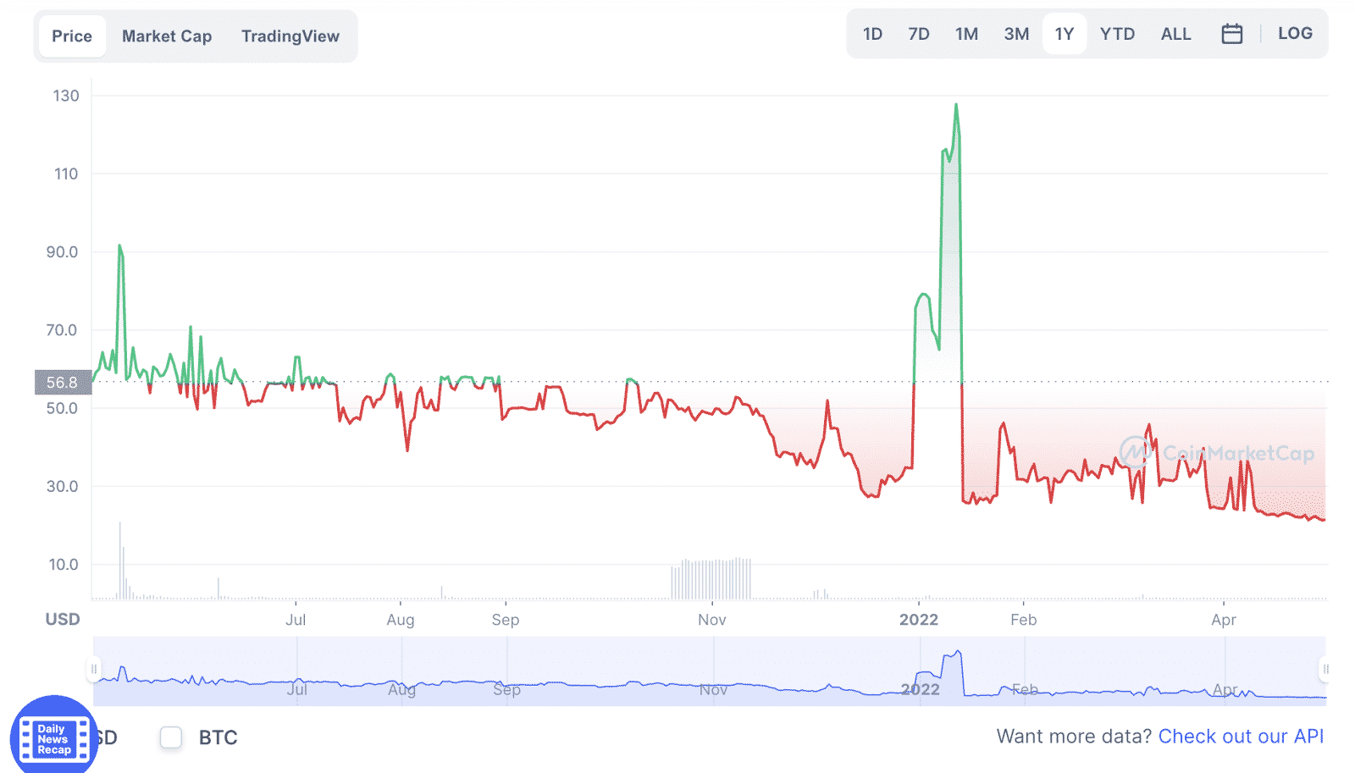
DGX/USD price chart for 1Y
Digix Gold Token is a trading instrument issued by DigixDAO (DGD), a decentralized autonomous organization (DAO). The company aims to create tokenized physical assets so that investors can take part in the crypto market without having the issue of volatility. This company uses the Proof of Provenance (PoP) to verify the asset’s existence through the chain of custody.
Digix is available to trade in most top-tiered crypto exchanges like Hotbit, Indodax, KULAP, and ProBit Global. Moreover, users can connect other apps and websites to this platform through APIs.
Is Digix Gold Token has the potential to grow?
It showed strong bullish momentum at the beginning of 2022 but rebounded immediately. However, as it is backed by physical gold, investors can consider it a buy based on the current demand for gold, which came from higher global inflation.
Perth Mint Gold Token (PMGT)
Market cap: $2,214,647
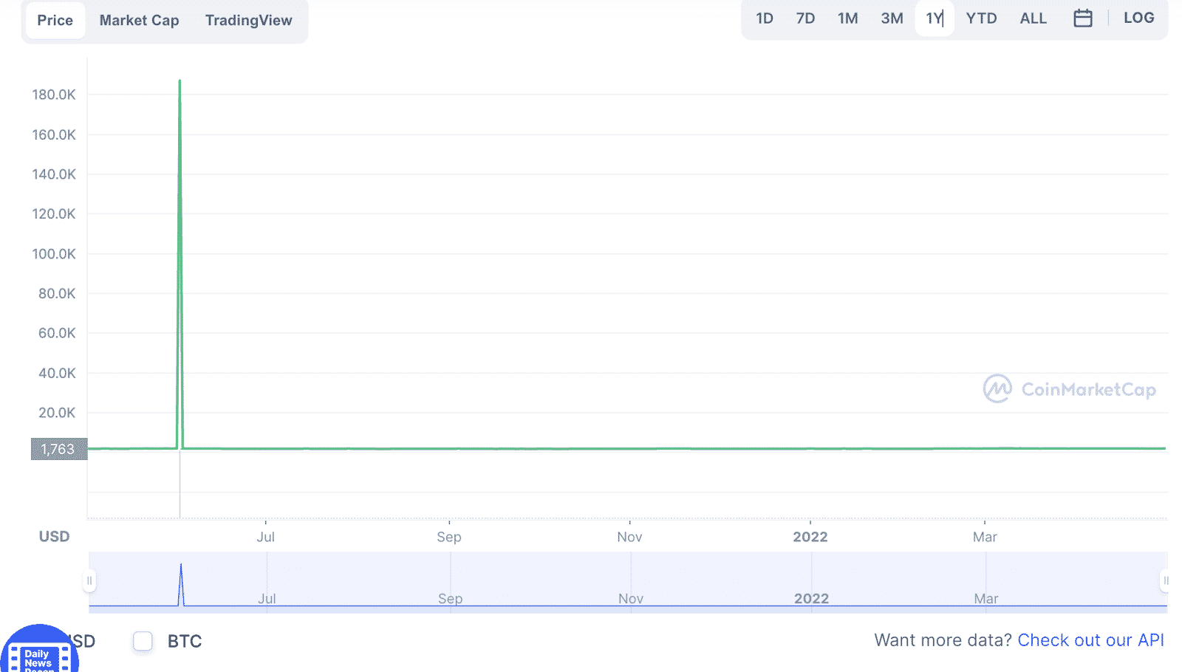
PMGT/USD 1Y price change
It is a gold backed crypto-asset built on the Ethereum blockchain. Each of these tokens represents one ounce of gold stored in the vault of the Perth Mint. Users can have peer-to-peer transactions in this asset through the smart contract of this token, where making a transfer with maximum security and safety is possible.
Is Perth Mint Gold Token has the potential to grow?
PMGT price remained stable for a long time allowing investors to keep them safe from the unexpected price volatility of the crypto market. However, buying an asset needs stable fundamental events, which are currently unavailable for the PMGT. However, the price of this token might get momentum after a massive user presence in this network.
GoldCoin (GLC)
Market cap: $1,669,279
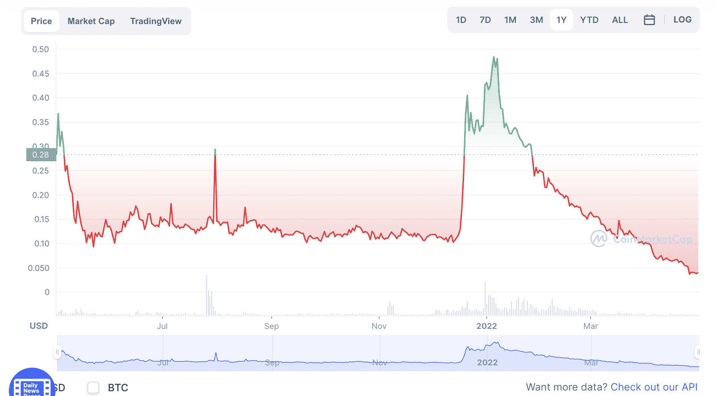
GLC/USD price for 1Y
GoldCoin offers trading in the peer-to-peer crypto, created by an anonymous person, which operates like Bitcoin with no company or person behind it. Users can make a transfer within two minutes through this network under the ERC 20 format. Moreover, it offers to convert crypto to physical gold.
Is GoldCoin has the potential to grow?
Like other cryptos on this list, the price of GLC/USD depends on how gold’s price changes in the spot market. Based on the current economic situation of 2022, the rising inflation rate, interest rate hikes, and the possibility of recession are signs that gold may soar with an upside pressure on all gold-backed assets.
Pax Gold (PAXG)
Market cap: $610,670,440
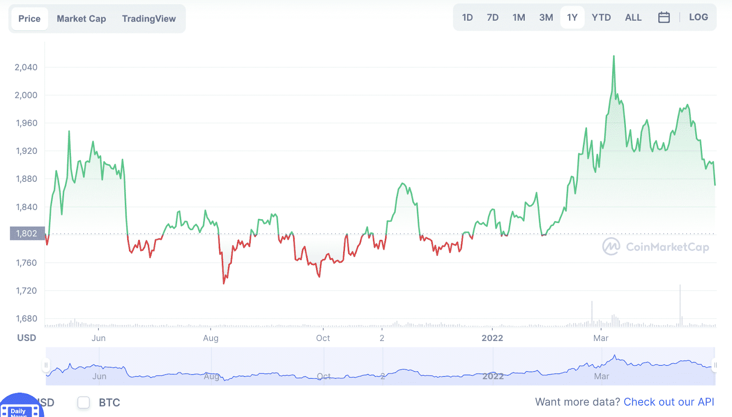
PAXG/USD 1Y price change
It is a gold backed crypto created by Paxos International. It runs through the ERC 20 token under the Ethereum blockchain and has become a reliable way to make money online with an aim to profit from gold.
The primary objective of this project is to make gold more attractive to investors as the physical commodity is not easy to divide among people. As per the Pax Gold whitepaper, investors are allowed to buy unlimited gold through this crypto.
Is PAXG has the potential to grow?
Based on the last year’s price action PAXG has a higher possibility of showing a rebound following the strong demand for physical gold from the global economic uncertainty.
Pros and cons

- Such cryptos are a solid alternative to physical gold. | - Investing in these assets needs sound knowledge of technical and fundamental analysis.
- These instruments track the price of physical gold where the volatility is very low compared to the broader crypto market. | - Investors need close attention to institutes or companies behind any gold-backed crypto projects to understand the reliability.
- These cryptos are reliable opportunities to hedge inflation. | - It is not wise to say these cryptos are 100% risk-free.
Final thoughts
Finally, we have seen the top five gold backed cryptos that are the potential to grow in 2022. Besides, there are some other assets, like gold backed ETFs, where you can expand the trading portfolio to minimize the market risk.
________________________________________________________________________
Example 2
Top 3 Crypto to Recover After Black Friday Crypto Crash

After a sharp drop in price followed by several days of steadily falling prices, several cryptos have fallen to their lowest point in six months, down more than 50% from their all-time high in November.
Speculators expect it will take years for bitcoin and the more significant market to recover from the severe dip. Crypto prices have fallen due to several factors, including a decrease in the stock market and expectations that the US Federal Reserve may raise interest rates shortly.
Bitcoin, Ethereum, and other leading cryptos often sell-off when the broader financial markets are shaky. The crypto market has lost nearly $1.5 trillion in the preceding two months, with each of the top cryptos losing value recently.
More than $175 million in BTC was liquidated on Bitcoin’s “Black Friday,” as some commentators dubbed it. This article will look at the top three crypto coins to recover after the Black Friday crypto crash.
Why is it worth investing in cryptos?
Income from a passive source. It’s uncommon to find someone who doesn’t appreciate a “freebie.” People desire to expand their money in a short amount of time, which is why mining has become so popular. It is sufficient to purchase the appropriate equipment, build the farm, and install the software to become a miner. It’s only a matter of pressing the start button to begin mining your chosen crypto.
Decentralization. No one can manage or monitor the issue of money or the movement of cash on the account because of this characteristic. Decentralization allows cryptos to be self-contained. Anonymity. You can’t monitor a person’s details; their wallet number and transactions are all you can see.
How to start?
A list of exciting coins may be compiled after learning more about the procedures involved and doing some study on specific projects. There are several brokers and exchanges through which you may buy and sell crypto. Be aware that crypto investments might be pretty risky. Prices might change substantially.
People like us see service costs as crucial in their decision-making process. For what reason would you pay more for the identical product? You may also invest in various projects on a single website, which appeals to a broad spectrum of people due to the high currency supply.
Let’s look at the top three crypto coins to recover after the black Friday crypto crash.
Bitcoin (BTC)
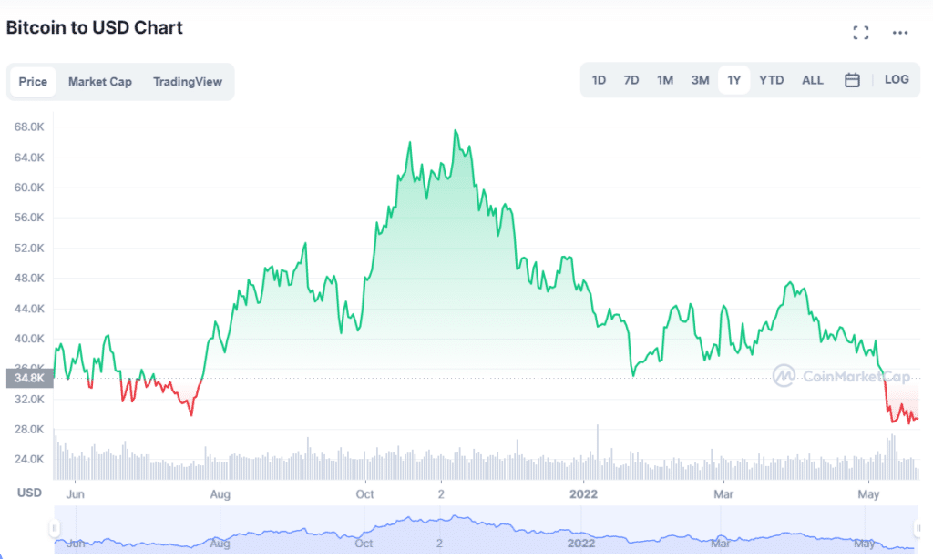BTC 1-year price chart
52-week range: $26,350.49-$68,789.62
1-year price change: -27.4%
Forecast 2022: with Bitcoin’s significant fall since then, the prediction game is even trickier. The most extreme crypto skeptics say Bitcoin will tank to as low as $10,000 in 2022, but a middle ground might be that the crypto can still climb to $100,000 like many experts predicted late last year — just on a slower timeline.
The first crypto, Bitcoin, emerged in the market in 2008. However, unlike other cryptos, no one knows who created Bitcoin. So instead, we only see the alias Satoshi Nakamoto.
You may discover more about Bitcoin here, the digital money founded on the blockchain distributed ledger. In the case of online money transfers, Bitcoin eliminates the need for third-party intermediaries like banks and credit card companies.
Rather than going via your financial institution, you may transfer one Bitcoin to a friend. The best of the decentralized and digital worlds come together in Bitcoin. As a result, currencies like the US dollar, British pound, and Japanese yen are under increasing pressure from this new currency.
A vast and active community of developers and investors makes BTC one of the most promising for the future. Since all significant exchanges and wallets support Bitcoin, even amateurs may buy it. In addition, companies are increasingly accepting Bitcoin as a form of payment. Bloomberg, Microsoft, Overstock.com, and Expedia are just a few organizations that have begun accepting Bitcoin payments.
Ethereum (Ether)
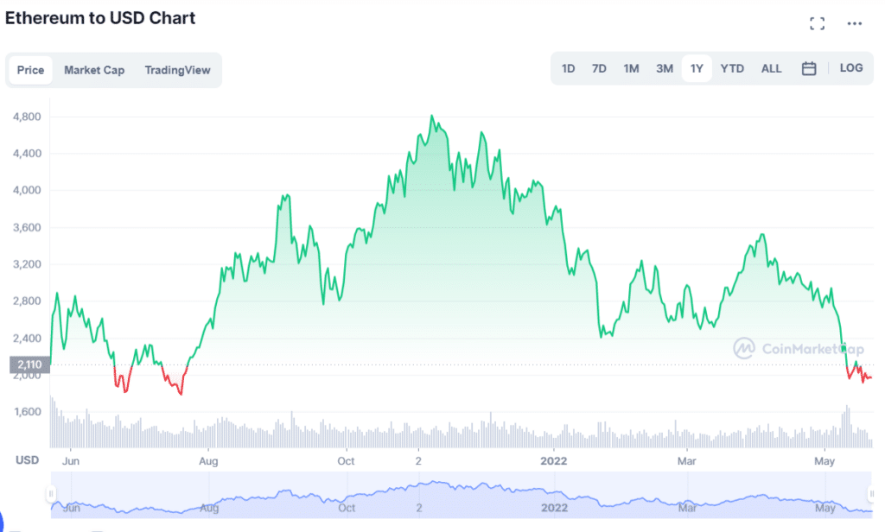
Ether 1-year price chart
52-week range: $1,707.60-$4,891.70
1-year price change: -29.1%
Forecast 2022: despite the challenge of predicting the price of volatile crypto, the experts we spoke with generally agree ETH could once again break $4,000 in 2022. And a recent Ethereum prediction by Bloomberg intelligence analyst Mike McGlone has it ending the year between $4,000-$4,500.
A close second to Bitcoin in terms of market capitalization is Ethereum. Vitalik Buterin launched Ethereum in 2015, and it’s much more than crypto.
Ethereum is a decentralized software and innovative contract platform built on the Ethereum blockchain. The Ethereum blockchain’s primary currency, Ether, is used in all transactions. Smart contracts and “blockchain-based agreements,” on the other hand, need to be distinguished.
A company or application idea that uses blockchain technology does not need the creation of a blockchain. Ethereum is the only primary crypto that can be mined straight from the Ethereum blockchain. This platform is often used to develop smart contracts, viewed as the next big thing in the BTC industry.
To launch other blockchain companies’ Initial Coin Offerings (ICOs), Ethereum is an attractive choice. Cryptocurrency ICOs raised $5.6 billion in 2017, most hosted on Ethereum. In addition, ETH, in contrast to BTC, may complete transactions in as few seconds.
Ripple (XRP)
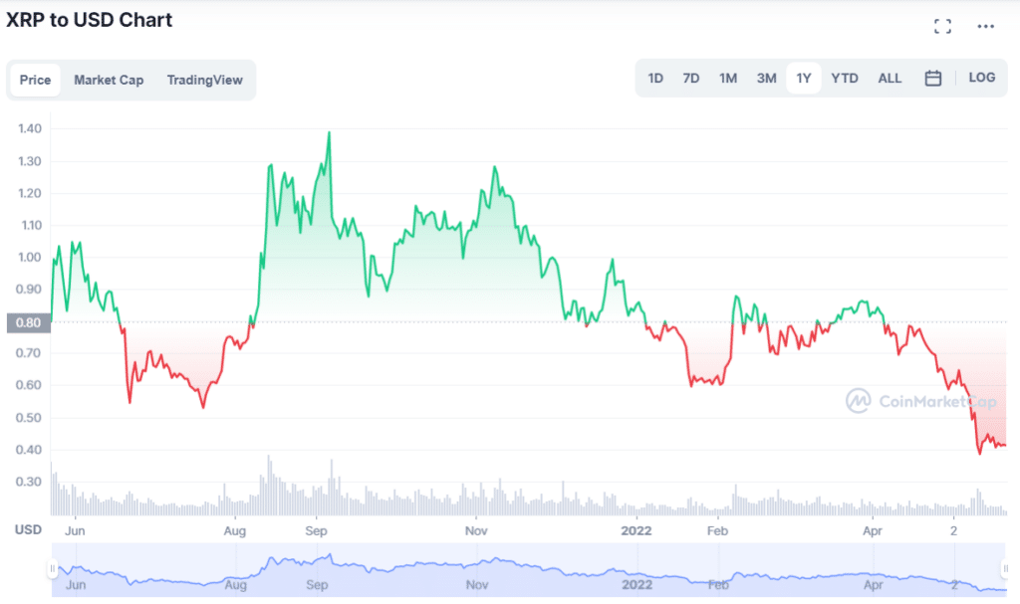
XRP 1-year price chart
52-week range: $0.34-$1.4
1-year price change: -65.1%
Forecast 2022: according to the technical analysis of XRP prices expected in 2022, the minimum cost of XRP will be $0.47. The maximum level that the XRP price can reach is $0.56. The average trading price is expected to be around $0.49.
One of the unique aspects of Ripple’s cryptocurrency is that it focuses only on international financial transactions. To make international transactions as fast and economical as feasible, it was founded in 2012.
Out of the 100 billion XRP that will exist, Ripple Labs now has 50 billion XRP. In contrast, no organization controls most of the coins in most of the ten most popular cryptos.
It might take up to a week to process an international money transfer. On the other hand, Ripple can do this in a couple of minutes. As a result, the expenses are far lower than those imposed by banks and other forms of digital currency.
Final thoughts
Since its inception, crypto volatility has been notoriously difficult to predict. Even though it has lately shown similar tendencies to more traditional financial markets, it has also been known to depart from such patterns entirely due to only one occurrence.
It’s observed that a single tweet from Elon Musk or a statement from a world leader may lead to either a collapse or a surge. According to HashEx CEO and co-founder Dmitry Mishunin, “Crypto is Crypto because macroeconomic events do not bind its growth possibilities. A rise in market sentiment might reignite a price surge at any time.”
_____________________________________________________________________
Example 3
Top 5 Most Viewed Crypto
There are thousands of different cryptos, from Bitcoin and Ethereum to Dogecoin and Tether, making it overwhelming when you’re first getting started in crypto. To help you get your bearings, these are the top five cryptos most viewed recently.
Top three things to know about cryptos before starting:
- Their market capitalization typically ranks them, and with good reason; the value of crypto directly reflects investor appetite.
- They are growing in popularity as an asset class that can build wealth quickly despite the volatility.
- Many of them, like Bitcoin, require a private key to access the currency tokens stored in a digital “wallet.”
Most viewed crypto to buy
Let’s take a look at the five cryptos to invest in.
French Connection Finance (FCF)
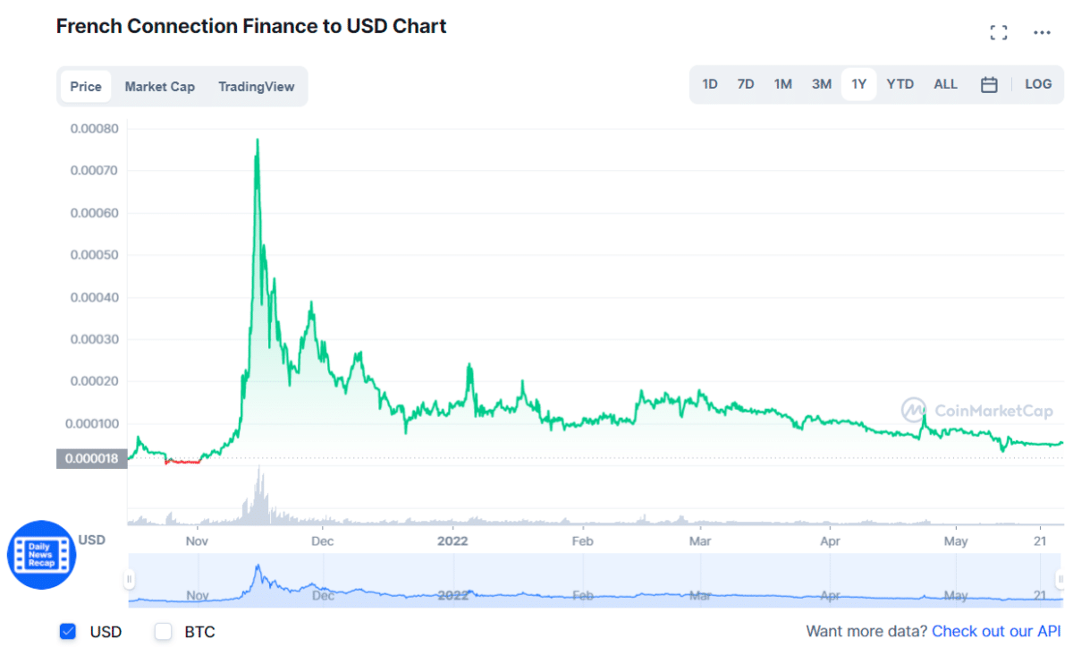FCF price chart
FCF is dividend-generating crypto that runs on the Binance Smart Chain network. It builds an ecosystem that benefits investors while developing products that have strong real-world value. It is led by John Nasr, who is the Founder & CEO.
Long-term investment in this crypto appears to be a sound option. As a result of the price evolution and projections, the graphs for this crypto will go up and down in the future.
Price history
Today, its price is $0,000054 with a 24-hour trading volume of $85 116,62. The current CoinMarketCap ranking is #4119, with a live market cap of not available.
- FCF hit an all-time high of $0.000786459248 on Nov 15, 2021.
- FCF had an all-time low of $0.000001255832 on Oct 24, 2021.
Where to buy it?
It is traded on four exchanges, with the top exchanges being Lbank, Hotbit, and PancakeSwap V2.
What are the perspectives of the FCF?
Its price will have reached a level similar to its previous all-time high. By 2022, we may expect an average price of $0.00006471. If everything goes smoothly, the maximum price of this crypto could be up to $0.00007306 in 2022.
Polkadot (DOT)
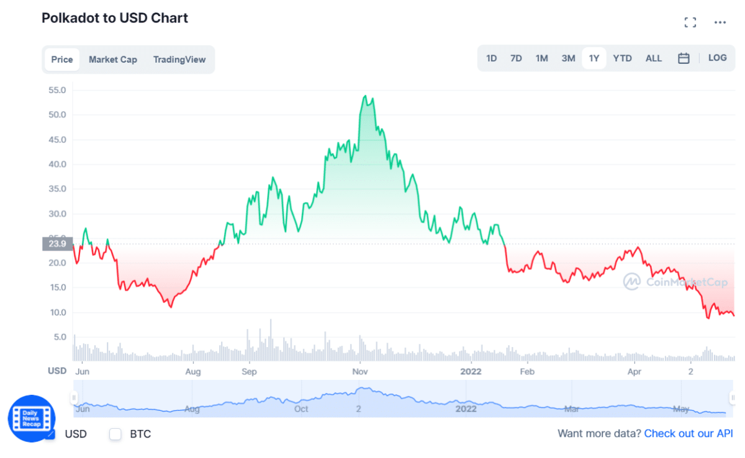DOT price chart
Polkadot is a protocol designed to create a network of interoperable blockchains. This would allow independent blockchains to communicate with one another and work together. Ultimately, the project’s goal is to build a completely decentralized web.
The native crypto on Polkadot is the DOT token. This is a governance token, which means token holders control the Polkadot protocol through voting. It’s also used to validate transactions through staking and bonding Polkadot’s parachains.
Price history
Today, its price is $9.19, with a 24-hour trading volume of $539,891,402. It has a circulating supply of 1.1 Billion DOT coins and a total supply of 1.2 Billion. The current CoinMarketCap ranking is #11.
- DOT hit an all-time high of $54.98 on Nov 04, 2021.
- DOT had an all-time low of $2.70 on Aug 20, 2020.
Where to buy it?
It is traded on 102 exchanges, with the top exchanges being Binance, FTX, and Nami.Exchange.
What are the perspectives of the DOT?
As of the end of 2022, its price predictions remain predominantly positive, with some analytics promising the price at about $10.64. Some experts even predict the possibility of the price reaching $27.22 by the end of the year.
Oceans Finance (OCEANS)
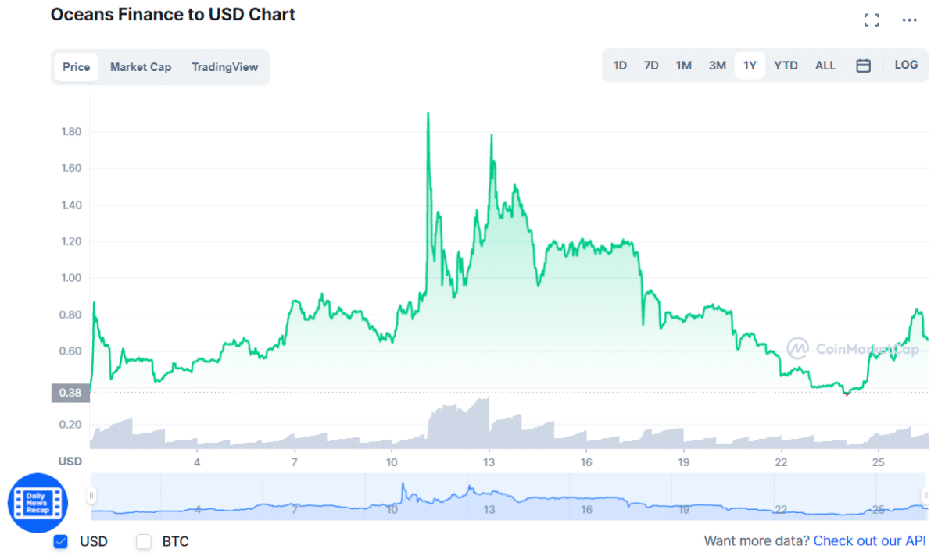OCEANS price chart
OCEAN is an exciting token that aims to transform the world of data and data privacy. It allows data owners to capitalize on digital assets without compromising their security or giving up control over them. It is an ERC-20 token and the native crypto token on the Ocean Protocol, which is based on the Ethereum blockchain.
Users can create a decentralized marketplace that records what data is there, who owns it, and who shares and exchanges it. Rather than relying on a traditional bidding system, it uses liquidity pools to allow trades to be settled through a range of smart contracts.
Price history
Today, its price is $0.664931 with a 24-hour trading volume of $69,109.30. It has a circulating supply of 0 OCEANS coins and a total supply of 1.77 Million. The current CoinMarketCap ranking is #4074.
- OCEANS hit an all-time high of $1.94 on May 11, 2022.
- OCEANS had an all-time low of $0.339209 on Apr 30, 2022.
Where to buy it?
It is traded on three exchanges, with the top exchanges being PancakeSwap V2, BabySwap, and Coinstore.
What are the perspectives of the OCEANS?
Its price predictions foretell initial months of 2022 will trade at $0.60, minimum price based on price forecasts is $0.73. The average price at which the coin trade for 2022 is predicted to be around $0.78.
Elrond (EGLD)
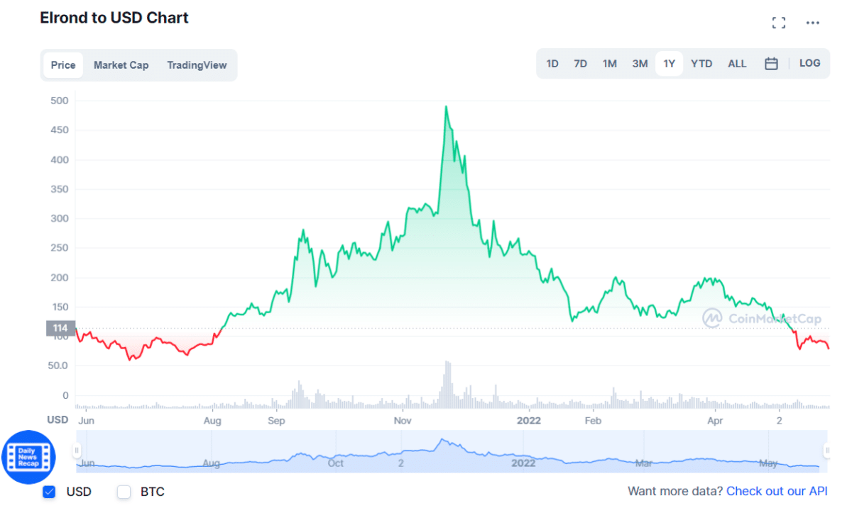EGLD price chart
Elrond utilizes the Secure PoS mechanism, as the network functions on the Adaptive State Sharding. The sharding means the whole process is divided into smaller portions, and nodes function over it. After completion, shards are sent back to the central blockchain for validation.
Price history
Today, its price is $77.54, with a 24-hour trading volume of $48,426,291. It has a circulating supply of 22 Million EGLD coins and a total supply of 23.7 Million. The current CoinMarketCap ranking is #38.
- EGLD hit an all-time high of $545.64 on Nov 23, 2021.
- EGLD had an all-time low of $6.51 on Oct 07, 2020.
Where to buy it?
It is traded on 37 exchanges, with the top exchanges being Binance, Nami.Exchange, and Digifinex.
What are the perspectives of EGLD?
It is forecasted to hit a maximum price of $311.29 and a minimum of $140.41. The token is expected to trade at $225.80 by 2022.
ARENUM (ARN)
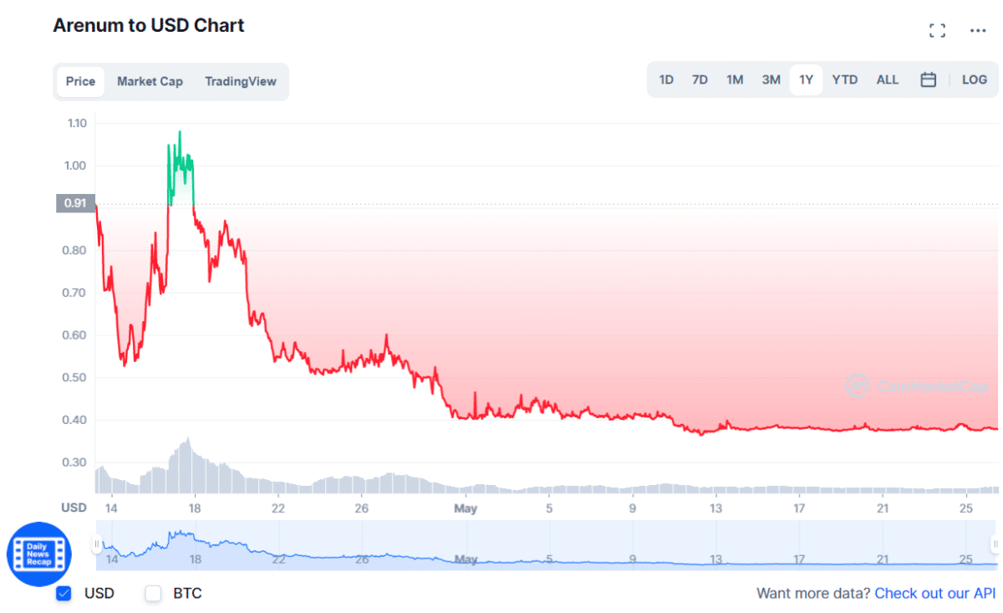ARN chart
Arenum infrastructure provides gamers and game developers with the elementary structure they require. Arenum is one step ahead of the other game-driven businesses. The popular games built are used as the stepping stone for developing the platform and powering the source of income.
Price history
Today, its price is $0.383493 with a 24-hour trading volume of $504,912. The current CoinMarketCap ranking is #3276.
- ARN hit an all-time high of $3.16 on Apr 12, 2022.
- ARN had an all-time low of $0.371056 on May 12, 2022.
Where to buy it?
It is traded on one exchange, HitBTC.
What are the perspectives of the ARN?
According to our technical analysis on past price data of ARN, in 2022, its price is predicted to reach at a minimum level of $0.47. It can reach a maximum of $0.54 with an average trading price of $0.49.
Final thoughts
Individuals interested in crypto should be aware of its unique risks before buying. Determining whether or not crypto is a good investment will depend on its suitability for a given investor’s investment goals and risk tolerance.

