Every day we express information and emotions through words and the speech they make up. Thanks to the diversity of language, we have the opportunity to convey the most important things as accurately and clearly as possible with the help of grammatical tools, which it is important to know how to use correctly and without mistakes. In this article I will consider such an important topic as the formation and use of indirect and direct speech in English. We will understand how tenses change in such cases and verb forms when changing from one type of sentence to another. We will also look at examples of speech in Agatha Christie's detective novel Murder on the Orient Express . I will provide you with vivid instances of the use of indirect and direct speech in English Literature.

* Direct and indirect speech : What is the difference?

In order to analyse each transformation in detail, it is necessary to understand their main differences.

Direct speech is a direct transmission of a thought, its exact quotation. In this case, we transfer words exactly as they sounded.

Indirect speech is a similar method of transmission, but in this case we avoid quoting in detail, but use a conditional retelling of what we heard from our own person.

When we move from one type of sentence to another, a number of changes occur, including temporal transformations.

Let's look at the table with concrete examples of transforming one tense into another:

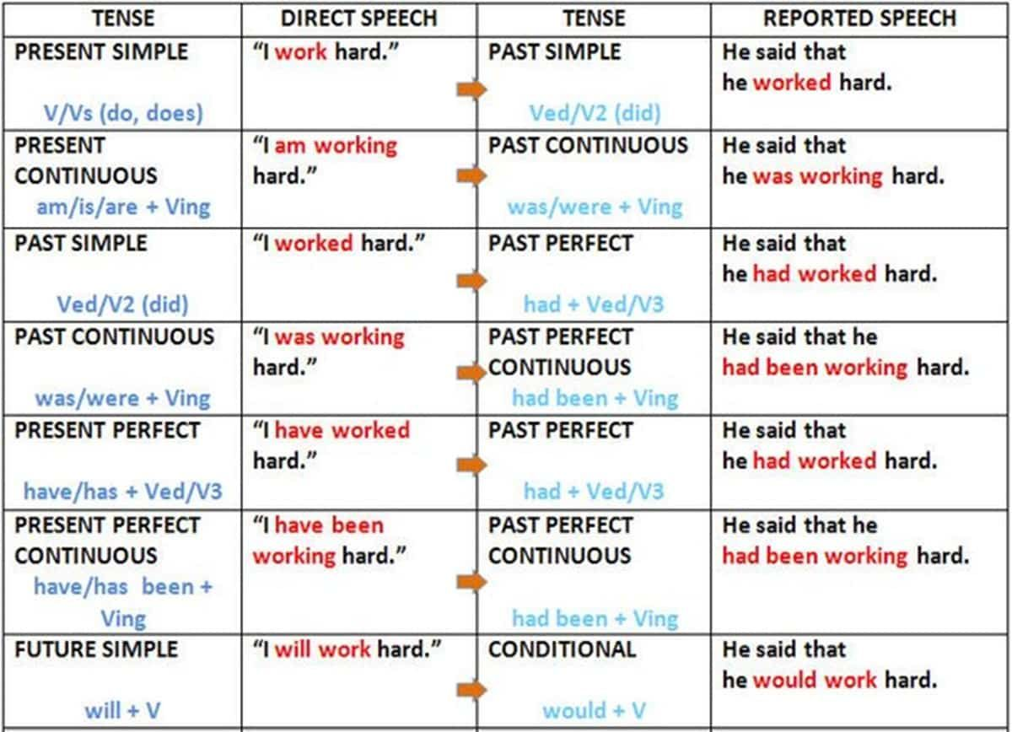

Now let us consider each type of speech and its construction separately:

* Direct speech

As mentioned above, direct speech is used to quote accurately without distorting or changing the sentence. Let's look at the rules of direct speech with examples:

1. Use inverted commas to emphasise an expression:

Alice said, "I will go to the store later." . This rule is important to follow to accurately distribute the words of the author and the quoted speech.

1. A colon or comma is placed before direct speech, depending on the context of the sentence.

Examples are : She said, "I will come tomorrow at seven." and He asked, "Are you coming to the party?".

With direct speech, it is quite easy to recognise it by the inverted commas in which the speaker's expression is enclosed. But what about indirect speech? Let's look at its nuances.

* Indirect speech

Indirect speech is used when we do not want to convey the speaker's words verbatim, but when it is important to convey the essence to the listeners. Unlike direct speech, conversion to indirect speech involves grammatical changes in sentence structure.

1. Change оf tense: if direct speech was used in the present tense, in indirect speech it changes to the past tense. I have given examples of such tense changes above.
2. The person of verbs changes according to the context.

Direct speech: He asked, "When will you arrive?"

Indirect speech: He asked when I would arrive.

1. Indicators of place and time can be changed to retain meaning (e.g. "here" becomes "there", "today" becomes "that day").

Direct speech : She said, "I am here."

Indirect speech : She said that she was there.

1. Inverted commas are not used to emphasise indirect speech.

Direct speech : The teacher said, "Study the rules."

Indirect speech : The teacher said to study the rules.

In summary, the use of indirect speech is an important aspect of constructing coherent and grammatically correct sentences. It allows us to change the point of view in statements, thus adapting the speech to the context.

* For a more complete analysis, we should also consider typical errors of converting direct speech into indirect speech in English:

1. Failure to change tenses: Not all tenses need to be changed. For example, when converting present simple to past simple: "She says, 'I like apples'" becomes "She said that she liked apples." However, if the direct speech is in present tense, it may remain unchanged
2. Omission of pronouns: When converting, pronouns should also be changed. For example, "He said, 'I will help you'" becomes "He said that he would help me.
3. Incorrect use of conjunctions: Usually 'that' is used, but it is not necessary. Some people forget to include it, e.g. "He said he was tired" (correct) instead of "He said that he was tired" (optional).
4. Preserving the direct word order: The word order may change during conversion. For example, "She said, 'I am coming'" becomes "She said that she was coming."
5. Errors with question sentences: Questions are converted into affirmative sentences. For example, "He asked, 'Are you coming?" becomes "He asked if I was coming."
6. Incorrect use of tense depending on the context: If the direct speech refers to the future, it may not change. For example, "She said, 'I will call you tomorrow'" may remain "She said that she will call you tomorrow."
7. Incorrect conversion of modal verbs: Some modal verbs change, others do not. For example, 'can' becomes 'could' but 'must' remains 'must'.

Now I propose to look at examples and analyse the use of direct and indirect speech in literature, namely in the lines from the novel "Murder on the Orient Express".

* "Mais oui. Stamboul, it is a city I have never visited. It would be a pity to pass through-comme ça." He snapped his fingers descriptively. "Nothing presses—I shall remain there as a tourist for a few days." - This is a good example of the classic use of direct speech. This is indicated by inverted commas, direct word order, and accurate presentation of the character's words
* Poirot reported that Mrs. Hubbard had insisted she hadn’t left her compartment all night. - This example shows how direct speech (Mrs Hubbard's words) is converted into indirect speech through the use of the expression "Mrs Hubbard had insisted" and the change of verb form.
* “I heard someone moving in the next compartment,” she said. Transform into “She mentioned that she had heard someone moving in the next compartment.” - Here direct speech is conveyed through the words "she mentioned," and the verb "heard" is changed to "had heard," to conform to the rules of indirect speech.
* And one more example: “I can’t understand how the door was locked,” MacQueen said. Turn into “MacQueen remarked that he couldn’t understand how the door had been locked.”

Of course, there are many more nuances of using direct and indirect speech. In my work, I wanted to show the basic rules that are generally accepted for constructing sentences. In any case, first of all, you should look at the context of the sentence and the grammatical basis, and from this to consider what kind of speech is more suitable in your case. Thank you for your attention!