MINISTRY OF EDUCATION AND SCIENCE OF UKRAINE KHARKIV NATIONAL ECONOMIC UNIVERSITY NAMED AFTER SEMEN KUZNETS

FACULTY OF INTERNATIONAL RELATIONS AND JOURNALISM DEPARTMENT OF INTERNATIONAL ECONOMIC RELATIONS

|  |  |
| --- | --- |
| Level of higher education | First (bachelor's) |
| Specialty | International economic relations |
| Educational program | International business |
| Group | 6.01.292.010.20.1,2 |

**THESIS**

on the topic :

«FORMATION OF BUSINESS COMMUNICATIONS IN THE SYSTEM OF INTERNATIONAL ENTREPRENEURSHIP »

Виконав(ла): студент (ка) Ірина ПЕТРЕНКО

Head : Candidate of Economic Sciences, Associate Professor Volodymyr USHKALYOV

Reviewer : CEO

PrJSC «Name »

Serhiy TKACHENKO

Kharkiv – 2025

**CONTENT**

**INTRODUCTION. . . . . . . . . . . . . . . . . . . . . . . . . . . . . . . . . . . . . . . . . . . . . . . . . . . . . . . . . . . . . . . . . . . 3**

**CHAPTER 1. THEORETICAL AND METHODOLOGICAL FOUNDATIONS OF BUSINESS COMMUNICATIONS IN INTERNATIONAL ENTREPRENEURSHIP. . . . . . . . . . . . . . . . . . . . . . . . . . . . . . . . . . . . . . . . . . . . . . . . . . 6**

**1.1. The concept, role and functions of business communications in international entrepreneurship. 6**

**1.2. Classification of business communications and factors affecting their effectiveness. . . . . . . . . . . . 9**

**1.3. Intercultural features of business communications and global trends in their development. . . . 12**

**Conclusions to section 1. . . . . . . . . . . . . . . . . . . . . . . . . . . . . . . . . . . . . . . . . . . . . . . . . . . . . . . . . . . . . . . 16**

**CHAPTER 2. ANALYSIS OF THE BUSINESS COMMUNICATIONS SYSTEM ON THE EXAMPLE OF LLC SCIENTIFIC AND EXPERT CENTER OF BUILDING TECHNOLOGIES "EXPERTIZATION ZO". . . . . . . . . . . . . .18**

**2.1. General characteristics of LLC "Expertization ZO" as a subject of international entrepreneurship 18**

**2.2. Analysis of internal and external business communications at the enterprise. . . . . . . . . . . . . . . . 24**

**2.3. Problems, barriers and directions for improving communication policy. . . . . . . . . . . . . . . . . . . . . 31**

**Conclusions to section 2. . . . . . . . . . . . . . . . . . . . . . . . . . . . . . . . . . . . . . . . . . . . . . . . . . . . . . . . . . . . . . . 38**

**SECTION 3. IMPROVING BUSINESS COMMUNICATIONS OF THE ENTERPRISE IN THE CONDITIONS OF THE INTERNATIONAL BUSINESS ENVIRONMENT. . . . . . . . . . . . . . . . . . . . . . . . . . . . . . . . . . . . . . . . . . . . 40**

**3.1. Directions of digital transformation of business communications based on best international practices . . . . . . . . . . . . . . . . . . . . . . . . . . . . . . . . . . . . . . . . . . . . . . . . . . . . . . . . . . . . . . . . . . . . . . . . . . . . 40**

**3.2. Implementation of a system of intercultural and customer-oriented communications. . . . . . . . . 43**

**3.3. Economic assessment of the effectiveness of the proposed changes. . . . . . . . . . . . . . . . . . . . . . . . 46**

**Conclusions to section 3. . . . . . . . . . . . . . . . . . . . . . . . . . . . . . . . . . . . . . . . . . . . . . . . . . . . . . . . . . . . . . . 49**

**CONCLUSIONS. . . . . . . . . . . . . . . . . . . . . . . . . . . . . . . . . . . . . . . . . . . . . . . . . . . . . . . . . . . . . . . . . . . . . . . .51**

**LIST OF SOURCES USED. . . . . . . . . . . . . . . . . . . . . . . . . . . . . . . . . . . . . . . . . . . . . . . . . . . . . . . . . . . . . . . . 53**

INTRODUCTION

**Relevance of the topic.**  In the modern world, business communications have become a strategic resource for the effective functioning of international entrepreneurship. They ensure the exchange of information, coordination of actions, building trust, developing partnerships and forming a sustainable image of the company in the global market. Globalization , Digitalization and increased intercultural interaction have led to increased demands on the professional organization of business communication. That is why research into the mechanisms for building and improving business communications at enterprises engaged in foreign economic activity is not only relevant, but also practically necessary. In Ukraine, such research is of particular importance in the context of integration into the European economic space, the introduction of international standards and strengthening the competitiveness of Ukrainian companies.

**Analysis of publications on a selected topic .** A number of works by leading researchers are devoted to the issues of business communications in international entrepreneurship. In particular, the issues of organizing intercultural interaction, ethics of business communication and the use of communication strategies are highlighted in the works of Holovach V.I., Shevchenko O.O., Kvalchuk M.S., Peres V., as well as in standardized international documents, such as ISO 9001:2015 and EU regulations. The authors focus on the role of communications as an element of corporate culture, which affects the image, the effectiveness of negotiations, logistics, project management and business relations with foreign partners.

**The purpose and objectives of the study.**  The purpose of the work is to substantiate the directions of improving business communications in international entrepreneurship using the example of the activities of a domestic business entity operating in a foreign economic environment. To achieve this goal, it is necessary to solve the following tasks:

1. analyze the theoretical and methodological foundations of business communications in international entrepreneurship;
2. to investigate the features of the communication system of LLC "Scientific and Expert Center of Construction Technologies "Expertise ZO"";
3. to propose practical directions for improving the enterprise's communication policy in accordance with international standards and trends.

**Object and subject of research.**  The object of the study is the sphere of international economic relations, and the subject is the processes of organization, functioning and improvement of business communications in international entrepreneurship, implemented on the example of a specific Ukrainian enterprise.

**Research methods.**  The research used general scientific and special methods: logical analysis and synthesis, comparative analysis, generalization, observation, structural-functional analysis, content analysis, and elements of expert evaluation. This set of methods allowed us to reasonably investigate the essence and dynamics of business communications, assess the effectiveness of practices used in the enterprise, and develop substantiated recommendations.

**Information basis of the work.**  The research was based on regulatory legal acts of Ukraine and the European Union, international standards (in particular ISO 9001:2015), official statistical sources, publications by scholars in the field of international business and communications, reporting documents of the enterprise, and results of pre-graduate practice.

**Information about the database of pre-graduate internships.**  LLC "Scientific and Expert Center of Construction Technologies "Expertiza ZO"" is a modern Ukrainian company specializing in engineering and technical expertise, scientific research and certification of building materials. It actively participates in international projects, supports cooperation with partners from EU countries, adheres to ISO standards and uses digital tools to increase the efficiency of its activities. This company was chosen as a base for conducting practice and an example for analyzing business communications in an international environment.

**Practical significance of the results obtained.**  The directions for improving business communications proposed in the thesis can be implemented directly into the activities of the enterprise. In particular, it concerns the optimization of the structure of business correspondence, strengthening the intercultural component in interaction with clients and partners, the implementation of CRM systems and platforms for communication management that meet the modern requirements of international business. The results obtained may also be useful for other Ukrainian companies seeking successful integration into the global market.

**Work structure** includes three sections: theoretical - reveals the essence and features of business communications in international entrepreneurship; analytical - contains a description of LLC "Expertiza ZO" and an analysis of its communication system; practical - suggests directions for improving communications taking into account international standards and digital solutions. The work consists of 55 printed sheets, 30 used sources, 10 tables, 5 illustrative material.

SECTION 1. THEORETICAL AND METHODOLOGICAL BASIS OF BUSINESS COMMUNICATIONS IN INTERNATIONAL ENTREPRENEURSHIP

1.1. The concept, role and functions of business communications in international entrepreneurship

In the system of international entrepreneurship, business communications are a critically important tool for coordination, management, forming partnerships and increasing competitiveness. They provide not only the exchange of information between participants in economic activity, but also serve as the basis for establishing long-term and mutually beneficial business relationships. In the context of globalization, digitalization and intercultural diversity, business communications are becoming more complicated, which requires an increased level of professional competence, strategic thinking and communication adaptability.

The definition of the concept of "business communication" is formulated in the works of many researchers. In particular, according to [1], business communication is a systematic interaction between economic entities aimed at achieving common goals through the exchange of messages, emotions, documents, and digital resources. The work [14] emphasizes that business communication is an important component of corporate culture, as it affects the reputation of the company, its international image, and also determines the effectiveness of negotiation processes. At the same time, [5] emphasizes that in the digital economy, communication interaction ceases to be purely interpersonal and is increasingly implemented through online platforms, CRM systems, digital documentation, and automated channels.

In the context of international entrepreneurship, business communications acquire an intercultural content, as they require consideration of linguistic, ethical, temporal and legal differences between partners. As noted [11], effective communication ensures the ability of an enterprise not only to carry out export-import operations, but also to participate in global value chains, form transnational alliances and enter foreign markets with offers of complex engineering and technological solutions. Functionally, business communications in international entrepreneurship are divided into strategic and operational. Strategic functions include: forming a positive international image, building long-term contacts, supporting the stability of international relations. Operational functions include: information support for negotiations, business correspondence, organization of transnational document flow, coordination of logistical and financial parameters of agreements. According to [20], proper organization of communications is one of the conditions for the effective functioning of the enterprise's quality management system, in particular regarding the availability, timeliness and reliability of information at all stages of the management process [21].

Digitalization has a significant impact on the development of business communications. In dynamic markets, companies use specialized software products to optimize communications: CRM systems, ERP platforms, project management systems (e.g., BIM), video conferencing, electronic document management. [16] notes that the implementation information modeling in engineering and construction projects allows to increase transparency, coherence of actions and quality of interorganizational interaction, which is especially important when cooperating with foreign partners. In addition, as studies show [2], the success of international business interaction largely depends on the ability for emotional self-regulation, cross-cultural empathy and understanding of social signals. This proves that effective business communications are based not only on technical literacy, but also on social and psychological competencies necessary for negotiations, conflict management and achieving agreement in conditions of cultural diversity.

**Table 1.1 - Functions and features of business communications in international business**

|  |  |  |
| --- | --- | --- |
| **Type of functions** | **Main functions** | **Peculiarities in the international context** |
| **Strategic** | Company image formation; Building long-term relationships; Reputation management  . | Taking into account the cultural norms of partners, interethnic ethics, and consistency of communication styles. |
| **Operational** | Negotiations; Business correspondence; Interaction with customers and suppliers  . | The need for multilingual communication, the use of international documentation standards . |
| **Management** | Information exchange between departments; Coordination of actions in transnational structures  . | Digitalization (CRM, ERP, video communication), time and language barriers. |
| **Marketing** | Presentations and advertising; Participation in international events; Work with the media  . | Adaptation of content to the partner country market, localization of communication materials . |
| **Legal and ethical** | Compliance with business etiquette; Ensuring transparency of transactions . | Taking into account differences in legislation, compliance with ISO and industry international regulations . |

Thus, business communications in international entrepreneurship constitute a multifaceted system of interactions that combines linguistic, technological, legal and socio-cultural aspects. They ensure the adaptation of the enterprise to the dynamics of the global environment, contribute to attracting investments, strengthening partnerships and expanding its presence in world markets. Their effective functioning requires the implementation of modern digital solutions, compliance with international standards and the formation of a high level of communication culture within the organization.

1.2. Classification of business communications and factors influencing their effectiveness

In the context of international entrepreneurship, business communications form the basis for the implementation of key business processes. Their typology allows not only to systematize channels and tools of interaction, but also to form a unified model of managing communication flows, taking into account the specifics of the external environment. For modern companies operating in an international format, the classification of business communications is not only a theoretical category, but also a tool for management analysis that ensures increased efficiency of business interaction. Depending on the direction of the information flow, business communications are divided into internal and external. Internal communications cover communications between structural units, management levels, and employees of various functional purposes. Their task is to ensure the effective functioning of the organization, optimize document flow, task distribution, coordination of actions, and knowledge exchange. External business communications are aimed at interaction with counterparties: partners, customers, suppliers, authorities, and international organizations. They require special attention to the content of messages, compliance with etiquette, language standards, and regulatory requirements.

According to the form of information transmission, oral, written, visual and electronic communications are distinguished. Oral communications are implemented during negotiations, video conferences, presentations, working meetings. Written communications include business correspondence, reports, contracts, commercial offers. Visual communications include graphs, diagrams, infographics, multimedia presentations that reinforce the content of the main message. Electronic business communications include e-mail, corporate chats, mobile applications, specialized platforms (CRM, ERP, BPM systems), which play a dominant role in the international business environment [6]. In terms of the direction of information, business communications can be vertical (top-down or bottom-up - between management and subordinates), horizontal (between colleagues of the same level), diagonal (cross-flows between departments of different levels). For international companies, it is important to ensure the effectiveness of all three types of communications, as shortcomings in horizontal or diagonal exchange can lead to a loss of coherence in distributed structures.

In the context of functional purpose, the following are distinguished:

* information communications (messages, instructions, reports),
* motivational (orders, thanks, initiatives, company values),
* regulatory (procedures, rules, standards),
* innovative (discussion of innovations, proposals for improvements),
* feedback communications (surveys, reports, performance evaluation).

As noted by [14], the effectiveness of each of these forms depends on the choice of the appropriate channel, the availability of information, its structuring and clarity. For example, reports or instructions based on international standards (in particular, ISO 9001:2015) help to avoid misunderstandings and ensure a unified management methodology, especially in transnational corporations [20]. One of the important areas of classification is the channel model of communications, which distinguishes single-channel and multi-channel interaction systems. In modern conditions, multi-channel ones are considered the most effective, since they provide flexibility, speed and adaptability to external changes. As indicated by [16], multi-channel improves the quality of communications between all participants in the engineering and construction process - from contractors to end customers - due to transparency, speed and availability of information in real time.

The effectiveness of business communications is determined by a number of internal and external factors. Internal factors include: organizational culture, management style, communication structure, the level of digital maturity of the company, personnel competence, and language training of employees. For example, companies that have integrated corporate standards for business correspondence, have specialized documentation templates, and train employees in cross-cultural ethics demonstrate higher performance in working with foreign partners [1]. External factors include: language, legal, and cultural barriers, time differences between countries, technical limitations, industry specifics, and business traditions of the partner country. The cross-cultural factor plays a special role, determining the perception of text, non-verbal signals, and the expected level of formality or flexibility in communication. According to research [2], emotional intelligence, empathy, and the ability to adapt to the cultural context are critical skills in international business communication.

In addition to subjective factors, the effectiveness of communications is significantly influenced by the technical base. It can be conditionally divided into three levels: basic infrastructure (Internet, servers, e-mail), communication software (CRM, Zoom, Slack, ERP), analytical tools for monitoring effectiveness (feedback systems, KPI-communications). With the presence of an appropriate technical infrastructure, an organization is able to ensure continuous and transparent exchange of information both within the company and at the level of external international contacts [11]. In the practice of international entrepreneurship, the concept of communication flexibility is becoming increasingly relevant - the ability of an organization to adapt its styles, channels and tools in accordance with a specific market, situation or type of partners. Companies that demonstrate a high level of flexibility are able to quickly change communication models, restructure document flow, transform presentation materials, which is a significant competitive advantage in the global market [16].

In conclusion, it is worth noting that the classification of business communications is a necessary tool for building an effective management model in international entrepreneurship. Awareness of the types of communications and factors affecting their effectiveness allows organizations to achieve high results, improve the quality of interaction and ensure a long-term presence in international markets.

1.3. Intercultural features of business communications and global trends in their development

In the process of international entrepreneurship, intercultural communication is not only a component of business etiquette, but also a key factor determining the success of cooperation with foreign partners, concluding agreements and implementing projects in a multicultural environment. In modern conditions of business globalization, when companies carry out operations on different continents, in different legal and cultural contexts, effective intercultural interaction becomes particularly relevant. It involves taking into account linguistic, behavioral, value and emotional differences between representatives of different nationalities and business cultures.

The issue of intercultural communication has been studied in the works of such authors as [1], [14], [2], as well as in international approaches to intercultural management, in particular in the theories of Hofstede and Hull. Geert Hofstede in his model of cultural dimensions identified six key parameters that significantly affect communicative behavior in the business environment: power distance, individualism versus collectivism, uncertainty avoidance, masculinity versus femininity, long-term orientation, and indulgence/restraint. For example, in countries with a high level of power distance (China, Russia), communication is built with a clear emphasis on status, subordination, and formality. On the other hand, in low-hierarchical cultures (Sweden, Denmark), communication is open, partner-like, and informal [19] .

In his concept, Hall E. distinguished two types of cultures: high-context (where the meaning of communication is transmitted through context, non-verbal signals, status, body language - examples are Japan, Arab countries) and low-context (where the main information is transmitted verbally, directly, with a minimum of subtext - examples are the USA, Germany, the Netherlands) [18]. These differences determine how a business message is formed, how it is perceived and what expectations partners have regarding communication style. Failure to understand this can lead to failures in negotiations, loss of contracts and reputational risks. A significant contribution to the understanding of intercultural aspects was made by [2], who emphasized the importance of emotional intelligence, interpersonal empathy, the ability to self-regulation and adaptation in a multicultural environment. It is emotional competence that allows managers and employees to function effectively in conditions of constant interaction with representatives of other cultures, prevent conflicts, and ensure a positive atmosphere in a team with ethnic diversity [2].

Intercultural competence involves not only knowledge of the characteristics of specific cultures, but also the ability to adapt the communication style to the circumstances, to take into account the socio-political, economic and ethical realities of the partner country. In this context, it is important to possess not only foreign languages, but also the skills of cross-cultural translation of meanings, to avoid direct confrontations, to understand the meaning of "face" in Eastern cultures, to be diplomatic and cautious in interpretations. In the 21st century, global trends in business communications are rapidly changing under the influence of digitalization, digital tools, the expansion of remote interaction and automation of processes. According to [16] and [11], modern communication tools in international business include:

* multilingual CRM systems for managing a customer base ;
* video communication platforms (Zoom, MS Teams) that support simultaneous translation ;
* mobile applications with artificial intelligence for instant translation of technical documentation;
* digital platforms with modular adaptation to local legal requirements (for example, GDPR in the EU).

The spread of remote work and the formation of global teams puts forward new requirements for the organization of communications. As noted [6], in such conditions it is especially important to ensure a clear communication structure, record agreements in digital form, create electronic archives, and monitor the compliance of messages with the cultural norms of the recipient country. Effective tools in this context are hybrid collaboration models that combine synchronous (online meetings) and asynchronous (e-mail, corporate portals) formats. One of the leading trends in recent years is the introduction of intercultural training in the HR system. . Large transnational companies conduct training for employees in intercultural communication, organize courses on business ethics of different countries, develop adaptation glossaries for international projects. In particular, in companies operating in the European and Asian markets, knowledge of the specifics of negotiations is important (for example, in Japan it is not customary to say “no” openly, in Germany punctuality is highly valued, and in India – flexibility and improvisation). Another current trend is the internationalization of business documentation – standardization of contracts, reports, technical documentation in accordance with the requirements of international formats (for example, templates of the International Chamber of Commerce, Incoterms rules, ISO requirements). Remarks [20] emphasize the need for understandable, formalized and culturally neutral communication within the framework of cross-border interaction.

Against the backdrop of the general trend towards sustainable business development, the importance of ethical communication standards is also increasing. Business partners increasingly expect not only economic benefits, but also compliance with the principles of transparency, gender equality, environmental responsibility, and inclusiveness. This is reflected in the language of letters, presentation materials, and negotiation standards. That is why the communication strategy of an international company must be not only effective, but also reputationally safe and socially responsible.

**Table 1.2 - Intercultural features of business communications in international entrepreneurship**

|  |  |  |
| --- | --- | --- |
| **Cultural characteristic** | **Example countries** | **Features of business communications** |
| High level of power distance | China, India, Russia | Formality, hierarchy, emphasis on status |
| Low level of power distance | Sweden, Netherlands, Denmark | Partnership style, openness, horizontal interaction |
| Individualism | USA, UK, Canada | Orientation towards personal achievements, initiative, direct communication |
| Collectivism | Japan, South Korea, Mexico | Attention to group norms, harmony, avoidance of direct criticism |
| High-context culture | Japan, Arab countries | Indirect speech, great importance of non-verbal signals, multi-layeredness |
| Low-context culture | Germany, USA, Switzerland | Directness, clarity, logic, detailed documentation |

Thus, the intercultural features of business communications form a multidimensional plane of interaction that requires a deep understanding of cultural differences, flexible application of communication styles and integration of digital technologies. Global trends indicate a gradual transition to a hybrid model of international business communication - a combination of technical standardization with cultural sensitivity, automation with humanity, speed with ethics. In this context, business communications are no longer just an accompanying tool for economic activity - they become a strategic asset of the company, shaping its position in the global market.

Conclusions to Chapter 1

The first section examined the theoretical and methodological foundations of business communications in international entrepreneurship, which allowed us to systematize scientific approaches to their understanding, classification, and assessment of effectiveness in a globalized business environment. The study showed that business communications are a key factor in ensuring effective interaction between business entities at the international level, since they encompass not only the transfer of information, but also the formation of trust, reputation, strategic partnerships, and adaptation to an intercultural environment.

The conceptual apparatus of business communications, their main functions (informational, coordination, regulatory, representative, innovative) and place in the structure of international management are specified. Different types of communications are analyzed – internal and external, oral and written, electronic and visual – which allows for flexible adaptation of the style and form of interaction depending on the context. Considerable attention is paid to factors that influence the effectiveness of communications, among which organizational culture, the level of digitalization, professional training of personnel and intercultural competence are especially important. The features of intercultural communication as a central element of international entrepreneurship are outlined. It is shown that differences in cultural parameters (power distance, contextuality, individualism/collectivism) significantly affect the structure of messages, the manner of negotiations and the expectations of the parties. Global trends in the development of business communications are focused on digital transformation, hybrid interaction models, the implementation of multilingual and multi-channel platforms, as well as the integration of ethical and sustainable approaches into companies' communication policies.

Thus, theoretical analysis confirms that an effective business communications system in international entrepreneurship must be flexible, technologically enabled, culturally sensitive, and strategically oriented. This creates the prerequisites for forming sustainable international partnerships, increasing the competitiveness of the enterprise, and ensuring its sustainable development in the global market.

CHAPTER 2. ANALYSIS OF THE BUSINESS COMMUNICATIONS SYSTEM ON THE EXAMPLE OF LLC SCIENTIFIC AND EXPERT CENTER FOR BUILDING TECHNOLOGIES "EXPERTIZATION ZO"

2.1General characteristics of LLC "Expertiza ZO" as a subject of international entrepreneurship

Limited Liability Company "Scientific and Expert Center of Construction Technologies "Expertise ZO"" is an example of a modern Ukrainian enterprise that actively operates within the international business environment, combining engineering and technical expertise, certification of construction technologies and scientific and research activities. The company was created with the aim of forming a high-quality expert environment that meets international standards, and today is one of the leading organizations providing professional support for construction projects in Ukraine and abroad.

The main activity of the enterprise covers several strategically important areas, each of which constitutes a separate specialized link in the provision of comprehensive engineering services. First of all, these are technical inspections of buildings and structures, which involve an in-depth analysis of their technical condition, identification of structural defects, assessment of operational safety and provision of relevant conclusions. This area is basic for the enterprise and provides about 38% of its annual income. Another important type of activity is the development of project documentation. This area covers the creation of technical solutions adapted to modern safety, energy efficiency and environmental requirements. In 2023, the number of such projects increased by 12%, which is explained by the activation of the construction industry in the context of infrastructure restoration. The third area of activity is related to the conduct of construction expertise, including an independent audit of facilities under construction or at the completion stage. Such examinations are conducted in accordance with Ukrainian DSTU and international standards ISO, EN, which allows the company to provide services not only to domestic but also to foreign customers, in particular in the field of import of construction products.

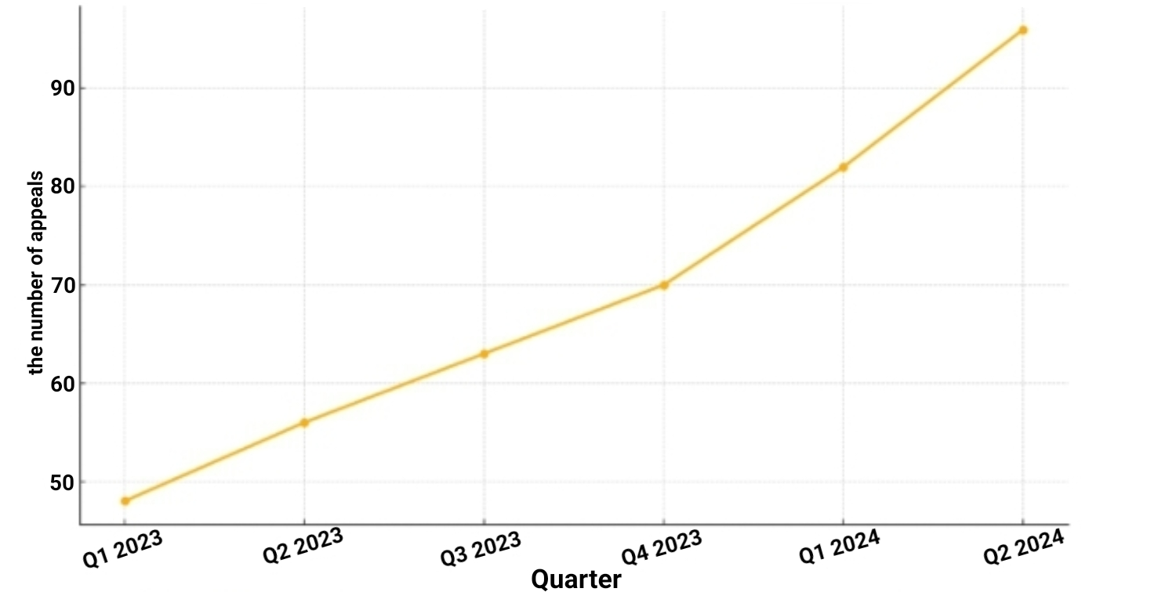

**Figure 2.1 – International Activity: Dynamics of International Requests by Quarter (2023–2024)**

A separate niche in the activities of LLC "Expertiza ZO" is the certification of building materials and technologies. This area has become especially popular after 2022, when the requirements for product compliance with safety, environmental friendliness, and operational durability standards have increased significantly. In 2024, more than 140 certificates of conformity were issued by the company in cooperation with partners from EU countries, which indicates the effective positioning of the company in the field of international technical standardization. At the same time, the company is actively developing a research area, which includes participation in scientific consortia, joint projects with universities (in particular, Polish, German, Czech), the development of innovations in the field of information modeling (BIM), green construction, and the implementation of digital solutions in design and expertise. In 2023–2024, LLC "Expertiza ZO" filed 5 patent applications for the development of new methods for assessing the wear and tear of building structures and developed its own internal energy audit standard, consistent with European practices.

The organizational structure of the enterprise is built on a functional principle and reflects a clear division of responsibilities between departments. It includes: the engineering and technical expertise department, the certification department, the design department, the research and development sector, the administrative unit, the marketing department, as well as a specialized international cooperation department. The latter coordinates communication with foreign clients, adaptation of documentation to ISO requirements, analyzes the international services market and supports export contracts.

At the beginning of 2024, the total number of personnel was 83 people, of which more than 25% have international certificates of conformity. This indicates a high level of personnel training and significant personnel investments in professional development. In addition, the company's internal policy provides for regular advanced training, participation of employees in international seminars and technical forums. The company's financial and economic performance indicators for the past two years confirm its stable growth. Thus, in 2023, the company's gross income amounted to UAH 16.2 million, and in 2024 - already UAH 20.1 million. Net profit for the same period increased by 21%, which allowed the company to invest in updating the technical base, upgrading software (in particular, licenses for Autodesk BIM, SCIA Engineer, Allplan) and opening a new design department in the city of Lviv. Over 60% of the company's clients in 2024 are representatives of small and medium-sized businesses that require technical support in the implementation of construction projects involving international investments. This confirms the reputation of LLC "Expertiza ZO" as a reliable consulting partner within the framework of inter-sectoral interaction.

**Table 2.1 - Main areas of activity of LLC "Expertiza ZO" and their share in the revenue structure (2024)**

|  |  |  |
| --- | --- | --- |
| **Field of activity** | **Service content** | **Share in revenues, %** |
| Technical inspections of buildings and structures | Diagnostics of the condition of objects, calculation of the residual resource | 38 % |
| Certification of building materials and technologies | Assessment of product compliance with DSTU, ISO, EN requirements | 27 % |
| Development of project documentation | Creation of technical solutions, support at the design stage | 14 % |
| Construction expertise | Audit of compliance with construction and construction quality standards | 11 % |
| Research and innovation projects | Participation in grants, implementation of new approaches, methods, technologies | 10 % |
| **Together** |  | **100 %** |

The company's foreign economic activity intensified in 2023–2024, when the company concluded new agreements with German, Polish and Czech partners, in particular with technical institutes, suppliers of certification equipment and construction holdings. In addition, the company participates in projects to rebuild destroyed facilities in eastern Ukraine with the support of international donors. Preparation of tender documentation, reports, technical passports of facilities - all this is accompanied by compliance with European norms and standards.

**Table 2.2 - Forms of international activity of LLC "Expertiza ZO" in 2023–2024**

|  |  |
| --- | --- |
| **Direction of international cooperation** | **Characteristics and implementation examples** |
| Participation in international projects and grants | Horizon Europe: digitalization of housing stock, BIM integration in planning (2023–2024) |

**Continuation of table 2.2**

|  |  |
| --- | --- |
| Technical partnership with foreign companies | Expertise of materials for Polish and Latvian importers, audit of documents for GIZ projects |
| Academic cooperation | Joint research with technical universities in Germany, the Czech Republic, and Poland |
| Participation in industry events | Bau Forum (Munich), green building conferences, presentations at IFCEE |
| Implementation of international standards | ISO 9001, ISO 14001, ISO 45001 — integration into management and technical processes |
| Foreign economic activity | 22% of revenue in 2024 was generated from international orders and technical support for imports |

In the context of modern globalization, enterprises that strive to occupy competitive positions must be not only oriented towards the domestic market, but also actively included in international processes. LLC "Scientific and Expert Center of Construction Technologies "Expertiza ZO"" demonstrates an example of such integration, effectively combining engineering and consulting activities with a flexible foreign economic strategy. The company has a stable system of international relations, which is based on cooperation with scientific institutions, foreign customers and expert organizations. According to internal documentation, the key areas of international activity are: participation in joint research projects with universities in Poland, the Czech Republic and Germany; preparation of expert opinions for companies that export or import building materials; implementation of technical solutions in accordance with EU directives; as well as organization of joint events within the framework of international construction forums and industry conferences.

A special role in the international positioning of the company is played by its communication strategies: multilingual correspondence, maintaining tender documentation in English, and applying international standards in certification. LLC "Expertiza ZO" is a registered participant in the system of international verification of certificates of conformity, which allows the company to provide test results for building materials in a format acceptable to EU countries. In 2023–2024, the company participated in two joint Horizon Europe grant programs, in particular in the areas of "Digitalization of Housing Management" and "Integration of BIM Solutions in Urban Planning". These projects not only expanded the company's technical capabilities, but also contributed to its recognition as a reliable partner 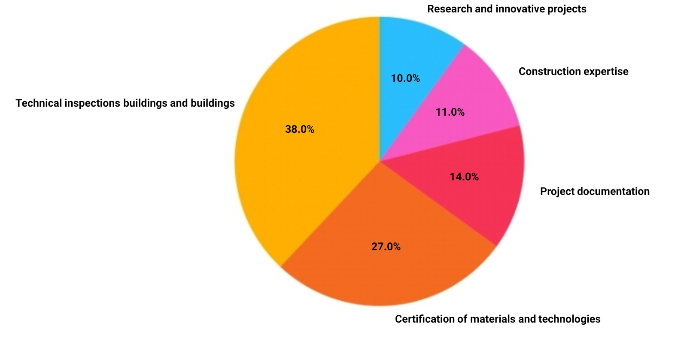among the scientific and engineering community in Europe.

**Figure 2.2 - Revenue structure of LLC "Expertiza ZO" by areas of activity (2024)**

The company's market orientation also has a pronounced external vector. In 2024, about 22% of the income of LLC "Expertiza ZO" was formed due to the sale of services outside Ukraine or on orders from foreign companies. The most active customers include companies from Poland, Hungary, Latvia, which require technical expertise of Ukrainian materials before import or verification of technical solutions in accordance with local standards. In addition, the company regularly participates in international industry events, such as the "Bau" exhibition in Munich, the "Green Building Ukraine" forum, as well as online conferences on digital design, which are held under the auspices of the International Federation of Civil Engineers. Such events are not only a platform for finding partners, but also a space for demonstrating technological maturity and promoting innovative approaches. LLC "Expertiza ZO" has experience working with external investors and participants in joint clusters. For example, in 2023, the company acted as a technical partner in a project on energy-efficient renovation of schools in the Dnipropetrovsk region, funded by GIZ (Germany). Its role was to audit technical documentation, provide recommendations on the use of certified materials, and support certification projects.

It is also worth noting the company's commitment to implementing international management standards. In particular, the company has implemented the principles of ISO 9001:2015 for the quality of internal processes [20], ISO 14001 for environmental management and ISO 45001 for occupational health and safety [21]. All reporting forms are adapted to the requirements of potential European counterparties, including energy passports, technical maps, and material specifications. Based on the analysis, it can be concluded that the international activities of LLC "Expertiza ZO" are not episodic, but strategically built into the company's business model. This allows it to expand the network of partnerships, participate in transnational projects and increase the level of integration into the European market. All this indicates the ability of the company to function not only as a local player, but also as an active subject of international construction consulting.

2.2. Analysis of internal and external business communications in the enterprise

Effective internal communication is an important prerequisite for the effective functioning of any organization, especially in the context of international business, where the speed of information exchange, the accuracy of instructions and the transparency of management decisions directly affect the quality of task performance. At LLC "Scientific and Expert Center of Construction Technologies "Expertiza ZO"", the internal communication system is based on the functional structure of the enterprise and modern digital tools adapted to the requirements of flexible management.

**Table 2.3 - Main internal communication channels of LLC "Expertiza ZO" in 2024**

|  |  |  |
| --- | --- | --- |
| **Communication channel** | **Form of implementation** | **Purpose / functions** |
| E-mail | Corporate email based on the company domain | Formal correspondence, mailings, exchange of business letters |
| CRM system (Bitrix24) | Integrated task management platform | Setting tasks, monitoring performance, reporting |
| Internal portal | Restricted environment with departmental access | Company news, documents, guides, policies |
| Corporate chats | Telegram, Viber, internal messenger in CRM | Quick informal communication, clarification, coordination |
| Operational meetings | Daily/weekly meetings | Decision-making, briefing, distribution of current tasks |
| Video communication | Zoom, Google Meet | Remote participation of employees, particularly in projects with an international component |

A key role in the internal communications system is played by daily operational meetings between heads of departments, weekly strategic meetings with the participation of middle management, and monthly analytical reporting, which is accumulated in a single database. Corporate email, an integrated CRM system (in particular, Bitrix24), and an internal portal for exchanging files, news, and messages between departments are used for communication exchange within the company. The positive side of organizing internal interaction is the high level of digitalization: the company has implemented modern software for project management, maintaining technical documentation, and monitoring task performance. In particular, platforms such as Trello for project management, Zoom for internal meetings in distributed teams, and Google Workspace for collaborative editing of documents are used.

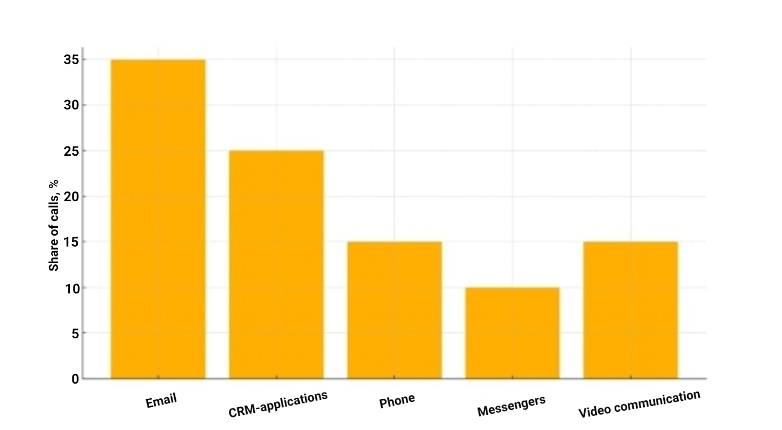

**Figure 2.3 - External communication: Distribution of external appeals by channel type (2024)**

It is worth noting that the company operates a hierarchical communications model, when information is transferred from the project manager to the executors through specific channels. This avoids duplication of functions and loss of information. At the same time, horizontal channels — message exchange between employees of the same level — are supported through an internal corporate chat. Each department has a communications coordinator responsible for timely informing employees about news, changes in orders, project deadlines, etc. However, despite the generally high level of organization, the company's reports also indicate vulnerabilities in the communication system. In particular, the lack of a centralized platform for archiving all communication information leads to the dispersion of documents across various media, which complicates access to the history of decisions made. Also among the problems mentioned is the insufficient training of new employees in the use of digital tools, which slows down the pace of staff integration into work processes.

In the area of interdepartmental interaction support, there is generally positive dynamics. Thus, in 2024, an internal KPI system for analyzing the effectiveness of interaction was introduced, as well as a system for electronic approval of technical documentation between the design, expert, and analytical departments. This allowed reducing the approval time by 23%, and the number of errors in documentation by 17%, which is confirmed by analytical reports of the internal audit.

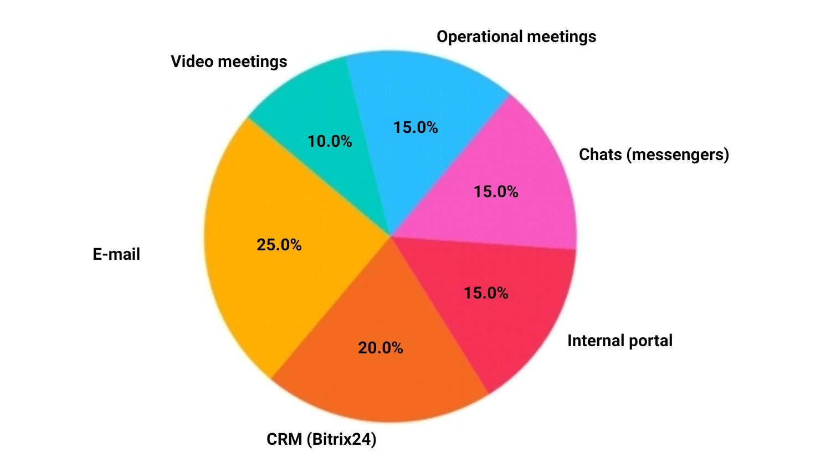

**Figure 2.4 - Internal communication channels in LLC "Expertiza ZO" (2024)**

The company pays significant attention to the development of communication culture. The company has business correspondence rules, standardized reporting templates, and instructions for using technical terminology. In 2023, internal training on the topic of "Effective Electronic Communication" was introduced, which covered more than 70% of employees. In addition, the company is gradually implementing an adaptation mentoring system for newcomers, which also improves the quality of internal interaction. As part of the digital transformation, LLC "Expertiza ZO" plans to implement a centralized integrated platform for managing internal processes based on Microsoft Teams or Zoho WorkDrive. This will allow combining the functions of messaging, video communication, documentation, and task management in a single system that meets modern approaches to organizing digital communication.

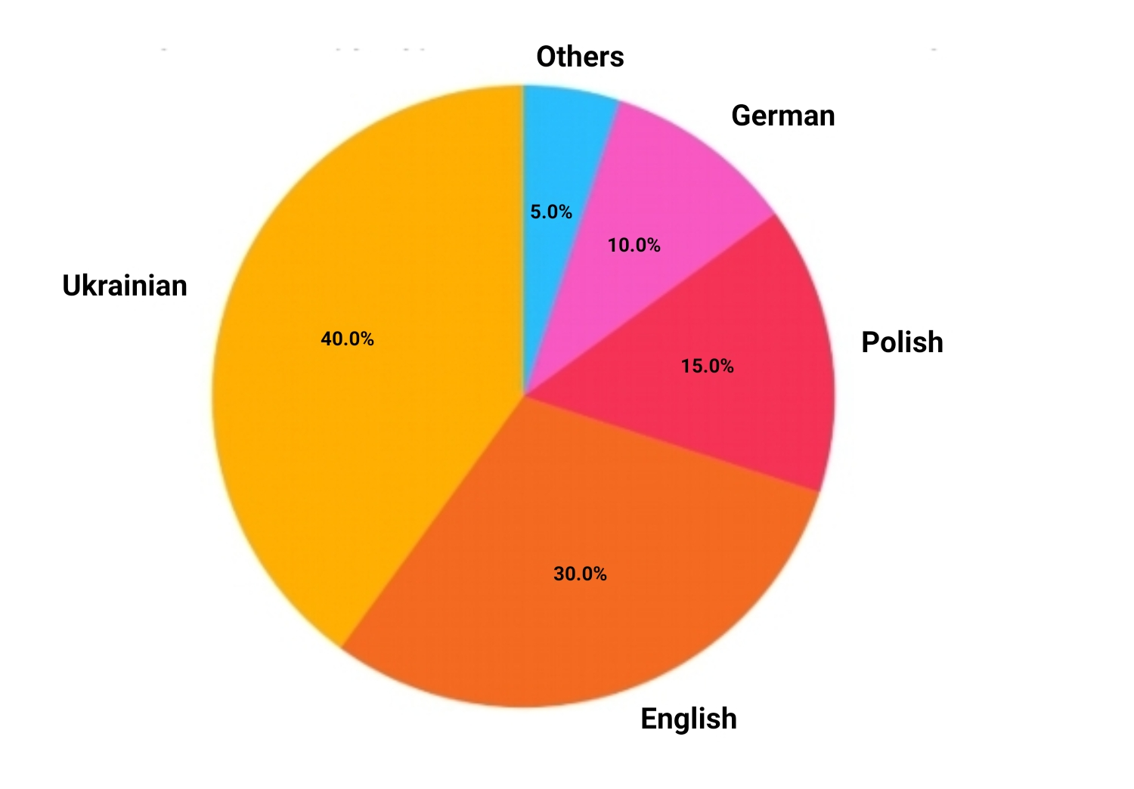

**Figure 2.5 - External communication: Structure of the client base by communication languages (2024)**

The external business communications system is one of the key factors in the sustainable development of LLC "Scientific and Expert Center of Construction Technologies "Expertise ZO"", since it is through external interaction that communication with the market, customer attraction, development of partnership relations and compliance with regulatory requirements are ensured. In the structure of the company's communications, external channels constitute a significant part and cover both the national and international levels. In the field of interaction with customers, the company practices a multi-level communication model, which includes individual consultations, electronic correspondence, presentation meetings, exchange of technical documentation and participation in joint meetings. The company pays special attention to personalizing communication: a manager is assigned to each client who supports the project at all stages. In 2023–2024, 87% of clients received service through an integrated CRM system with the ability to quickly view the history of requests, which significantly increases the level of service and responsiveness.

**Table 2.4 - Main directions of external communication of LLC "Expertiza ZO" in 2023–2024**

|  |  |  |  |
| --- | --- | --- | --- |
| **Interaction category** | **Key counterparties** | **Forms of communication** | **Basic tools** |
| Clients | Service customers in Ukraine and the EU | Consultations, correspondence, presentations, support | CRM system, email, phone, video meetings |
| Partners | Design organizations, engineering firms, suppliers | Negotiations, joint meetings, exchange of technical documentation | Video communication, document management, bilingual presentations |
| Government agencies | Ministry of Regional Development, DABI, local councils, DNIDBK | Reporting, approval of conclusions, participation in tenders | Electronic reporting, certification forms, regulatory framework |
| International partners | Horizon Europe, GIZ, universities, investors | Joint grants, expertise, technical support | Language adaptation of documents, ISO formats, multilingual support |

In working with partners (including international ones), the main channel of communication is business correspondence, negotiations (including online), preparation and approval of contractual documents, mutual technical review of materials. The company ensures that all external documentation is maintained in at least two languages - Ukrainian and English, and if necessary, also in Polish or German. Participation in international forums, webinars and exhibitions (in particular, "Bau" in Germany) allows the company to expand its network of contacts, form new partnerships and promote its own engineering products and methods to foreign markets. The company interacts with state authorities mainly in the context of regulatory and legal support of its activities, reporting, participation in state tenders, approval of expert opinions and product certification. It is important to note that the company cooperates with the State Architectural and Construction Inspectorate, the State Research Institute of Building Structures, the Ministry of Regional Development, as well as individual local government bodies within the framework of the implementation of regional reconstruction projects. The tools for supporting external communication are:

* Official website with functions for submitting applications, uploading documentation and generating reports;
* Multilingual presentations, executed in a uniform style, used during negotiations with foreign counterparties ;
* An electronic document management system that allows technical and legal documents to be coordinated without the physical presence of the parties ;
* Video conferencing platforms (Zoom, MS Teams), which allow for full-fledged technical meetings remotely.

In 2024, it was recorded that more than 40% of the company's external communications are with foreign customers or partners, and the average response time to a request was reduced to 12 hours. This was made possible by the introduction of a multilingual support service, within which key employees speak at least two foreign languages, as well as by the automation of request processing. Participation in international projects and consortia imposes high requirements on communication standards. The company uses a unified structure of business correspondence and adheres to the requirements for transparency and formalization of communications in accordance with ISO 9001:2015. The implementation of specialized software (in particular, CRM modules for external clients) allows the company not only to store the entire history of cooperation, but also to conduct analytics on the effectiveness of external communication by indicators: response time, duration of the approval stage, repetition of requests.

Thus, external communication at LLC "Expertiza ZO" is systematic, multi-level and focused on both the quality of customer service and compliance with international standards of cooperation with partners and regulators. This contributes to the formation of a positive image of the company, increasing trust in the market and expanding its international presence.

2.3. Problems, barriers and directions for improving communication policy

In the process of studying the business communications system of LLC "Scientific and Expert Center of Construction Technologies "Expertiza ZO"", a number of problems and barriers were identified that are systemic in nature and to a certain extent hinder the development of effective interaction both within the enterprise and in the context of its external activities. Despite significant efforts in digitalization, the introduction of innovations and the expansion of international partnerships, there are communication limitations that require comprehensive improvement.

**Table 2.5 - Key problems and barriers in the communications system of LLC "Expertiza ZO"**

|  |  |  |
| --- | --- | --- |
| **Communication sphere** | **Problem/barrier identified** | **Nature of manifestation** |
| Internal | Lack of a single digital platform | Dispersion of information, difficulties in accessing archives |
| Internal | Insufficient digital training of some staff | Long adaptation of new employees, errors in task processing |
| External | Non-standardized external documentation | Lack of unified templates, different styles of design of technical files |
| External | Language difficulties in technical departments | Problems with English-language documentation, delays due to translation |
| External | Bureaucratic approval with government agencies | Long document review, paper-based interaction |
| External / intercultural | Lack of systematic intercultural training for staff | Risks of misunderstandings in negotiations, especially with partners from high-context countries |
| Technical | Incompatibility of CRM, document management and task management systems | Complicated analytics, coordination, and consolidated reporting generation |

One of the key challenges of internal communication is the fragmentation of the information infrastructure. The lack of a unified digital platform for storing and archiving all official documentation leads to the dispersion of data between different systems - CRM, internal portal, email, cloud services. This situation significantly complicates access to the history of decisions, protocols, technical specifications, and also makes centralized analytics of communication flows impossible. In departments working with technical documentation, duplication of messages and untimely updating of files are sometimes observed, which can lead to confusion or even technical errors in the implementation of projects.

Another problem is the uneven digital competence of the staff. Despite the fact that at the management level the company widely uses modern management tools - CRM systems, electronic document management systems, video communication platforms - some of the technical staff do not fully possess the skills to work effectively with these tools. This is especially true for new employees, who require a longer adaptation period than is provided for by formal standards. In some cases, the process of full entry into the company's communication environment can last up to three months, which slows down the implementation of interdepartmental projects and reduces the flexibility of teamwork.

At the same time, a number of barriers have also been identified in the field of external communication. One of them is the insufficient level of standardization of business documentation. In particular, the lack of a unified approach to creating templates for commercial offers, technical specifications, and reports on work performed complicates mutual understanding between company divisions and clients, partners, and government agencies. In some cases, technical documents from different departments are drawn up in different styles, without agreed terminology, which contradicts the principles of corporate unity and can cause misunderstandings.

Particular attention should be paid to the language barrier in working with international partners. Although the company has qualified managers who speak foreign languages, at the level of technical specialists and analysts there is a certain limitation in professional English-language communication. This complicates work with technical documentation, preparation of presentations, participation in international tenders and technical negotiations. In some cases, technical translations are performed with a delay or with the involvement of third-party consultants, which affects the efficiency and cost of implementing external contracts. A significant barrier in external interaction with government agencies is the excessive bureaucracy of the procedures for approving expert opinions and certifications. For example, the approval of individual documents with the State Agency for the Development of Communities and Territories of Ukraine can take more than 20 working days, which slows down the implementation of construction and design works and negatively affects the company's business image before customers. The lack of electronic interaction with a number of regulators forces employees to use paper documentation or in-person presence to submit applications, which is inefficient and resource-consuming in today's digital environment.

Another pressing challenge is the insufficient level of intercultural competence. Despite the increasing number of international contracts and contacts with partners from the EU, East Asia and the Middle East, the company does not have a systematic program to train employees in the rules of intercultural business etiquette. In cases of communication with partners from countries with a high level of contextuality (for example, Japan or Turkey), an attempt to use direct or overly structured correspondence formats may be perceived as incorrect or too aggressive. The lack of appropriate intercultural training creates risks of misunderstandings, especially at the stage of negotiations or agreement on contract details. In addition, the technical barrier to the development of effective communication remains the incomplete integration of the digital solutions used. The project management, document management and CRM systems are currently not synchronized, which creates information gaps, complicates task performance control, generation of consolidated reports and analytics. For example, customer communication data in CRM is not automatically linked to the technical report approval calendar or tender participation deadlines, which leads to the risk of missed deadlines or errors in coordination between departments.

Therefore, it can be stated that the communication system of LLC "Expertiza ZO", despite its overall efficiency and development, needs improvement in several key areas. The main barriers include the fragmentation of the digital infrastructure, the lack of unified standards, language difficulties at the technical level, the lack of intercultural training programs for personnel, and the incomplete integration of digital solutions. Taken together, these factors pose risks both for the efficiency of internal processes and for the formation of long-term relationships with customers and partners.

In the context of the identified problems and barriers in the system of internal and external communications of LLC "Scientific and Expert Center of Construction Technologies "Expertise ZO"", it is relevant to develop a holistic strategy for improving communication policy. Such a strategy should meet the modern challenges of international entrepreneurship, cover both technical and organizational solutions, and also take into account the human factor and the intercultural context of interaction.

**Table 2.6 - Proposals for improving the business communications system of LLC "Expertiza ZO"**

|  |  |  |
| --- | --- | --- |
| **Direction of improvement** | **Offer** | **Expected effect** |
| Technical | Implementation of a single digital platform for communications and document management | Reducing fragmentation, increasing efficiency |
| Personnel | Organization of training in digital literacy and effective business correspondence | Faster adaptation of beginners, reduced errors |
| Intercultural interaction | Introduction of trainings in intercultural communication and English-language negotiations | Improving the quality of international interaction |
| Documentation | Development of unified templates for external documentation | Standardization, unity of corporate style |

**Continuation of table 2.5**

|  |  |  |
| --- | --- | --- |
| Regulatory interaction | Connection to government platforms for electronic approval of documentation | Reducing approval times, minimizing errors |
| Process automation | Using AI for translation, query processing, performance analysis | Accelerate communication, improve customer service quality |
| Performance evaluation | Implementation of KPIs and a system of regular feedback with customers and employees | Continuous improvement, strategy adaptability |

First of all, the priority step should be the introduction of a single integrated digital platform that will combine the functionality of a CRM system, document management, task management and communication analytics. Such a tool (for example, Microsoft Teams, Slack or Zoho One) will allow you to synchronize all communication channels, store the history of business contacts, control the deadlines for completing tasks and reduce data fragmentation. In addition, it will allow you to form a centralized archive of internal decisions, which will help increase the transparency of management processes. To overcome the barriers associated with insufficient digital literacy of some staff, it is advisable to introduce internal training courses. Such programs should be aimed at improving skills in working with modern communication platforms (Bitrix24, Google Workspace, Zoom), and also include elements of effective electronic correspondence, digital task management and the use of business document templates. Regular staff training in this area should become a component of the company's personnel policy.

A separate vector of improvement should be the optimization of intercultural communication, which is critically important in the conditions of active foreign economic activity. To this end, it is recommended to introduce specialized trainings on conducting negotiations in English, intercultural business etiquette, and adapting the presentation style to the expectations of foreign partners. Such training will not only avoid misunderstandings, but also strengthen the company's professional image when cooperating with international clients. Another important area of improvement is the standardization of external communication. It is necessary to develop a single corporate style for business letters, reports, presentations, and commercial proposals. This should include agreed terminology, formatting templates, and stylistic recommendations for different languages. Such an approach will help improve the quality of documentation, reduce the likelihood of errors, and form a consistent external image of the company.

In the field of cooperation with state bodies, it is advisable to introduce mechanisms for preliminary electronic approval of documents through connection to national digital document flow platforms. This will reduce the time for approval of technical conclusions and certifications, avoid resubmission of documents in the event of minor shortcomings, and increase the efficiency of communication with state structures. The use of artificial intelligence in communication analytics is also promising. For example, the integration of automatic translation tools, categorization of customer requests, and assessment of the speed of managers' response in CRM will not only speed up the processing of requests, but also improve service quality management. The company's reports already mention the feasibility of automating the translation of technical documentation - such an innovation would significantly relieve employees and minimize the human factor at critical points of communication. In addition to technical tools, it is worth implementing a system for regular assessment of communication efficiency. This can be done through quarterly surveys of employees and partners, analytics of response times to requests, frequency of repeat requests, customer satisfaction assessments. This approach will allow not only to record problems, but also to track the dynamics of improvements in real time, and therefore make communication management flexible and adaptive.

Taking into account the above, a phased implementation of an updated communication strategy of the enterprise is proposed, which should include: integration of a platform for internal and external communication; training of personnel in digital and intercultural competencies; standardization of business documentation; automation of technical translation and document flows; introduction of KPIs for monitoring the quality of communications. The expected effect will be an increase in the efficiency, consistency and professionalism of communications, which will strengthen the competitive position of LLC "Expertiza ZO" both in the national and international markets.

Conclusions to Chapter 2

In the second section, a comprehensive analysis of the business communications system was carried out using the example of LLC "Scientific and Expert Center of Construction Technologies "Expertise ZO"", which allowed us to comprehensively characterize the specifics of the internal and external interaction of the enterprise as a subject of international entrepreneurship.

A study of the organizational structure and main areas of activity of the company has shown its high level of specialization in the field of engineering and technical expertise, certification of construction technologies and participation in transnational projects. The company demonstrates an active international orientation, in particular in cooperation with European partners, implementation of projects within the framework of the Horizon Europe programs, as well as in the provision of services to foreign customers, the share of which in revenues increased to 22% in 2024. An analysis of internal business communications showed that the company has a fairly developed digital infrastructure (CRM, corporate portal, video communication), a formalized information exchange structure and established channels of horizontal and vertical interaction. At the same time, a number of limitations associated with fragmentation of systems, insufficient integration of individual tools, as well as the need to increase the digital literacy of personnel were identified.

In the field of external communications, the company effectively uses multilingual correspondence, business presentations, video conferencing systems, and maintains a professional level of documentation support for cooperation with clients, partners, and government agencies. However, certain barriers have been identified here, including language difficulties among technical personnel, the lack of unified documentation templates, and delays in coordinating technical solutions with government agencies. The main problems of the communications system have been summarized, the most significant of which are: fragmentation of the digital environment, lack of intercultural competence, insufficient standardization of business style, and low level of feedback automation. Accordingly, a number of practical recommendations have been formulated to improve the communications strategy: implementation of integrated platforms, staff training, documentation unification, connection to government electronic services, and the use of AI tools in customer service.

Thus, the analysis of the enterprise allowed not only to identify the current state of the business communications system, but also to identify specific ways to improve it in accordance with international standards and digital challenges of the modern business environment.