Текст оригинальный.
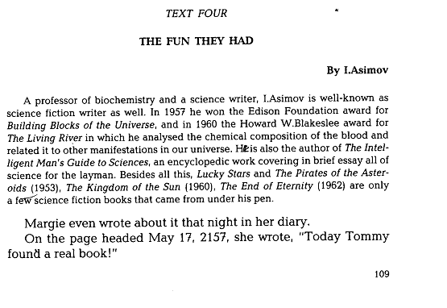

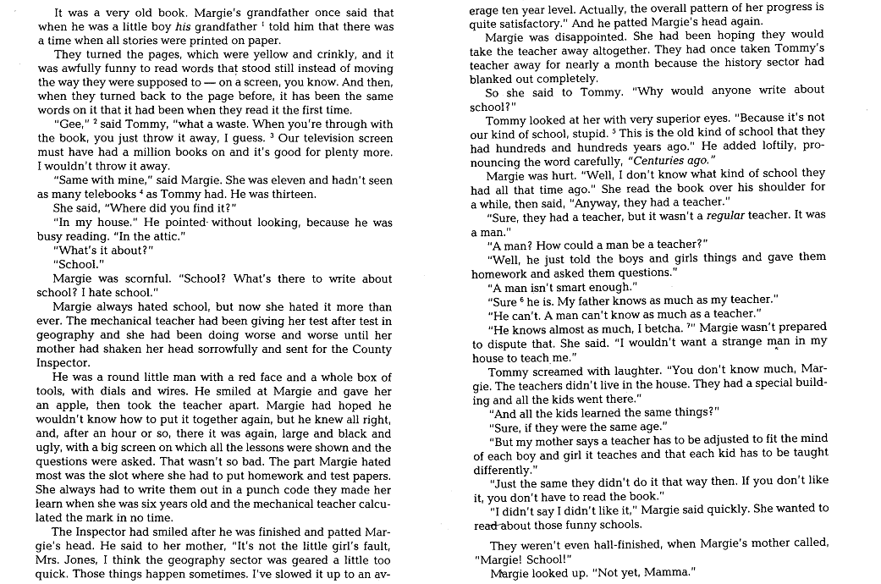

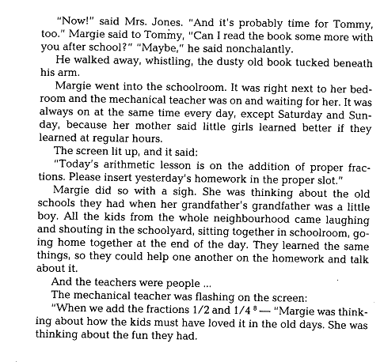

“Vocabulary story” – “Lesson 4” – “Аракин 2” – “3 курс”

Once my friend was reading a book at his note-book in the park. It was a book of a science fiction writer. He paid less attention to the writer`s biography covered in brief essay, but got interested in books came from under his pen. When he was through with the preface, by the way, he did it in no time, he began reading the book.

It was dedicated to the education in the future. In the future all the children received education at home with the mechanical teachers. All the books were on a television screen, and the lines with the text were moving instead of standing still as they were supposed to. As for the tasks and the tests the kids were given in, were flashed on a screen of the mechanical teachers. The entire home works were written in a punch code learned at an early age and were put into the slot. The funny thing was the fact that when the teachers got broken, it was taken to the county inspector and was taken apart, fixed or slowed up to an average level, and then put together.
My friend`s hair stood on end when he got to the part of dismantling the teacher and seeing that thing every day as a form master.

It stood to reason that in the future it might be proper to this kind of education through the mechanical teacher, which would be adjusted to the kid, but with this form of treatment, the kids, at their adultly would not be able to take over or to be on the level with the persons of the same age. What a scream, was my friend`s thoughts while reading the book.

Being busy and not having been even half – finished with the book my friend did not notice how the time flew, and as he kept regular hours for his being in park, and he was out of time, he had to go home, with his note-book tucked beneath his arm.

My friend liked the science fiction and would go on reading that book if he had time, but if he could not, he would try to find some way to fit in with his regular hours, and read more of that author.

